JK

2024 SPP Transmission Expansion Plan Report

By SPP Engineering
Published on February 6, 2024
Version 1

Revision History
Date or version number | Author | Change Description | Comments
1/16/2024 | SPP Staff | Submitted to MOPC

Contents
Revision History i
List of Tables and figures iii
Executive Summary 1
Portfolio Summary 3
Project Summary 5
NTC and Upgrade Activity 7
Completed Upgrades 7
Upgrades Approved for Construction 9
NTCs Withdrawn 16
Study Overviews 18
Transmission Service Studies 18
Completed Aggregate Facility Studies 18
Attachment AR Studies 18
Attachment AQ Requests 18
Generator Interconnection Studies 18
Transmission Planning (ITP) 19
Balanced Portfolio 19
High Priority Studies 19
Sponsored Upgrade Studies 19
Interregional Studies 20
20-Year Assessment 20
Appendix 1 21

List of Tables and figures
Table 1: Upgrade Cost by Study and Status ($ Millions) 2
Table 2: Completed Upgrades 4
Table 3: NTCs Issued 15
Table 4: NTCs Withdrawn 16
Table 5: 2023 Sponsored Upgrades 18
Table 6: 2013 ITP20 Upgrades 22
Table 7: 2022 ITP20 Upgrades 24

Figure 1: STEP Upgrades by Type ($ Millions) 2
Figure 2: STEP Upgrades by Status ($ Millions) 3
Figure 3: STEP Upgrades by Type ($ Millions) 4
Figure 4: Upgrade Summary by Type 4
Figure 5: Upgrade Cost by In-Service Year ($ Millions) 5
Figure 6: Completed Upgrades 3
Figure 7: NTCs Issued 5
Figure 8: NTCs Withdrawn 15

Executive Summary
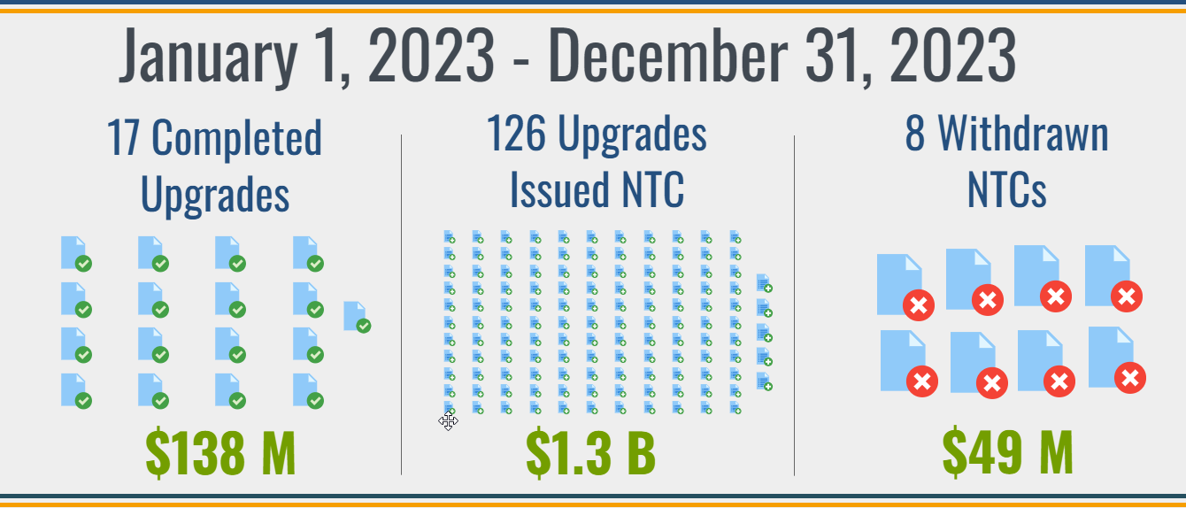
The SPP Transmission Expansion Plan (STEP) is a comprehensive listing of all transmission projects in SPP for the 20-year planning horizon. Projects in the current portfolio include all Network Upgrades for which construction activities are ongoing or those for which construction has completed but not all closeout requirements have been fulfilled in accordance with Section 13 in Business Practice 7060. Projects in the STEP portfolio include:
- Upgrades required to satisfy requests for transmission service (TS)
- Upgrades required to satisfy requests for generator interconnection (GI)
- Requests pursuant to Attachment AQ of this Tariff (AQ)
- Approved projects from the Integrated Transmission Planning Assessment (ITP)
- Upgrades within approved Balanced Portfolios (BP)
- Approved high priority upgrades (HP)
- Endorsed Sponsored Upgrades (SP)
- Approved Interregional Projects (IR)³
- Approved projects from Generator Retirement Process (GR)³

Figure 1: STEP Upgrades by Type ($ Millions)

SPP actively monitors and supports the progress of transmission expansion projects, emphasizing the importance of maintaining accountability for areas such as regional grid reliability standards, firm transmission commitments, and SPP Open Access Transmission Tariff (tariff) cost recovery. SPP staff solicits quarterly feedback from the project owners to determine the progress of each approved transmission project. This report charts the progress of all SPP transmission projects approved by the SPP Board of Directors (Board) or through a Federal Energy Regulatory Commission (FERC)-filed service agreement under the tariff. A summary of the project portfolio is also included.
Stakeholder Action Requested. We invite stakeholders and all interested parties to submit any written comments on the projects included in the STEP via the SPP Request Management System (RMS). SPP solicits feedback on proposed solutions to transmission needs through stakeholder working groups and planning summits, as well as through meetings, teleconferences, web conferences, and via email or secure web-based workspaces. These meetings provide an open forum where all stakeholders have an opportunity to provide advice and recommendations to SPP to aid in the development of the STEP. In addition to these opportunities, we also invite stakeholders to provide SPP with any transmission needs they deem to be beneficial to the transmission planning process through our website or RMS.

Portfolio Summary
3,463 M
Figure 2: STEP Upgrades by Status ($ Millions)

SPP assigns a project status to all network upgrades based on the projected in-service dates provided by the Designated Transmission Owner (DTO) relative to the Need Date determined for the project. Project status definitions are provided below:
- Closed Out: Construction complete and in-service; all close-out requirements fulfilled. Upgrades are reported as Closed Out for one quarter and then removed from the active portfolio
- Complete: Construction complete and in-service
- Delay - Mitigation: Projected In-Service Date beyond Need Date; interim mitigation provided or project may change but time permits the implementation of project
- Delay – Mitigation Window: Behind schedule, interim mitigation pending or project may change but time permits the implementation of project
- Identified: Upgrade identified and included in Board-approved study results
- In Service: Upgrade is operational, but not all construction activities are complete
- Notification to Construct with Conditions (NTC-C) Project Estimate Window: Within the NTC-C Project Estimate (CPE) window
- Notification to Construct (NTC) Commitment Window: NTC/NTC-C issued, still within the 90-day written commitment to construct window and no commitment received
- On Schedule < 4: On Schedule within four-year horizon
- On Schedule > 4: On Schedule beyond four-year horizon
- Re-evaluation: Project active; pending re-evaluation
- RFP Issued: Responses for competitive upgrades are being submitted and/or reviewed
- Suspended: NTC/GIA suspended

Figure 3: STEP Upgrades by Type ($ Millions)

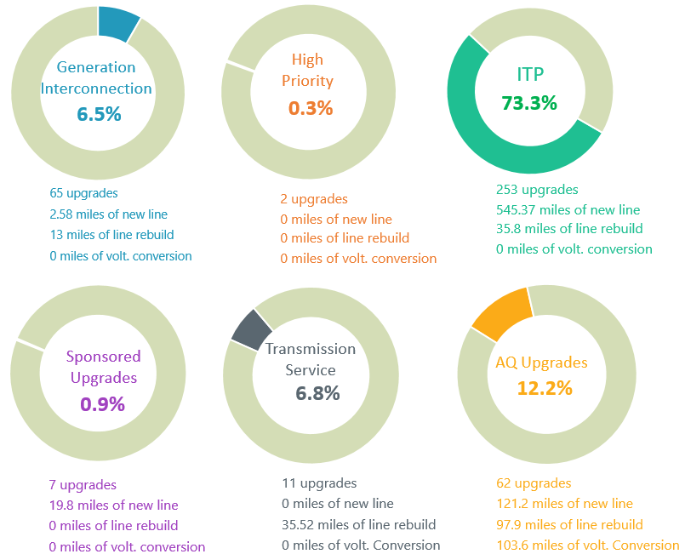
Figure 4: Upgrade Summary by Type

Project Summary
In adherence to the tariff and SPP Business Practice 7060 (BP 7060), SPP issues NTCs to DTOs to begin work on network upgrades that have been approved or endorsed by the SPP Board to meet the construction needs of the STEP, tariff, or RTO.

Figure 5 shows the estimated cost by in-service year for all network upgrades resulting from studies identified in Attachment O of the tariff. Table 1 shows all upgrade costs by upgrade status in each study. Note: Figure 5 and Table 1 provide data for all projects issued an NTC or NTC-C, included in an active Generator Interconnection Agreement (GIA), or identified in the tariff as a base plan upgrade. This chart includes costs for network upgrades no longer included in the active Project Tracking Portfolio.

Figure 5: Upgrade Cost by In-Service Year ($ Millions)

Source Study | Complete | Closed Out | Delay | In Service | Commitment Window | On Schedule | Re-evaluation | Total
2006 STEP | $0 | $189 | $0 | $0 | $0 | $0 | $0 | $189
2007 STEP | $0 | $494 | $0 | $0 | $0 | $0 | $0 | $494
2008 STEP | $0 | $413 | $0 | $0 | $0 | $0 | $0 | $413
2009 STEP | $0 | $550 | $0 | $0 | $0 | $0 | $0 | $550
2010 STEP | $0 | $116 | $0 | $0 | $0 | $0 | $0 | $116
2012 ITP10 | $0 | $365 | $451 | $0 | $0 | $0 | $0 | $816
2012 ITPNT | $0 | $185 | $0 | $0 | $0 | $0 | $0 | $185
2013 ITPNT | $0 | $489 | $0 | $0 | $0 | $0 | $0 | $489
2014 ITPNT | $0 | $439 | $0 | $0 | $0 | $0 | $0 | $439
2015 ITP10 | $0 | $44 | $0 | $0 | $0 | $0 | $0 | $44
2015 ITPNT | $0 | $196 | $0 | $0 | $0 | $0 | $0 | $196
2016 ITPNT | $0 | $408 | $36 | $0 | $0 | $0 | $2 | $446
2017 ITP10 | $0 | $10 | $0 | $0 | $0 | $0 | $0 | $11
2017 ITPNT | $0 | $53 | $0 | $0 | $0 | $0 | $0 | $53
2018 ITPNT | $0 | $30 | $24 | $0 | $0 | $0 | $0 | $54
2019 ITP | $36 | $10 | $62 | $0 | $0 | $226 | $0 | $333
2020 ITP | $10 | $35 | $115 | $0 | $0 | $138 | $14 | $313
2021 ITP | $1 | $0 | $694 | $1 | $0 | $300 | $0 | $995
2022 ITP | $0 | $0 | $10 | $1 | $0 | $9 | $0 | $20
2023 ITP | $0 | $0 | $0 | $0 | $396 | $0 | $0 | $396
AG Studies | $75 | $885 | $1 | $0 | $0 | $150 | $0 | $1,112
Balanced Portfolio | $0 | $823 | $0 | $0 | $0 | $0 | $0 | $823
DPA Studies | $59 | $496 | $207 | $0 | $0 | $4 | $0 | $765
GI Studies | $469 | $319 | $30 | $104 | $0 | $91 | $0 | $1,013
HPILS | $0 | $569 | $11 | $0 | $0 | $0 | $0 | $580
IS Integration | $0 | $272 | $0 | $0 | $0 | $0 | $0 | $272
Priority Projects | $0 | $1,318 | $0 | $0 | $0 | $0 | $0 | $1,318
Sponsored Upgrade | $6 | $14 | $8 | $0 | $0 | $16 | $0 | $44
Grand Total | $655 | $8,721 | $1,649 | $106 | $396 | $933 | $17 | $12,476
Table 1: Upgrade Cost by Study and Status ($ Millions)

NTC and Upgrade Activity
In adherence with the tariff and BP 7060, SPP issues NTCs to DTOs to begin work on network upgrades that have been approved or endorsed by the Board to meet the construction needs of the tariff or RTO. Figure 6 and Table 2 show completed upgrades. Figure 7 and Table 3 show upgrades issued NTCs. Figure 8 and Table 4 show upgrades where the NTC was withdrawn during the reporting period.

Completed Upgrades

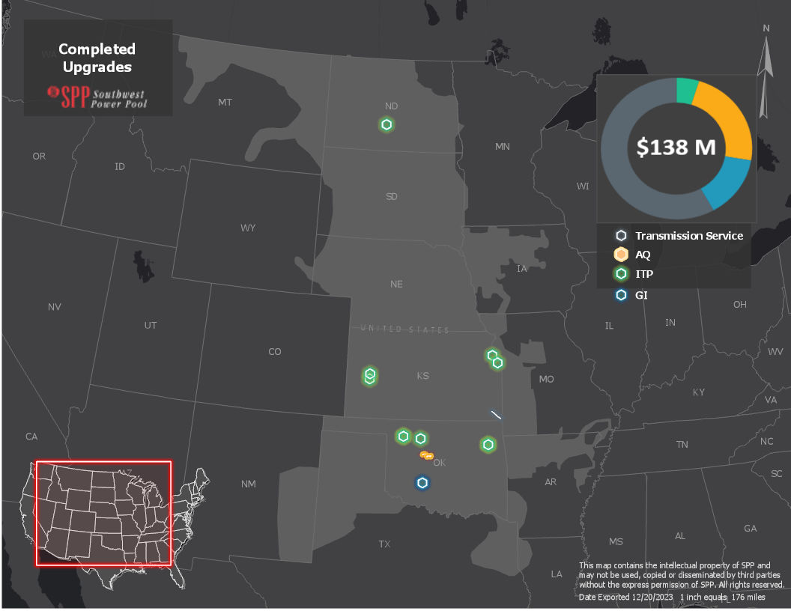
Figure 6: Completed Upgrades

NTC ID | IN SERVICE DATE | UID | OWNER | UPGRADE NAME | SOURCE STUDY | COST ESTIMATE
210543 | 10/25/2023 | 112452 | SEPC | Pile - Scott City 115kV Terminal Upgrades | 2019 ITP | $130,000
210543 | 10/11/2023 | 112453 | SEPC | Scott City - Setab 115kV Terminal Upgrades | 2019 ITP | $144,495
210578 | 1/31/2023 | 122717 | GRDA | GRDA1 345 kV Terminal Upgrades Transformer Ckt 1 | 2020 ITP | $374,400
210578 | 1/31/2023 | 122718 | GRDA | GRDA1 161 kV Terminal Upgrades Transformer Ckt 1 | 2020 ITP | $453,000
210579 | 11/30/2023 | 143157 | WAPA | Bismarck 12.47 kV Reactors | 2020 ITP | $4,309,263
210586 | 2/23/2023 | 122865 | WFEC | Mooreland - Aspen 138 kV Terminal Upgrades | 2020 ITP | $202,500
210586 | 2/23/2023 | 122866 | WFEC | Mooreland - Pic 138 kV Terminal Upgrades | 2020 ITP | $405,000
210637 | 2/10/2023 | 143663 | EKC | Jarbalo Junction 115 kV Breaker | 2021 ITP | $195,694
210647 | 5/1/2023 | 143666 | EM | Craig 161 kV Breaker #2 | 2021 ITP | $267,643
210656 | 3/1/2023 | 143786 | OGE | Cleo Corner 69 kV Terminal Upgrades | 2021 ITP | $168,228
210483 | 5/31/2023 | 72015 | WFEC | Omega - Watonga SW 138 kV Ckt 1 Voltage Conversion | DPA-2017-August-767-774-776 | $12,428,000
210483 | 5/31/2023 | 72029 | WFEC | Kingfisher SW - Park Community 138 kV Ckt 1 New Line | DPA-2017-August-767-774-776 | $6,141,513
210560 | 1/18/2023 | 122575 | BEPC | Northshore 230 kV Substation | DPA-2018-August-918 | $12,877,495
 | 5/1/2023 | 112333 | AEP | Gracemont - Lawton East Side 345 kV Substation GEN-2016-091 (TOIF) (AEPW) | Generation Interconnection | $1,704,279
 | 5/1/2023 | 112334 | AEP | Gracemont - Lawton East Side 345 kV Substation GEN-2016-091 (NU) (AEPW) | Generation Interconnection | $17,798,882
210569 | 1/13/2023 | 112457 | EKC | Neosho - Riverton 161kV Rebuild (EKC) | SPP-2019-AG1-AFS-2 | $7,612,143
210570 | 1/13/2023 | 112456 | EDE | Neosho - Riverton 161kV Rebuild (EDE) | SPP-2019-AG1-AFS-2 | $72,381,260
17 Upgrade(s) Completed |  |  |  |  |  | $137,593,795
Table 2: Completed Upgrades

Upgrades Approved for Construction
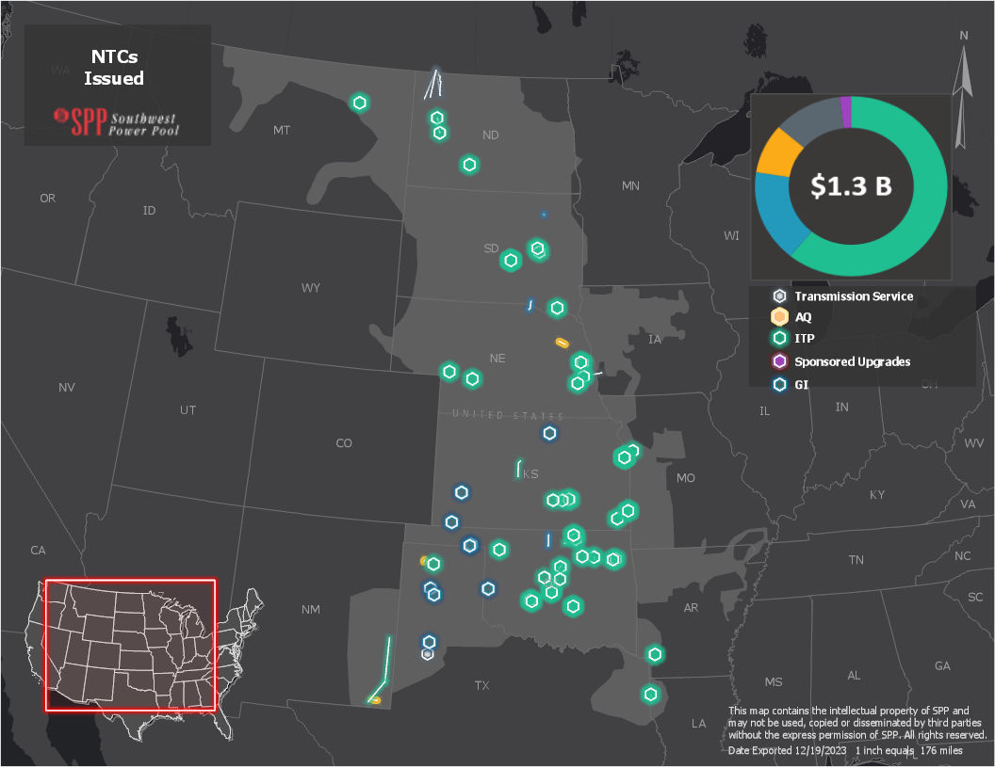
Figure 7: NTCs Issued

NTC ID | NTC ISSUE DATE | UID | OWNER | UPGRADE NAME | SOURCE STUDY |  | COST ESTIMATE OF NEW UPGRADES | COST ESTIMATE OF PREVIOUSLY APPROVED UPGRADES
220754 | 12/15/2023 | 122754 | WFEC | Anadarko - Gracemont 138 kV Ckt3 (WFEC) | 2023 ITP |  | $19,500,000 | $0
220754 | 12/15/2023 | 122756 | WFEC | Anadarko138 kV Substation | 2023 ITP |  | $20,000,000 | $0
220739 | 12/15/2023 | 122761 | OGE | Czech Hall 138 kV Terminal Upgrade | 2023 ITP |  | $69,476 | $0
220720 | 3/16/2023 | 143588 | BEPC | Kummer Ridge - Round Up 345 kV | 2021 ITP |  | $0 | $78,293,357
220720 | 3/16/2023 | 143589 | BEPC | Kummer Ridge 345 kV Terminal Upgrades | 2021 ITP |  | $0 | $342,000
220720 | 3/16/2023 | 143590 | BEPC | Round Up 345 kV Terminal Upgrades | 2021 ITP |  | $0 | $342,000
220727 | 8/24/2023 | 144206 | SPS | Twist 115 kV Substation | DPA-2021-Feb-1279-1280 |  | $0 | $9,087,788
220727 | 8/24/2023 | 144207 | SPS | RB-Exum - Hilmar Cheese Ckt 1, Twist 115 kV New Lines, north side. | DPA-2021-Feb-1279-1280 |  | $0 | $3,909,647
220727 | 8/24/2023 | 144208 | SPS | RB-Kemp - Moore County Ckt 1, Twist 115 kV New Lines, south side. | DPA-2021-Feb-1279-1280 |  | $0 | $3,561,243
210697 | 1/12/2023 | 144326 | OGE | Badger 345 kV Substation Reconfiguration | DISIS-2017-001 |  | $8,500,000 | $0
220722 | 5/24/2023 | 156240 | BEPC | North Dakota/Saskatchewan Border (Tableland) - Tande 230 kV Ckt 1 | SPP- 2021-AG2 |  | $78,880,406 | $0
220722 | 5/24/2023 | 156241 | BEPC | Tande 230 kV Terminal Equipment | SPP- 2021-AG2 |  | $2,562,090 | $0
220722 | 5/24/2023 | 156248 | BEPC | North Dakota/Saskatchewan Border (Tableland) - Wheelock 230 kV Ckt 1 | SPP- 2021-AG2 |  | $65,123,051 | $0
220722 | 5/24/2023 | 156249 | BEPC | Wheelock 230 kV Terminal Upgrade | SPP- 2021-AG2 |  | $2,476,563 | $0
220741 | 11/15/2023 | 156301 | GRDA | Kerr - Maid 161 kV Ckt 1 Rebuild #2 | 2023 ITP |  | $8,440,000 | $0
220741 | 11/15/2023 | 156302 | GRDA | Kerr 161 kV Terminal Equipment | 2023 ITP |  | $730,199 | $0
220741 | 11/15/2023 | 156303 | GRDA | Maid 161 kV Terminal Equipment | 2023 ITP |  | $1,107,600 | $0
220741 | 11/15/2023 | 156304 | GRDA | Kerr - Maid 161 kV Ckt 2 Rebuild | 2023 ITP |  | $8,440,000 | $0
220741 | 11/15/2023 | 156305 | GRDA | Kerr 161 kV Terminal Equipment Ckt 2 | 2023 ITP |  | $730,200 | $0
220741 | 11/15/2023 | 156306 | GRDA | Maid 161 kV Terminal Upgrade Ckt 2 | 2023 ITP |  | $1,107,600 | $0
220726 | 10/3/2023 | 156411 | NEET | Crossroads - Hobbs 345 kV ckts 1 & 2 | 2021 ITP |  | $196,135,073 | $0
220726 | 10/3/2023 | 156412 | NEET | Hobbs - Phantom 345 kV ckts 1 & 2 | 2021 ITP |  | $95,479,502 | $0
220734 | 12/12/2023 | 156454 | SEPC | Concordia West 230/115 kV Transformer | DISIS-2017-002 |  | $7,720,372 | $0
220735 | 12/12/2023 | 156469 | WAPA | Groton South - Groton BE7 115kV CKT2 New Line | DISIS-2017-002 |  | $2,800,000 | $0
220729 | 10/6/2023 | 156471 | EKC | Viola to Renfrow 345 kV Rebuild | DISIS-2017-002 |  | $47,418,633 | $0
220732 | 10/24/2023 | 156493 | SPS | Carpentar 345 kV Line Reactor | DISIS-2017-002 |  | $836,245 | $0
220732 | 10/24/2023 | 156494 | SPS | Potter County 345 kV Line Reactor | DISIS-2017-002 |  | $1,228,089 | $0
220732 | 10/24/2023 | 156495 | SPS | Carpenter 345 kV-Finney 345 kV Line Reactors | DISIS-2017-002 |  | $1,884,762 | $0
220732 | 10/24/2023 | 156497 | SPS | Border 345 kV-Tuco 345 kV Line Reactors | DISIS-2017-002 |  | $2,316,446 | $0
220724 | 9/13/2023 | 156850 | WAPA | Ft Randall - Spencer 115 kV Ckt 1 Rebuild | DISIS-2017-002 |  | $14,216,800 | $0
220732 | 10/24/2023 | 156857 | SPS | Randall 230 kV Reactive Support | DISIS-2017-002 |  | $66,361,449 | $0
220733 | 10/25/2023 | 156858 | AEP | Sweetwater 230 kV Reactive Support | DISIS-2017-002 |  | $58,762,790 | $0
220751 | 11/19/2023 | 157186 | SEPC | Ellsworth Tap - Great Bend 115 kV Ckt 1 Structure Upgrade | 2023 ITP |  | $750,000 | $0
220746 | 12/15/2023 | 157202 | EM | Craig 161 kV Ckt 2 Terminal Upgrade | 2023 ITP |  | $1,329,162 | $0
220746 | 12/15/2023 | 157203 | EM | Lenexa South 161 kV Ckt 2 Terminal Upgrade | 2023 ITP |  | $1,329,161 | $0
220739 | 12/15/2023 | 157241 | OGE | Seminole 345/138 kV Transformer Ckt 3 (138 kV) | 2023 ITP |  | $3,415,129 | $0
220739 | 12/15/2023 | 157242 | OGE | Seminole 345/138 kV Transformer Ckt 3 (345 kV) | 2023 ITP |  | $4,891,214 | $0
220739 | 12/15/2023 | 157254 | OGE | Lightning Creek 138 kV Breaker #1 | 2023 ITP |  | $1,418,348 | $0
220746 | 12/15/2023 | 157255 | EM | Blue Valley 161 kV Breaker #1 | 2023 ITP |  | $310,000 | $0
220746 | 12/15/2023 | 157256 | EM | Craig 161 kV Breaker #1 | 2023 ITP |  | $609,491 | $0
220746 | 12/15/2023 | 157257 | EM | Craig 161 kV Breaker #3 | 2023 ITP |  | $609,490 | $0
220746 | 12/15/2023 | 157258 | EM | Craig 161 kV Breaker #4 | 2023 ITP |  | $609,491 | $0
220746 | 12/15/2023 | 157259 | EM | Craig 161 kV Breaker #5 | 2023 ITP |  | $609,491 | $0
220737 | 12/15/2023 | 157263 | AEP | Longwood - Oak Pan-Harr 138 kV Ckt 1 Rebuild | 2023 ITP |  | $4,070,000 | $0
220737 | 12/15/2023 | 157264 | AEP | Longwood 138 kV Terminal Upgrade | 2023 ITP |  | $150,000 | $0
220737 | 12/15/2023 | 157266 | AEP | Flournoy - Oak Pan-Harr 138 kV Ckt 1 Rebuild | 2023 ITP |  | $15,260,000 | $0
220737 | 12/15/2023 | 157268 | AEP | Turk 138/115 kV Transformer Ckt 1 (138 kV) | 2023 ITP |  | $5,250,000 | $0
220739 | 12/15/2023 | 157274 | OGE | Woodward Nitrogen 69 kV Terminal Upgrade | 2023 ITP |  | $815,000 | $0
220748 | 12/15/2023 | 157280 | WAPA | Dawson County-Fort Peck 230 kV Line Reactor | 2023 ITP |  | $4,007,750 | $0
220760 | 12/5/2023 | 157296 | SPS | XFR - Phantom 345/115 kV Transformer | DPA-2022-March-1564 |  | $13,713,562 | $0
220760 | 12/5/2023 | 157302 | SPS | Road Runner - Red Bluff 115 kV Reconductor | DPA-2022-March-1564 |  | $7,627,279 | $0
220760 | 12/5/2023 | 157303 | SPS | Phantom 115 kV New Cap Bank (72 MVAR) | DPA-2022-March-1564 |  | $7,675,058 | $0
220760 | 12/5/2023 | 157304 | SPS | Livingston Ridge 115 kV New Cap Bank (57.6 MVAR) | DPA-2022-March-1564 |  | $3,481,978 | $0
220760 | 12/5/2023 | 157305 | SPS | Lynch 115 kV New Cap Bank (14.4 MVAR) | DPA-2022-March-1564 |  | $2,746,172 | $0
220760 | 12/5/2023 | 157307 | SPS | Phantom 345 kV New Cap Bank (200 MVAR) | DPA-2022-March-1564 |  | $18,426,313 | $0
220760 | 12/5/2023 | 157308 | SPS | Malaga Bend 115 kV New Cap Bank (28.8 MVAR) | DPA-2022-March-1564 |  | $3,032,336 | $0
220760 | 12/5/2023 | 157309 | SPS | North Loving 345 kV New Cap Bank (100 MVAR) | DPA-2022-March-1564 |  | $12,183,265 | $0
220760 | 12/5/2023 | 157310 | SPS | North Loving 115 kV New Cap Bank (28.8 MVAR) | DPA-2022-March-1564 |  | $3,032,765 | $0
220747 | 12/15/2023 | 157375 | BEPC | Broadland 345 kV Reactor | 2023 ITP |  | $5,445,170 | $0
220750 | 12/15/2023 | 157377 | SPS | Moore Co 115 kV Terminal Upgrade | 2023 ITP |  | $210,000 | $0
220758 | 12/15/2023 | 157382 | WFEC | Anadarko 138 kV Terminal Upgrade Ckt 1 | 2023 ITP |  | $1,000,000 | $0
220743 | 12/15/2023 | 157383 | NPPD | Sub 976 115/69 kV Transformer Ckt 2 (69 kV) | 2023 ITP |  | $5,600,000 | $0
220743 | 12/15/2023 | 157384 | NPPD | Fremont 115/69 kV Transformer Ckt 2 (115 kV) | 2023 ITP |  | $300,000 | $0
220745 | 12/15/2023 | 157385 | LES | Sub 1214 - 70th & Bluff 161 kV Ckt 1 Rebuild (LES) | 2023 ITP |  | $1,200,000 | $0
220744 | 12/15/2023 | 157386 | OPPD | Sub 1214 161 kV Terminal Upgrade | 2023 ITP |  | $114,179 | $0
220745 | 12/15/2023 | 157387 | LES | 70th & Bluff 161 kV Terminal Upgrade | 2023 ITP |  | $2,700,000 | $0
220739 | 12/15/2023 | 157390 | OGE | Southgate - Westmoore Tap 138 kV Extend Line | 2023 ITP |  | $6,470,000 | $0
220739 | 12/15/2023 | 157392 | OGE | Westmoore 138 kV Terminal Upgrade #2 | 2023 ITP |  | $4,790,000 | $0
220739 | 12/15/2023 | 157393 | OGE | Pennsylvania 138 kV Terminal Upgrade | 2023 ITP |  | $200,000 | $0
220738 | 12/15/2023 | 157395 | OGE | Gracemont 138 kV Ck 2 Terminal Upgrade | 2023 ITP |  | $2,171,478 | $0
220754 | 12/15/2023 | 157396 | WFEC | Anadarko 138 kV Ckt 3 Terminal Upgrade | 2023 ITP |  | $2,500,000 | $0
220745 | 12/15/2023 | 157397 | LES | 70th & Bluff 161/115 kV Transformer Ckt 1 (115 kV) | 2023 ITP |  | $4,900,000 | $0
220749 | 12/15/2023 | 157403 | EKC | Neosho 345 kV Terminal Upgrade | 2023 ITP |  | $3,415,129 | $0
220749 | 12/15/2023 | 157405 | EKC | Butler 138 kV Terminal Upgrade | 2023 ITP |  | $1,329,161 | $0
220749 | 12/15/2023 | 157406 | EKC | Midian 138 kV Ckt 1 Terminal Upgrade | 2023 ITP |  | $1,329,161 | $0
220737 | 12/15/2023 | 157475 | AEP | Pine & Peoria Tap - 46Th Street Tap 138 kV Ckt 1 Rebuild | 2023 ITP |  | $1,481,809 | $0
220737 | 12/15/2023 | 157517 | AEP | Tulsa North - 46Th Street Tap 138 kV Ckt 1 Rebuild | 2023 ITP |  | $14,714,997 | $0
220737 | 12/15/2023 | 157518 | AEP | Tulsa North 138 kV Terminal Upgrade | 2023 ITP |  | $150,000 | $0
220736 | 12/15/2023 | 157526 | AEP | Shidler - Webb City Tap 138 kV Ckt 1 Rebuild | 2023 ITP |  | $4,718,963 | $0
220736 | 12/15/2023 | 157527 | AEP | Webb City Tap 138 kV Terminal Upgrade | 2023 ITP |  | $902,559 | $0
220736 | 12/15/2023 | 157528 | AEP | Shidler 138 kV Terminal Upgrade | 2023 ITP |  | $150,000 | $0
220736 | 12/15/2023 | 157529 | AEP | Webb City Tap - Osage 138 kV Ckt 1 Rebuild (AEP) | 2023 ITP |  | $4,765,631 | $0
220738 | 12/15/2023 | 157530 | OGE | Osage 138 kV Terminal Upgrade | 2023 ITP |  | $4,500,000 | $0
220736 | 12/15/2023 | 157534 | AEP | Webb City Tap 138 kV Terminal Upgrade #2 | 2023 ITP |  | $902,559 | $0
220753 | 12/15/2023 | 157551 | WAPA | Fort Thompson 345/230 kV Transformer Ckt 1 (345 kV) | 2023 ITP |  | $12,963,375 | $0
220753 | 12/15/2023 | 157552 | WAPA | Fort Thompson 345/230 kV Transformer Ckt 2 (230 kV) | 2023 ITP |  | $4,891,214 | $0
220753 | 12/15/2023 | 157553 | WAPA | Fort Thompson 345/230 kV Transformer Ckt 2 (345 kV) | 2023 ITP |  | $12,963,375 | $0
220753 | 12/15/2023 | 157554 | WAPA | Fort Thompson 345/230 kV Transformer Ckt 1 (230 kV) | 2023 ITP |  | $2,728,949 | $0
220743 | 12/15/2023 | 157594 | NPPD | Gerald Gentleman Station - Ogallala 230 kV Line & Terminal Upgrades | 2023 ITP |  | $1,600,000 | $0
220743 | 12/15/2023 | 157595 | NPPD | Ogallala 230 kV Terminal Upgrade | 2023 ITP |  | $100,000 | $0
220749 | 12/15/2023 | 157620 | EKC | Franklin 161/69 kV Transformer Ckt 2 (69 kV) | 2023 ITP |  | $1,661,885 | $0
220749 | 12/15/2023 | 157621 | EKC | Franklin 161/69 kV Transformer Ckt 2 (161 kV) | 2023 ITP |  | $1,661,884 | $0
220739 | 12/15/2023 | 157644 | OGE | Fitzgerald Creek - Kinze 138 kV Line Tap | 2023 ITP |  | $10,016,640 | $0
220739 | 12/15/2023 | 157650 | OGE | Valley 138 kV Terminal Equipment | 2023 ITP |  | $483,360 | $0
220742 | 12/15/2023 | 157721 | NWE | Huron West Park 115 kV Terminal Upgrade | 2023 ITP |  | $393,298 | $0
220742 | 12/15/2023 | 157724 | NWE | Huron B Tap 115 kV Terminal Upgrade | 2023 ITP |  | $393,298 | $0
220755 | 12/15/2023 | 157736 | MSG | Devaul 115 kV Reactor | 2023 ITP |  | $1,671,705 | $0
220738 | 12/15/2023 | 157879 | OGE | Anadarko - Gracemont 138 kV Ckt 3 New Line (OGE) | 2023 ITP |  | $22,081,965 | $0
220738 | 12/15/2023 | 157880 | OGE | Webb City Tap - Osage 138 kV Ckt 1 Rebuild (OGE) | 2023 ITP |  | $28,250,000 | $0
220742 | 12/15/2023 | 157891 | NWE | Huron - Huron West Park 115 kV Ckt 1 Rebuild (NWE) | 2023 ITP |  | $11,554,745 | $0
220742 | 12/15/2023 | 157892 | NWE | Huron - Huron 'B' Tap 115 kV Ckt 1 Rebuild (NWE) | 2023 ITP |  | $207,080 | $0
220738 | 12/15/2023 | 157897 | OGE | Anadarko - Gracemont 138kV Ckt 2 New Line (OGE) | 2023 ITP |  | $22,081,965 | $0
220754 | 12/15/2023 | 157899 | WFEC | Anadarko - Gracemont 138kV Ckt 2 New Line (WFEC) | 2023 ITP |  | $19,500,000 | $0
220748 | 12/15/2023 | 157946 | WAPA | Gavins Point - Yankton Junction 115 kV Ckt 1 Rebuild (WAPA) | 2023 ITP |  | $4,000,000 | $0
220748 | 12/15/2023 | 157948 | WAPA | Gavins Point 115 kV Terminal Upgrade | 2023 ITP |  | $264,000 | $0
220742 | 12/15/2023 | 157949 | NWE | Yankton Junction 115 kV Ckt 1 Terminal Upgrade | 2023 ITP |  | $393,298 | $0
220747 | 12/15/2023 | 158019 | BEPC | Groton 345 kV Reactor | 2023 ITP |  | $5,162,152 | $0
220762 | 12/20/2023 | 158042 | NPPD | Norfolk - Stanton North 115 kV line | DPA-2021-October-1442 |  | $14,436,071 | $0
220762 | 12/20/2023 | 158043 | NPPD | Hoskins 230/115 kV Transformer | DPA-2021-October-1442 |  | $11,617,895 | $0
220746 | 12/15/2023 | 158045 | EM | Craig 161 kV Breaker #6 | 2023 ITP |  | $609,492 | $0
220744 | 12/15/2023 | 158445 | OPPD | Sub 976 69 kV Terminal Equipment | 2023 ITP |  | $165,695 | $0
220723 | 10/3/2023 | 158446 | OPPD | S1363 - S1362 161 kV | SUS-038 |  | $7,754,624 | $0
220723 | 10/3/2023 | 158447 | OPPD | S1281 - S1361 161 kV | SUS-038 |  | $3,111,647 | $0
220723 | 10/3/2023 | 158448 | OPPD | Tap S1345 - S1236 161 kV | SUS-038 |  | $13,199,959 | $0
220749 | 12/15/2023 | 158452 | EKC | Benton 345 kV Terminal Upgrade | 2023 ITP |  | $3,415,129 | $0
220749 | 12/15/2023 | 158453 | EKC | Wichita 345 kV Terminal Upgrade | 2023 ITP |  | $3,415,129 | $0
220738 | 12/15/2023 | 158573 | OGE | Redbud 345 kV Terminal Upgrade | 2023 ITP |  | $3,415,129 | $0
220738 | 12/15/2023 | 158574 | OGE | Matthewson 345 kV Terminal Equipment #2 | 2023 ITP |  | $3,415,129 | $0
220761 | 12/15/2023 | 158629 | SPS | Potter County 345/230 kV Transformer Ckt 2 (345 kV) | 2023 ITP |  | $7,500,000 | $0
220761 | 12/15/2023 | 158630 | SPS | Potter County 345/230 kV Transformer Ckt 1 (230 kV) | 2023 ITP |  | $7,500,000 | $0
220761 | 12/15/2023 | 158631 | SPS | Potter County 345/230 kV Transformer Ckt 1 | 2023 ITP |  | $7,500,000 | $0
220761 | 12/15/2023 | 158632 | SPS | Potter County 345 kV Substation Expansion | 2023 ITP |  | $7,500,000 | $0
220738 | 12/15/2023 | 158637 | OGE | Gracemont 138 kV Ckt 3 Terminal Equipment | 2023 ITP |  | $2,171,478 | $0
220754 | 12/15/2023 | 158638 | WFEC | Anadarko 138 kV Ckt 3 Terminal Equipment | 2023 ITP |  | $2,500,000 | $0
220749 | 12/15/2023 | 158653 | EKC | 87th St. Terminal Equipment Ckt 2 | 2023 ITP |  | $5,100,000 | $0
220749 | 12/15/2023 | 158654 | EKC | 87th St. 345/115 kV Transformer | 2023 ITP |  | $5,100,000 | $0
126 Upgrade(s) Issued |  |  |  |  |  | $1,180,592,162 |  | $95,536,035
Table 3: NTCs Issued

NTCs Withdrawn
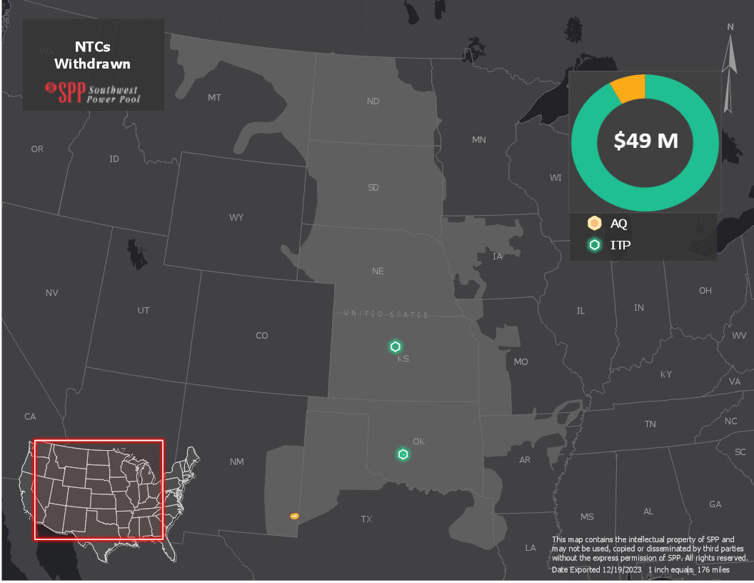
Figure 8: NTCs Withdrawn

NTC ID | NTC WITHDRAWN DATE | UID | OWNER | UPGRADE NAME | SOURCE STUDY | COST ESTIMATE OF WITHDRAWN UPGRADES
210719 | 2/27/2023 | 122803 | SEPC | Russell 115 kV Capacitor Bank | 2020 ITP | $7,172,538
220756 | 11/29/2023 | 122755 | OGE | Gracemont 138 kV Ckt 2 Terminal Equipment | 2020 ITP | $1,124,593
220757 | 11/29/2023 | 122577 | WFEC | Anadarko - Gracemont 138 kV Ckt 1 Rebuild | 2020 ITP | $5,750,000
220757 | 11/29/2023 | 122753 | WFEC | Anadarko - Gracemont 138 kV Ckt 2 Rebuild | 2020 ITP | $30,712,664
210720 | 3/16/2023 | 50600 | WFEC | Hazelton 69 kV Capacitor | DPA-2012-MAR-143-147 | $735,000
210721 | 3/16/2023 | 50628 | WFEC | Hazelton Capacitor 69 kV #2 | DPA-2012-MAR-151-154-161-JUL-218-SEP-243 | $0
220725 | 8/3/2023 | 112510 | SPS | Hobbs Interchange to Millen Rebuild 115 kV Ckt1 | DPA-2018-Mar-854 | $3,165,684
220725 | 8/3/2023 | 122510 | SPS | Johnson Draw 115 kV Capacitor Bank | DPA-2018-Mar-854 | $0
8 Upgrade(s) Withdrawn |  |  |  |  |  | $48,660,479
Table 4: NTCs Withdrawn

Study Overviews

Transmission Service Studies
The Transmission Services department evaluates long-term requests for network integration and point-to-point transmission service through various processes, including the Aggregate Transmission Service Study (ATSS) process under Attachment Z1 of the tariff, performs screening studies through the Delivery Point Transfer (DPT) and Long-Term Service Request (LTSR) processes under Attachment AR of the tariff and Delivery Point Addition (DPA) studies under Attachment AQ of the tariff. Links to studies posted during the reporting period are below.

Completed Aggregate Facility Studies
2023-AG1-AFS-2 Report Tables Facility Log
2022-AG2-AFS-2 Report Tables Facility Log
2022-AG1-AFS-2 Report Tables Facility Log
2021-AG1-AFS-1 Report Tables Facility Log

Attachment AR Studies
2023 Delivery Point Transfer Request

SPP-DPT-2023-001

2022 Delivery Point Transfer Request
SPP-DPT-2022-001
SPP-DPT-2022-002
2023 Long Term Service Request
LTSR-2023-001
LTSR-2023-002

2022 Long Term Service Request
LTSR-2022-001
LTSR-2022-002
LTSR-2022-003
LTSR-2022-004
LTSR-2022-005

Attachment AQ Requests
2023 Delivery Point Addition Studies
2022 Delivery Point Addition Studies
2021 Delivery Point Addition Studies
2020 Delivery Point Addition Studies

Generator Interconnection Studies
SPP’s Generator Interconnection team creates stakeholder value by evaluating impacts of connecting new power sources to the existing transmission system. We facilitate agreements between generation producers and transmission owners while ensuring positive outcomes for the regional power grid. Links to studies posted during the reporting period are below.

Generator Interconnection Studies

Transmission Planning (ITP)
SPP Board approved the 2022 ITP Assessment reports and portfolios on October 31, 2023.

2023 ITP Assessment Report v1.0

Balanced Portfolio
SPP did not perform a Balanced Portfolio study during the reporting period.

High Priority Studies
SPP did not perform a High Priority study during the reporting period.

Sponsored Upgrade Studies
Study Name | ILTCRs Studied | Study Report Final | Board Approval
SUS-035 Cimarron XFMR | Yes⁵ | 12/6/2022 | 1/31/2023
SUS-036 Franklin | Yes | 1/20/2023 | 4/25/2023
SUS-038 Omaha Metro Area 161kV | No | 6/16/2023 | 7/25/2023
Table 5: 2023 Sponsored Upgrades

Interregional Studies
SPP coordinates interregional transmission planning activities with neighboring Planning Regions as approved by the FERC for purposes of Order 1000. Furthermore, SPP coordinates interregional planning and operations activities across all applicable areas of the organization in accordance with SPP's Joint Operating Agreements (JOAs) and other similar coordination arrangements that may not be required by FERC Order 1000.
Throughout 2023, SPP continued collaboration with Midcontinent Independent System Operator (MISO) through refining the Joint Targeted Interconnection Queue (JTIQ) project proposal. Key takeaways were a revised portfolio with cost allocation updates, as well as JTIQ being awarded $464 million from the Department of Energy’s Grid Resilience and Innovation Partnership Program (GRIP). Staff also initiated the SPP Stakeholder process with education presentation as well as began updating Tariff language to begin the RR process in 2024.
MISO-SPP did not propose performing a Coordinated System Plan (CSP) study since a CSP was completed in 2022. Although not part of the CSP process, significant time and resources were dedicated to Long Range Transmission Plan in MISO as well as toward the Interregional NOPR, FERC Order 2023 and other Common Seams Initiatives. In 2023, the MISO-SPP JOA had revisions to clarify various Affected Systems coordination processes and the enhancement of study tie line improvements. However, the Targeted Market Efficiency Project’s process, an effort to identify mutually beneficial transmission improvements within MISO and SPP’s transmission systems that address historical market-to-market (M2M) congestion has been delayed and is now targeted to be included in the MISO-SPP JOA in the last half of 2024.
Furthermore, SPP and Associated Electric Cooperative, Inc. (AECI) did not perform a Joint Coordinated System Plan (JCSP) in 2023 in accordance with the AECI-SPP JOA in which the JCSP is performed every other year. The 2024 JCSP study process has started early evaluating the reliability and robustness of the SPP and AECI transmission system and due to more frequent extreme winter weather conditions will include the extreme weather analysis from the 2024 ITP Assessment and AECI will included extreme winter weather analysis with power transfers in the 2024 AECI Long Range Plan Assessment.
In addition to work with MISO and AECI, SPP also participated in planning coordination the Southeastern Regional Transmission Planning (SERTP) group in accordance with Addendum 4 to Attachment O of the SPP Tariff.

20-Year Assessment
The goal of the 2022 20-Year Assessment (20YA) is to develop a collection of extra high voltage (EHV) transmission projects for the SPP region to leverage in its integrated transmission planning process. The 20YA identifies economic and public policy EHV transmission projects further into the future that are needed to provide a grid flexible enough to provide benefits to the region across multiple scenarios. The assessment results in the identification of projects that economically deliver energy within the SPP region while addressing a reasonable range of future industry uncertainty. The resulting library of projects from the 20YA will provide a source of candidate projects that will inform the shorter-term ITP assessments for the purpose of injecting longer-term vision into those assessments. There are no Notifications to Construct (NTCs) requested for issuance from the 20YA.

2022 20-YR Assessment Report v1.0

ITP20 Upgrades
ITP20 assessments were performed in 2010, 2013, and 2022. While the projects proposed by those studies are incorporated into the STEP Project List, they were not included in SPP’s project tracking effort as part of the Quarterly Tracking Report prior to Q1 2019. A list of active ITP20 projects will be maintained in the STEP Report and Quarterly Project Tracking Report lists going forward. The 2013 ITP20 projects are listed below in Table 6. The 2022 ITP20 projects are listed below in Table 7.

Project ID | Upgrade ID | Owner | Upgrade Name | Study | RTO Determined Need Date | Latest Cost Estimate
30401 | 50492 | TBD | Cass Co. - S.W. Omaha (aka S3454) 345 kV Ckt1 | 2013 ITP20 | 1/1/2033 | $33,126,800
30599 | 50769 | AEP | South Fayetteville 345/161 kV Transformer Ckt1 | 2013 ITP20 | 1/1/2033 | $12,600,000
30599 | 50770 | TBD | Chamber Springs - South Fayetteville 345 kV Ckt1 | 2013 ITP20 | 1/1/2033 | $21,295,800
30600 | 50771 | EMW | Maryville 345/161 kV Transformer Ckt1 | 2013 ITP20 | 1/1/2033 | $12,600,000
30602 | 50773 | TBD | Keystone - Red Willow 345 kV Ckt1 | 2013 ITP20 | 1/1/2033 | $130,141,000
30603 | 50774 | TBD | Tolk - Tuco 345 kV Ckt1 | 2013 ITP20 | 1/1/2033 | $75,718,400
30604 | 50775 | SEPC | Holcomb 345/115 kV Transformer Ckt2 | 2013 ITP20 | 1/1/2033 | $12,600,000
30605 | 50776 | TBD | Neosho - Wolf Creek 345 kV Ckt1 | 2013 ITP20 | 1/1/2033 | $117,126,900
30606 | 50777 | TBD | Clinton - Truman 161 kV Ckt1 Reconductor | 2013 ITP20 | 1/1/2033 | $15,701,325
30606 | 50778 | TBD | North Warsaw - Truman 161 kV Ckt1 Reconductor | 2013 ITP20 | 1/1/2033 | $1,082,850
30608 | 50779 | EKC | Auburn 345/115 kV Transformer Ckt2 | 2013 ITP20 | 1/1/2033 | $12,600,000
30608 | 50780 | TBD | Auburn - Swissvale 345 kV Ckt1 Voltage Conversion | 2013 ITP20 | 1/1/2033 | $20,112,700
30608 | 50781 | TBD | Auburn - Jeffrey EC 345 kV Ckt1 Voltage Conversion | 2013 ITP20 | 1/1/2033 | $35,493,000
30607 | 50782 | OGE | Muskogee/Pecan Creek 345 kV Terminal Upgrades | 2013 ITP20 | 1/1/2033 | $34,605,675
14 Total Projects |  |  |  |  |  | $534,804,450
Table 6: 2013 ITP20 Upgrades

Project ID | Upgrade ID | Owner | Upgrade Name | Study | RTO Determined Need Date | Latest Cost Estimate
93109 | 157811 | TBD | Ft. Smith - Thistle 345 kV CKT 1 | 2022 20 Year Assessment | 1/1/2042 | $461,160,280
93109 | 158510 | OGE | Ft. Smith 345 kV Terminal Equipment | 2022 20 Year Assessment | 1/1/2042 | $2,428,753
93109 | 158511 | SEPC | Thistle 345 kV Terminal Equipment | 2022 20 Year Assessment | 1/1/2042 | $2,428,753
93110 | 157812 | TBD | Flint Creek - Buffalo Flats 345 kV | 2022 20 Year Assessment | 1/1/2042 | $349,831,855
93110 | 158512 | EM | Buffalo Flats 345 kV Terminal Equipment | 2022 20 Year Assessment | 1/1/2042 | $2,428,753
93110 | 158513 | AEP | Flint Creek 345 kV Terminal Equipment | 2022 20 Year Assessment | 1/1/2042 | $2,428,753
93111 | 157813 | OGE | Ft Smith - Sooner 345 kV CKT 1 | 2022 20 Year Assessment | 1/1/2042 | $290,563,847
93111 | 158514 | OGE | Ft. Smith 345 kV Terminal Equipment #2 | 2022 20 Year Assessment | 1/1/2042 | $2,428,753
93111 | 158515 | OGE | Sooner 345 kV Terminal Equipment | 2022 20 Year Assessment | 1/1/2042 | $2,428,753
93113 | 157905 | TBD | Huben - Lacygne 345 kV Ckt 1 New Line | 2022 20 Year Assessment | 1/1/2042 | $198,791,206
93113 | 158520 | AECI | Huben 345 kV Terminal Equipment | 2022 20 Year Assessment | 1/1/2042 | $2,428,753
93113 | 158521 | EM | Lacygne 345 kV Terminal Equipment | 2022 20 Year Assessment | 1/1/2042 | $2,428,753
93114 | 157824 | TBD | Riverside Station - Matthewson 345 kV (OGE) | 2022 20 Year Assessment | 1/1/2042 | $180,577,999
93114 | 158522 | OGE | Matthewson 345 kV Terminal Equipment | 2022 20 Year Assessment | 1/1/2042 | $2,428,753
93114 | 158523 | AEP | Riverside Station 345 kV Terminal Equipment | 2022 20 Year Assessment | 1/1/2042 | $2,428,753
93115 | 157825 | SPS | Potter County Interchange - Tolk Station 345 kV | 2022 20 Year Assessment | 1/1/2042 | $147,667,045
93115 | 158524 | SPS | Potter County Interchange 345 kV Terminal Equipment | 2022 20 Year Assessment | 1/1/2042 | $2,428,753
93115 | 158525 | SPS | Tolk Station 345 kV Terminal Equipment | 2022 20 Year Assessment | 1/1/2042 | $2,428,753
93116 | 157826 | MDU | Twin Brooks 3 to Ellendale 3 345 kV Tap | 2022 20 Year Assessment | 1/1/2042 | $16,467,621
93116 | 157827 | WAPA | Groton Tap - Groton 345 kV | 2022 20 Year Assessment | 1/1/2042 | $32,935,242
93116 | 157828 | WAPA | Broadland - Groton 345 kV | 2022 20 Year Assessment | 1/1/2042 | $32,935,242
93116 | 157873 | TBD | Twin Brooks 3 to Ellendale 3 345 kV Tap (OTP) | 2022 20 Year Assessment | 1/1/2042 | $16,467,621
93116 | 157875 | WAPA | Groton Tap 345 kV Sub | 2022 20 Year Assessment | 1/1/2042 | $0
93117 | 157829 | EM | Sibley - Nashua 345 kV | 2022 20 Year Assessment | 1/1/2042 | $43,969,609
93117 | 158526 | EM | Nashua 345 kV terminal Equipment | 2022 20 Year Assessment | 1/1/2042 | $2,428,753
93117 | 158527 | EM | Sibley 345 kV Terminal Equipment | 2022 20 Year Assessment | 1/1/2042 | $2,428,753
93120 | 157846 | TBD | Sibley - Hawthorn 345 kV CKT 2 | 2022 20 Year Assessment | 1/1/2042 | $25,368,257
93120 | 158530 | AEP | Hawthorn 345 kV Terminal Equipment #2 | 2022 20 Year Assessment | 1/1/2042 | $2,428,753
93120 | 158531 | EM | Sibley 345 kV Terminal Equipment #2 | 2022 20 Year Assessment | 1/1/2042 | $2,428,753
93121 | 157847 | WFEC | Anadarko 345/138 kV Transformer | 2022 20 Year Assessment | 1/1/2042 | $4,891,214
93121 | 157848 | TBD | Anadarko - Gracemont 345 kV | 2022 20 Year Assessment | 1/1/2042 | $5,619,548
93121 | 157849 | WFEC | Anadarko - Gracemont 345 kV (WFEC) | 2022 20 Year Assessment | 1/1/2042 | $5,619,547
93121 | 157850 | WFEC | Anadarko 345 kV Substation | 2022 20 Year Assessment | 1/1/2042 | $13,972,613
93121 | 122591 | OGE | Gracemont 345 kV Terminal Equipment | 2022 20 Year Assessment | 1/1/2042 | $0
93122 | 157851 | TBD | Cimarron - Norman Hill 345 kV CKT 2 | 2022 20 Year Assessment | 1/1/2042 | $20,616,250
93122 | 158532 | OGE | Cimarron 345 kV Terminal Equipment | 2022 20 Year Assessment | 1/1/2042 | $2,428,753
93122 | 158533 | OGE | Norman Hill 345 kV Terminal Equipment | 2022 20 Year Assessment | 1/1/2042 | $2,428,753
37 Total Projects |  |  |  |  |  | $1,891,172,550
Table 7: 2022 ITP20 Upgrades

Appendix 1
(See accompanying list of STEP Projects)

SPP OATT Business Practices
Pursuant to RR 467, all Upgrades resulting from under attachment AQ are tracked independently of transmission service upgrades as of 6/1/2022
There are no Generator Retirement, Balanced Portfolio or Interregional projects included in the STEP report.
Mileage not available for all upgrade categories.
Documents contains ILTCR information

