
JK

2025 SPP Transmission Expansion Plan Report

By SPP Engineering
Published on January 14, 2025
Version 1

Revision History
Date or version number | Author | Change Description | Comments
1/14/2025 | SPP Staff | Submitted to MOPC

Contents
Revision History i
List of Tables and figures iii
Executive Summary 1
Portfolio Summary 3
Project Summary 5
NTC and Upgrade Activity 9
Completed Upgrades 9
Upgrades Approved for Construction 13
NTCs Withdrawn 45
In-service date delays 47
Study Overviews 48
Transmission Service Studies 48
Generator Interconnection Studies 48
Transmission Planning (ITP) 49
Balanced Portfolio 49
High Priority Studies 49
Sponsored Upgrade Studies 49
Interregional Studies 49
ITP20 Upgrades 51
Appendix 1 55

List of Tables and figures
Table 1: Upgrade Cost by Study and Status ($ Millions) 8
Table 2: Completed Upgrades 12
Table 3: NTCs Issued 44
Table 4: NTCs Withdrawn 47
Table 5: 2024 Sponsored Upgrades 49
Table 6: 2013 ITP20 Upgrades 52
Table 7: 2022 ITP20 Upgrades 54

Figure 1: STEP Upgrades by Type ($ Millions) 2
Figure 2: STEP Upgrades by Status ($ Millions) 3
Figure 3: STEP Upgrades by Type ($ Millions) 4
Figure 4: Upgrade Summary by Type 5
Figure 5: Upgrade Cost by In-Service Year ($ Millions) 6
Figure 6: Completed Upgrades 9
Figure 7: NTCs Issued 13
Figure 8: NTCs Withdrawn 45

Executive Summary
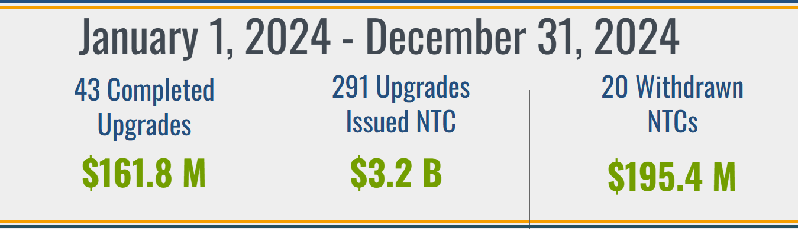
The SPP Transmission Expansion Plan (STEP) is a comprehensive listing of all transmission projects in SPP for the 20-year planning horizon. Projects in the current portfolio include all Network Upgrades for which construction activities are ongoing or those for which construction has completed but not all closeout requirements have been fulfilled in accordance with Section 13 in Business Practice 7060. Projects in the STEP portfolio include:
- Upgrades required to satisfy requests for transmission service (TS)
- Upgrades required to satisfy requests for generator interconnection (GI)
- Requests pursuant to Attachment AQ of this Tariff (AQ)
- Approved projects from the Integrated Transmission Planning Assessment (ITP)
- Upgrades within approved Balanced Portfolios (BP)
- Approved high priority upgrades (HP)
- Endorsed Sponsored Upgrades (SP)
- Approved Interregional Projects (IR)⁴
- Approved projects from Generator Retirement Process (GR)⁴

$6,772 M
Figure 1: STEP Upgrades by Type ($ Millions)

SPP actively monitors and supports the progress of transmission expansion projects, emphasizing the importance of maintaining accountability for areas such as regional grid reliability standards, firm transmission commitments, and SPP Open Access Transmission Tariff (tariff) cost recovery. SPP staff solicits quarterly feedback from the project owners to determine the progress of each approved transmission project. This report charts the progress of all SPP transmission projects approved by the SPP Board of Directors (Board) or through a Federal Energy Regulatory Commission (FERC)-filed service agreement under the tariff. A summary of the project portfolio is also included.
Stakeholder Action Requested. We invite stakeholders and all interested parties to submit any written comments on the projects included in the STEP via the SPP Request Management System (RMS). SPP solicits feedback on proposed solutions to transmission needs through stakeholder working groups and planning summits, as well as through meetings, teleconferences, web conferences, and via email or secure web-based workspaces. These meetings provide an open forum where all stakeholders have an opportunity to provide advice and recommendations to SPP to aid in the development of the STEP. In addition to these opportunities, we also invite stakeholders to provide SPP with any transmission needs they deem to be beneficial to the transmission planning process through our website or RMS.

Portfolio Summary

Figure 2: STEP Upgrades by Status ($ Millions)

SPP assigns a project status to all network upgrades based on the projected in-service dates provided by the Designated Transmission Owner (DTO) relative to the Need Date determined for the project. Project status definitions are provided below:
- Closed Out: Construction complete and in-service; all close-out requirements fulfilled. Upgrades are reported as Closed Out for one quarter and then removed from the active portfolio
- Complete: Construction complete and in-service
- Delay - Mitigation: Projected In-Service Date beyond Need Date; interim mitigation provided or project may change but time permits the implementation of project
- Delay – Mitigation Window: Behind schedule, interim mitigation pending or project may change but time permits the implementation of project
- Identified: Upgrade identified and included in Board-approved study results
- In Service: Upgrade is operational, but not all construction activities are complete
- Notification to Construct with Conditions (NTC-C) Project Estimate Window: Within the NTC-C Project Estimate (CPE) window
- Notification to Construct (NTC) Commitment Window: NTC/NTC-C issued, still within the 90-day written commitment to construct window and no commitment received
- On Schedule < 4: On Schedule within four-year horizon
- On Schedule > 4: On Schedule beyond four-year horizon
- Re-evaluation: Project active; pending re-evaluation
- RFP Issued: Responses for competitive upgrades are being submitted and/or reviewed
- Suspended: NTC/GIA suspended

Figure 3: STEP Upgrades by Type ($ Millions)

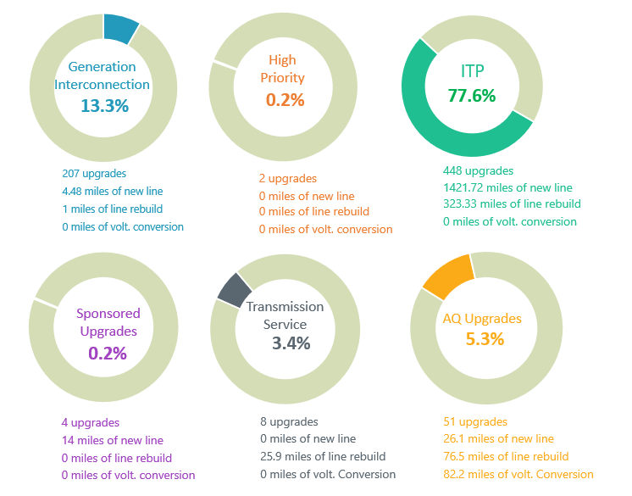
Figure 4: Upgrade Summary by Type

Project Summary
In adherence to the tariff and SPP Business Practice 7060 (BP 7060), SPP issues NTCs to DTOs to begin work on network upgrades that have been approved or endorsed by the SPP Board to meet the construction needs of the STEP, tariff, or RTO.

Figure 5 shows the estimated cost by in-service year for all network upgrades resulting from studies identified in Attachment O of the tariff. Table 1 shows all upgrade costs by upgrade status in each study. Note: Figure 5 and Table 1 provide data for all projects issued an NTC or NTC-C, included in an active Generator Interconnection Agreement (GIA), or identified in the tariff as a base plan upgrade. This chart includes costs for network upgrades no longer included in the active Project Tracking Portfolio.

Figure 5: Upgrade Cost by In-Service Year ($ Millions)

Source Study | Complete | Closed Out | Delay | In Service | Commitment Window | On Schedule | Re-evaluation | Total
2006 STEP | $0 | $189 | $0 | $0 | $0 | $0 | $0 | $189
2007 STEP | $0 | $494 | $0 | $0 | $0 | $0 | $0 | $494
2008 STEP | $0 | $413 | $0 | $0 | $0 | $0 | $0 | $413
2009 STEP | $0 | $550 | $0 | $0 | $0 | $0 | $0 | $550
2010 STEP | $0 | $116 | $0 | $0 | $0 | $0 | $0 | $116
2012 ITP10 | $0 | $365 | $497 | $0 | $0 | $0 | $0 | $861
2012 ITPNT | $0 | $185 | $0 | $0 | $0 | $0 | $0 | $185
2013 ITPNT | $0 | $489 | $0 | $0 | $0 | $0 | $0 | $489
2014 ITPNT | $0 | $439 | $0 | $0 | $0 | $0 | $0 | $439
2015 ITP10 | $0 | $44 | $0 | $0 | $0 | $0 | $0 | $44
2015 ITPNT | $0 | $196 | $0 | $0 | $0 | $0 | $0 | $196
2016 ITPNT | $4 | $409 | $28 | $0 | $0 | $0 | $2 | $444
2017 ITP10 | $0 | $10 | $0 | $0 | $0 | $0 | $0 | $11
2017 ITPNT | $0 | $52 | $0 | $0 | $0 | $0 | $0 | $52
2018 ITPNT | $25 | $30 | $0 | $0 | $0 | $0 | $0 | $56
2019 ITP | $4 | $51 | $57 | $0 | $28 | $219 | $0 | $358
2020 ITP | $9 | $47 | $167 | $0 | $6 | $83 | $0 | $313
2021 ITP | $18 | $1 | $989 | $0 | $0 | $11 | $0 | $1,020
2022 ITP | $3 | $1 | $2 | $1 | $0 | $8 | $0 | $15
2023 ITP | $20 | $0 | $240 | $0 | $26 | $34 | $15 | $334
2024 ITP | $0 | $0 | $0 | $0 | $2,757 | $0 | $0 | $2,757
AG Studies | $74 | $888 | $0 | $0 | $0 | $158 | $0 | $1,120
Balanced Portfolio | $0 | $823 | $0 | $0 | $0 | $0 | $0 | $823
DPA Studies | $24 | $561 | $232 | $0 | $0 | $101 | $0 | $919
GI Studies | $533 | $319 | $42 | $440 | $0 | $408 | $0 | $1,743
HPILS | $0 | $569 | $11 | $0 | $0 | $0 | $0 | $580
IS Integration | $0 | $272 | $0 | $0 | $0 | $0 | $0 | $272
Priority Projects | $0 | $1,318 | $0 | $0 | $0 | $0 | $0 | $1,318
Sponsored Upgrade | $13 | $28 | $0 | $0 | $0 | $3 | $0 | $44
Grand Total | $728 | $8,857 | $2,267 | $442 | $2,816 | $1,025 | $17 | $16,152
Table 1: Upgrade Cost by Study and Status ($ Millions)

NTC and Upgrade Activity
In adherence with the tariff and BP 7060, SPP issues NTCs to DTOs to begin work on network upgrades that have been approved or endorsed by the Board to meet the construction needs of the tariff or RTO. Figure 6 and Table 2 show completed upgrades. Figure 7 and Table 3 show upgrades issued NTCs. Figure 8 and Table 4 show upgrades where the NTC was withdrawn during the reporting period.

Completed Upgrades

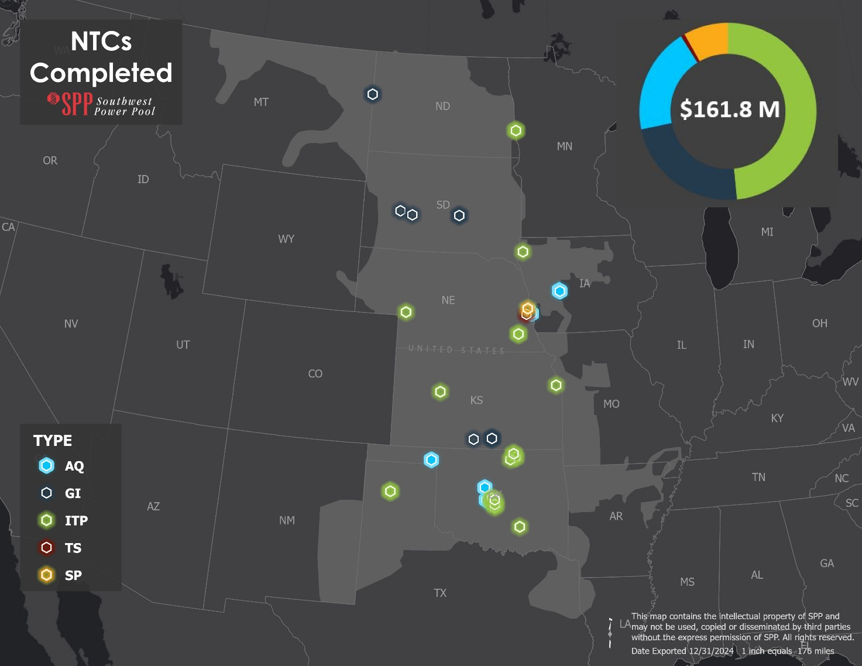
Figure 6: Completed Upgrades

NTC ID | IN SERVICE DATE | UID | OWNER | UPGRADE NAME | SOURCE STUDY | COST ESTIMATE
200397 | 12/31/2023 | 11113 | WFEC | Sara Road - Sunshine Canyon 69 kV Ckt 1 Rebuild | 2016 ITPNT | $643,784
200433 | 12/31/2023 | 51764 | WFEC | Tupelo 138 kV Terminal Upgrades | 2017 ITP10 | $410,000
210496 | 11/22/2024 | 92151 | SPS | McDowell Creek 230/115kV Substation | 2018 ITPNT | $17,545,007
210496 | 11/22/2024 | 92152 | SPS | McDowell Creek 230/115kV Transformer | 2018 ITPNT | $7,892,662
210538 | 7/2/2024 | 112403 | NPPD | Firth Cap Bank 115kV Ckt 1 | 2019 ITP | $570,000
210538 | 7/2/2024 | 112404 | NPPD | Firth 115 kV Substation Expansion | 2019 ITP | $3,036,560
210543 | 1/4/2024 | 112451 | SEPC | Arnold - Ransom 115kV Terminal Upgrades | 2019 ITP | $972,168
210585 | 10/10/2024 | 143159 | MRES | Moorehead 230 kV Reactor | 2020 ITP | $6,477,481
210640 | 8/27/2024 | 143667 | MRES | Moorhead 230 kV Substation Reconfiguration | 2021 ITP | $15,997,845
210645 | 12/31/2023 | 144143 | NPPD | Ogallala (Tri State) - Ogallala (NPPD) 115 kV (NPPD) | 2021 ITP | $326,708
210712 | 7/1/2024 | 156320 | NIPCO | Eagle - J1 Center 69 kV Ckt 1 rebuild | 2022 ITP | $1,644,058
210713 | 4/28/2024 | 156372 | OGE | West Oak 138 kV Breaker #1 | 2022 ITP | $462,388
210713 | 4/27/2024 | 156373 | OGE | West Oak 138 kV Breaker #2 | 2022 ITP | $462,388
210713 | 2/29/2024 | 156375 | OGE | Cherry Creek 138 kV Breaker | 2022 ITP | $462,388
210713 | 5/30/2024 | 156376 | OGE | Indian Hill 138 kV Breaker | 2022 ITP | $462,388.00
210713 | 2/29/2024 | 156377 | OGE | Turner 138 kV Breaker | 2022 ITP | $188,467
220739 | 6/1/2024 | 157254 | OGE | Lightning Creek 138 kV Breaker #1 | 2023 ITP | $250,000
220749 | 5/30/2024 | 158654 | EKC | 87th St. 345/115 kV Transformer | 2023 ITP | $11,225,504
220775 | 7/31/2024 | 157526 | AEP | Shidler - Webb City Tap 138 kV Ckt 1 Rebuild | 2023 ITP | $3,525,731
220775 | 7/31/2024 | 157527 | AEP | Webb City Tap 138 kV Terminal Upgrade | 2023 ITP | $1,150,033
220775 | 7/31/2024 | 157528 | AEP | Shidler 138 kV Terminal Upgrade | 2023 ITP | $29,515
220775 | 7/31/2024 | 157529 | AEP | Webb City Tap - Osage 138 kV Ckt 1 Rebuild (AEP) | 2023 ITP | $3,387,468
220775 | 7/31/2024 | 157534 | AEP | Webb City Tap 138 kV Terminal Upgrade #2 | 2023 ITP | $1,150,033
210676 | 5/29/2024 | 143118 | EKC | Buffalo Flats 345 kV | DISIS-2017-001 | $13,299
210483 | 5/30/2024 | 72024 | WFEC | El Reno - Mustang 138 kV Ckt 1 Voltage Conversion | DPA-2017-August-767-774-776 | $12,155,000
210483 | 6/15/2024 | 72025 | WFEC | Mustang - Sara Road 138 kV Ckt 1 Voltage Conversion | DPA-2017-August-767-774-776 | $2,663,911
210483 | 1/31/2024 | 72030 | WFEC | Kingfisher SW 138 kV Substation | DPA-2017-August-767-774-776 | $5,769,534
210548 | 6/7/2024 | 102163 | OPPD | S1209 - S1231 Ckt 2 161 kV Reconductor | DPA-2018-February-841 | $7,345,497
210505 | 1/31/2024 | 102172 | WFEC | Clear Creek Tap 69 kV Cap Bank | DPA-2018-June-902 | $1,366,875
210600 | 6/19/2024 | 143178 | OPPD | S3456 to S3458 345 kV Ckt 1 Terminal Upgrades | DPA-2018-October-949 | $100,000
220764 | 2/1/2024 | 158570 | CBPC | Coon Rapids 69 kV Capacitor Bank | DPA-2023-April-1762 | $1,099,448.80
220764 | 5/1/2024 | 158571 | CBPC | Tall Corn Ethanol 69 kV- Tall Corn Ethanol Tap 69 kV | DPA-2023-April-1762 | $850,000
 | 9/30/2024 | 112339 | WAPA | Ft. Thompson to Oahe 230kV GEN-2016-094 Interconnection (TOIF) (WAPA) | Generation Interconnection | $250,000
 | 10/24/2024 | 112340 | WAPA | Ft. Thompson to Oahe 230kV GEN-2016-094 Interconnection (Non-Shared NU) (WAPA) | Generation Interconnection | $8,805,000
 | 12/1/2024 | 122673 | EKC | Viola 345kV GEN-2016-153 Interconnection (Non-Shared NU) (WERE) | Generation Interconnection | $90,000
 | 10/4/2024 | 122684 | TSGT | Sidney 115kV GEN-2016-147 Interconnection Costs (TOIF) (TSGT) | Generation Interconnection | $1,636,796
 | 10/4/2024 | 122687 | TSGT | Sidney 115kV GEN-2016-147 Interconnection Costs (Non-Shared NU) (TSGT) | Generation Interconnection | $2,155,837
 | 12/15/2024 | 122792 | EKC | Viola 345/138 kV Transformer CKT 2 (DISIS-2016-002-2) | Generation Interconnection | $12,195,318
 | 12/1/2024 | 132956 | WAPA | Philip Tap 230 kV GEN-2017-014 Interconnection (TOIF) (WAPA) | Generation Interconnection | $400,000
 | 12/1/2024 | 132957 | WAPA | Philip Tap 230 kV GEN-2017-014 Interconnection (Non-Shared NU) (WAPA) | Generation Interconnection | $12,195,000
 | 10/15/2024 | 133065 | EKC | Viola 345 kV Substation GEN-2017-086 Interconnection (Non-Shared NU) (EKC) | Generation Interconnection | $38,569
210716 | 5/31/2024 | 156844 | OPPD | S1254 - S1281 161 kV Ckt 1 Reconductor | SPP-2022-AG1-AFS-2 | $1,171,441
220723 | 2/29/2024 | 158448 | OPPD | Tap S1345 - S1236 161 kV | SUS-038 | $13,199,959
43 Upgrade(s) Completed |  |  |  |  |  | $161,774,061
Table 2: Completed Upgrades

Upgrades Approved for Construction
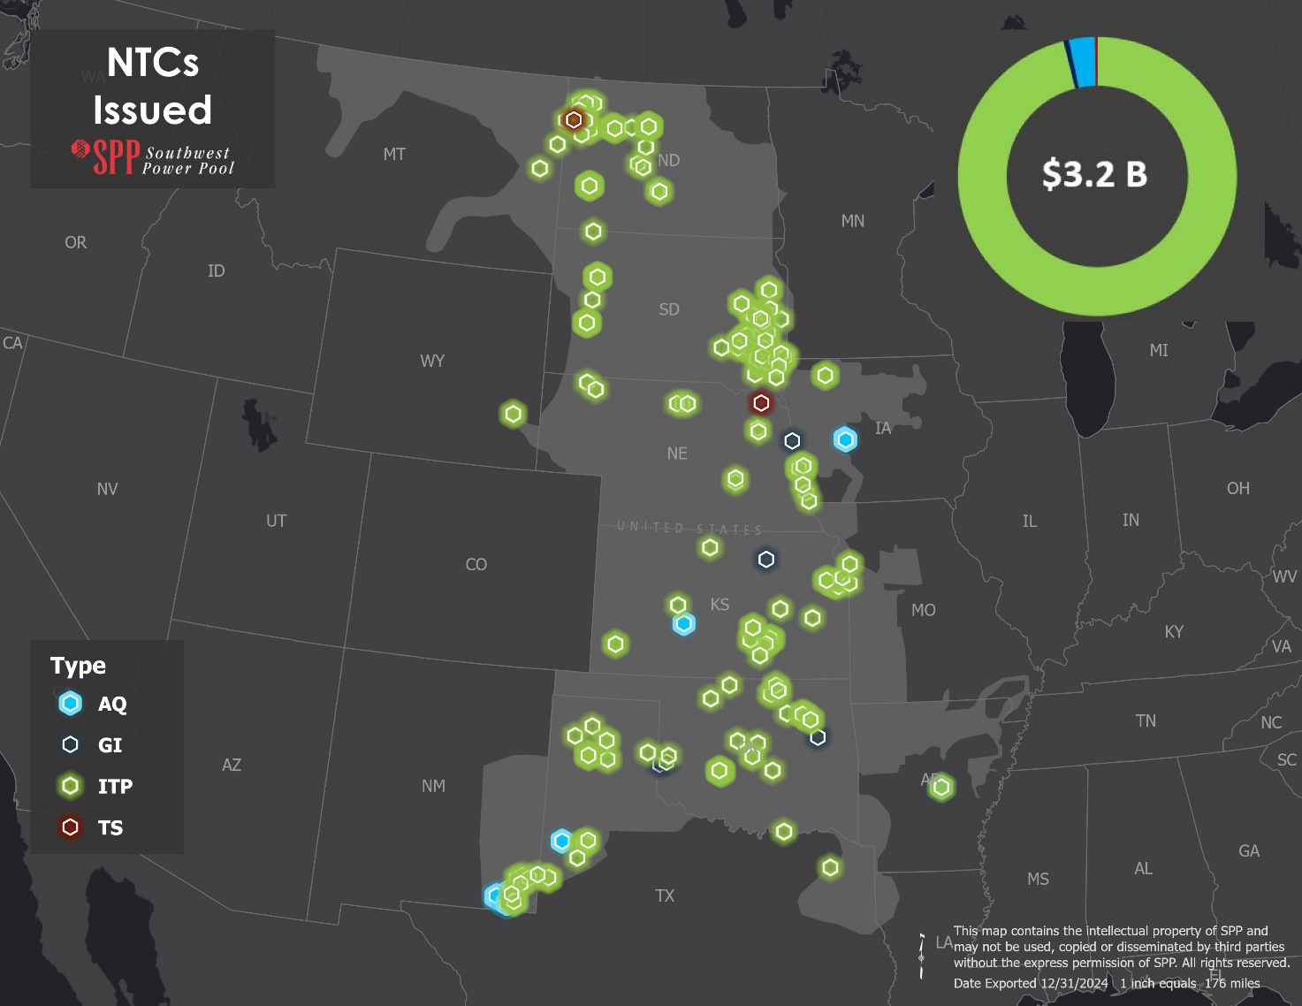
Figure 7: NTCs Issued

NTC ID | NTC ISSUE DATE |  | UID | OWNER | UPGRADE NAME | SOURCE STUDY | COST ESTIMATE OF NEW UPGRADES | COST ESTIMATE OF PREVIOUSLY APPROVED UPGRADES
220789 | 8/16/2024 |  | 112509 | EKC | Wolf Creek 345kV Terminal Equipment | 2019 ITP | $0 | $27,665,252
220772 | 3/25/2024 |  | 158573 | OGE | Redbud 345 kV Terminal Upgrade | 2023 ITP | $3,579,283 | $0
220772 | 3/25/2024 |  | 158574 | OGE | Matthewson 345 kV Terminal Equipment #2 | 2023 ITP | $3,952,014 | $0
220773 | 4/11/2024 |  | 158638 | WFEC | Anadarko SPA 138 kV Ckt 2 Terminal Equipment | 2023 ITP | $2,500,000 | $0
220773 | 4/11/2024 |  | 122756 | WFEC | Anadarko SPA 138 kV Substation Rebuild and Line Re-termination | 2023 ITP | $22,000,000 | $0
220773 | 4/11/2024 |  | 157396 | WFEC | Anadarko SPA 138 kV Ckt 3 Terminal Equipment | 2023 ITP | $2,500,000 | $0
220774 | 4/11/2024 |  | 157395 | OGE | Gracemont 138 kV Ck 2 Terminal Upgrade | 2023 ITP | $2,177,750 | $0
220774 | 4/11/2024 |  | 157879 | OGE | Anadarko - Gracemont 138 kV Ckt 3 New Line (OGE) | 2023 ITP | $10,000,000 | $0
220774 | 4/11/2024 |  | 157880 | OGE | Webb City Tap - Osage 138 kV Ckt 1 Rebuild (OGE) | 2023 ITP | $28,880,257 | $0
220774 | 4/11/2024 |  | 157897 | OGE | Anadarko - Gracemont 138kV Ckt 2 New Line (OGE) | 2023 ITP | $10,000,000 | $0
220774 | 4/11/2024 |  | 157530 | OGE | Osage 138 kV Terminal Upgrade | 2023 ITP | $1,203,344 | $0
220774 | 4/11/2024 |  | 158637 | OGE | Gracemont 138 kV Ckt 3 Terminal Equipment | 2023 ITP | $2,177,750 | $0
220775 | 4/11/2024 |  | 157534 | AEP | Webb City Tap 138 kV Terminal Upgrade #2 | 2023 ITP | $902,559 | $0
220775 | 4/11/2024 |  | 157529 | AEP | Webb City Tap - Osage 138 kV Ckt 1 Rebuild (AEP) | 2023 ITP | $4,765,631 | $0
220775 | 4/11/2024 |  | 157526 | AEP | Shidler - Webb City Tap 138 kV Ckt 1 Rebuild | 2023 ITP | $4,718,963 | $0
220775 | 4/11/2024 |  | 157527 | AEP | Webb City Tap 138 kV Terminal Upgrade | 2023 ITP | $902,559 | $0
220775 | 4/11/2024 |  | 157528 | AEP | Shidler 138 kV Terminal Upgrade | 2023 ITP | $150,000 | $0
220780 | 5/24/2024 |  | 158629 | SPS | Potter County 345/230 kV Transformer Ckt 2 (345 kV) | 2023 ITP | $9,642,772 | $0
220780 | 5/24/2024 |  | 158630 | SPS | Potter County 345/230 kV Transformer Ckt 1 (230 kV) | 2023 ITP | $5,577,000 | $0
220780 | 5/24/2024 |  | 158631 | SPS | Potter County 345/230 kV Transformer Ckt 1 | 2023 ITP | $10,187,000 | $0
220780 | 5/24/2024 |  | 158632 | SPS | Potter County 345 kV Substation Expansion | 2023 ITP | $10,172,000 | $0
220791 | 11/4/2024 |  | 158640 | EKC | Atlantic Substation 115 kV | 2023 ITP | $18,112,045 | $0
220791 | 11/4/2024 |  | 158641 | EKC | Atlantic Substation 345 kV | 2023 ITP | $28,916,224 | $0
220791 | 11/4/2024 |  | 158645 | EKC | Eudora Township – Atlantic 115 kV Tap | 2023 ITP | $7,633,566 | $0
220791 | 11/4/2024 |  | 158648 | EKC | Atlantic 345/115 kV Transformer (115 kV) | 2023 ITP | $15,465,263 | $0
220791 | 11/4/2024 |  | 159064 | EKC | Atlantic Terminal Equipment 345 kV Transformer (345 kV) | 2023 ITP | $749,750 | $0
220792 | 11/4/2024 |  | 158646 | EM | West Gardner - Craig 345 kV | 2023 ITP | $30,685,881 | $0
220825 | 11/14/2024 |  | 157697 | LEA | Buckeye Tap to the Lea County REC Texaco Line Work | 2023 ITP | $2,347,150 | $0
220826 | 11/14/2024 |  | 157794 | SPS | Buckeye Tap - Cunningham - Quahada 115 kV Ckt 1 New Line | 2023 ITP | $3,292,649 | $0
220826 | 11/14/2024 |  | 157696 | SPS | Buckeye Tap 115 kV Ckt 1 Substation | 2023 ITP | $12,507,654 | $0
220826 | 11/14/2024 |  | 157796 | SPS | Cunningham - Quahada 115 kV New Substation | 2023 ITP | $10,753,102 | $0
220804 | 12/13/2024 |  | 170405 | AEP | Tulsa North 138 kV Ckt 1 Terminal Upgrade #3 | 2024 ITP | $425,503 | $0
220804 | 12/13/2024 |  | 170415 | AEP | Catoosa 161/138 kV Transformer (AEP) | 2024 ITP | $4,765,714 | $0
220804 | 12/13/2024 |  | 170385 | AEP | Tulsa North 345/138 kV Transformer Ckt 2  (345 kV) | 2024 ITP | $1,537,869 | $0
220804 | 12/13/2024 |  | 170389 | AEP | Cherokee Data Center East - Tulsa North 138 kV Ckt 1 Rebuild | 2024 ITP | $5,008,393 | $0
220804 | 12/13/2024 |  | 170390 | AEP | Cherokee Data Center East 138 kV Ckt 1 Terminal Upgrade | 2024 ITP | $425,503 | $0
220804 | 12/13/2024 |  | 170384 | AEP | Tulsa North 345/138 kV Transformer Ckt 2 (138 kV) | 2024 ITP | $11,484,217 | $0
220805 | 12/13/2024 |  | 159585 | CBPC | Wisdom 69 kV Ckt 1 Terminal Upgrade | 2024 ITP | $600,000 | $0
220805 | 12/13/2024 |  | 159583 | CBPC | Spencer - Wisdom 69 kV Ckt 1 Rebuild (CBPC) | 2024 ITP | $171,500 | $0
220806 | 12/13/2024 |  | 159532 | CPEC | Bismarck - East Bismarck 115 kV Ckt 1 Rebuild (CPEC) | 2024 ITP | $198,331 | $0
220806 | 12/13/2024 |  | 159534 | CPEC | East Bismarck 115 kV Ckt 1 Terminal Upgrade | 2024 ITP | $385,333 | $0
220807 | 12/13/2024 |  | 170381 | WFEC | Colbert 138 kV Capacitor | 2024 ITP | $1,400,000 | $0
220808 | 12/13/2024 |  | 170123 | EKC | Chisholm - Maize 138 kV Ckt 1 Rebuild | 2024 ITP | $15,698,179 | $0
220808 | 12/13/2024 |  | 170124 | EKC | Chisholm 138 kV Ckt 1 Terminal Upgrade | 2024 ITP | $799,157 | $0
220808 | 12/13/2024 |  | 170127 | EKC | Maize 138 kV Ckt 1 Terminal Upgrade #2 | 2024 ITP | $425,503 | $0
220808 | 12/13/2024 |  | 159362 | EKC | Butler South - Tallgrass 138 kV Ckt 1 Rebuild #1 | 2024 ITP | $18,255,414 | $0
220808 | 12/13/2024 |  | 159363 | EKC | Butler South 138 kV Ckt 1 Terminal Upgrade #2 | 2024 ITP | $1,316,572 | $0
220808 | 12/13/2024 |  | 159364 | EKC | Tallgrass 138 kV Ckt 1 Terminal Upgrade #2 | 2024 ITP | $0 | $0
220808 | 12/13/2024 |  | 159286 | EKC | Lawrence Hill 115 kV Ckt 1 Terminal Upgrade | 2024 ITP | $634,072 | $0
220808 | 12/13/2024 |  | 159289 | EKC | Lawrence Energy Center Unit 3 115 kV Ckt 1 Terminal Upgrade #2 | 2024 ITP | $634,076 | $0
220808 | 12/13/2024 |  | 159305 | EKC | Butler - Midian 138 kV Ckt 1 Rebuild | 2024 ITP | $9,164,661 | $0
220808 | 12/13/2024 |  | 159306 | EKC | Butler 138 kV Ckt 1 Terminal Upgrade #1 | 2024 ITP | $1,316,572 | $0
220808 | 12/13/2024 |  | 159307 | EKC | Midian 138 kV Ckt 1 Terminal Upgrade | 2024 ITP | $425,503 | $0
220808 | 12/13/2024 |  | 159285 | EKC | Lawrence Energy Center Unit 3 - Lawrence Hill 115 kV Ckt 1 Rebuild | 2024 ITP | $2,365,074 | $0
220808 | 12/13/2024 |  | 159412 | EKC | Weaver - Tallgrass 138 kV Ckt 1 Rebuild #1 | 2024 ITP | $11,521,060 | $0
220808 | 12/13/2024 |  | 159413 | EKC | Weaver 138 kV Ckt 1 Terminal Upgrade #2 | 2024 ITP | $1,316,569 | $0
220808 | 12/13/2024 |  | 159414 | EKC | Weaver - Tallgrass 138 kV Ckt 1 Rebuild #2 | 2024 ITP | $1,316,569 | $0
220808 | 12/13/2024 |  | 159449 | EKC | Evans Energy Center North - Maize 138 kV Ckt 1 Rebuild | 2024 ITP | $5,764,867 | $0
220808 | 12/13/2024 |  | 159460 | EKC | Edwardsville 161/115 kV Transformer Ckt 2 | 2024 ITP | $6,345,206 | $0
220809 | 12/13/2024 |  | 159592 | MWE | Ren-Williston 115 kV Ckt 1 Rebuild | 2024 ITP | $8,627,381 | $0
220809 | 12/13/2024 |  | 159594 | MWE | Ren 115 kV Ckt 1 Terminal Upgrade | 2024 ITP | $385,333 | $0
220809 | 12/13/2024 |  | 159252 | MWE | Satterthwaite 115 kV Ckt 1 Terminal Upgrade | 2024 ITP | $1,303,988 | $0
220809 | 12/13/2024 |  | 159250 | MWE | Crane Creek - Satterthwaite115 kV Ckt 1 New Line | 2024 ITP | $14,500,000 | $0
220809 | 12/13/2024 |  | 170404 | MWE | Zahl 115 kV Capacitor | 2024 ITP | $818,430 | $0
220809 | 12/13/2024 |  | 170298 | MWE | Sanderson - Pioneer 115 kV Ckt 1 New Line | 2024 ITP | $10,941,451 | $0
220809 | 12/13/2024 |  | 170386 | MWE | Simpson - Ellisville 115 kV Ckt 1 New Line | 2024 ITP | $16,899,667 | $0
220809 | 12/13/2024 |  | 170387 | MWE | Simpson 115 kV Ckt 1 Terminal Upgrade | 2024 ITP | $385,333 | $0
220809 | 12/13/2024 |  | 170388 | MWE | Ellisville 115 kV Ckt 1 Terminal Upgrade | 2024 ITP | $385,333 | $0
220810 | 12/13/2024 |  | 170147 | NPPD | Aurora - Central City 115 kV Ckt 1 New Line | 2024 ITP | $12,700,000 | $0
220810 | 12/13/2024 |  | 170148 | NPPD | Aurora 115 kV Ckt 1 Terminal Upgrade #1 | 2024 ITP | $500,000 | $0
220810 | 12/13/2024 |  | 170149 | NPPD | Central City 115 kV Ckt 1 Terminal Upgrade | 2024 ITP | $500,000 | $0
220810 | 12/13/2024 |  | 159309 | NPPD | Hoskins 115 kV Ckt 1 Terminal Upgrade | 2024 ITP | $100,000 | $0
220810 | 12/13/2024 |  | 159310 | NPPD | Stanton North 115 kV Ckt 1 Terminal Upgrade | 2024 ITP | $100,000 | $0
220810 | 12/13/2024 |  | 159308 | NPPD | Hoskins - Stanton North 115 kV Ckt 1 Rebuild | 2024 ITP | $3,800,000 | $0
220811 | 12/13/2024 |  | 159465 | MRES | Watertown 115 kV Ckt 1 Terminal Upgrade | 2024 ITP | $385,333 | $0
220811 | 12/13/2024 |  | 159466 | MRES | 15th Ave 115 kV Ckt 1 Terminal Upgrade | 2024 ITP | $385,333 | $0
220811 | 12/13/2024 |  | 159464 | MRES | Watertown - 15th Ave 115 kV Ckt 1 Rebuild | 2024 ITP | $1,388,314 | $0
220812 | 12/13/2024 |  | 169664 | OGE | Tinker 138kV Breaker 121 Replacement | 2024 ITP | $300,000 | $0
220812 | 12/13/2024 |  | 169665 | OGE | Tinker 138kV Breaker 122 Replacement | 2024 ITP | $300,000 | $0
220812 | 12/13/2024 |  | 170168 | OGE | Maud Tap 138 kV Ckt 1 Terminal Upgrade | 2024 ITP | $425,503 | $0
220813 | 12/13/2024 |  | 159379 | OPPD | Sub 1209 - Sub 1358 161 kV Ckt 1 Rebuild | 2024 ITP | $1,661,726 | $0
220813 | 12/13/2024 |  | 159380 | OPPD | Sub 1209 161 kV Ckt 1 Terminal Upgrade | 2024 ITP | $0 | $0
220813 | 12/13/2024 |  | 159381 | OPPD | Sub 1358 161 kV Ckt 1 Terminal Upgrade #1 | 2024 ITP | $0 | $0
220813 | 12/13/2024 |  | 159373 | OPPD | Sub 1250 - Sub 1358 161 kV Ckt 1 Rebuild | 2024 ITP | $1,661,726 | $0
220813 | 12/13/2024 |  | 159374 | OPPD | Sub 1250 161 kV Ckt 1 Terminal Upgrade | 2024 ITP | $152,000 | $0
220813 | 12/13/2024 |  | 159375 | OPPD | Sub 1358 161 kV Ckt 1 Terminal Upgrade | 2024 ITP | $0 | $0
220815 | 12/13/2024 |  | 159533 | WAPA | Bismarck 115 kV Terminal Upgrade | 2024 ITP | $626,000 | $0
220815 | 12/13/2024 |  | 159584 | WAPA | Spencer 69 kV Ckt 2 Terminal Upgrade | 2024 ITP | $248,675 | $0
220815 | 12/13/2024 |  | 159593 | WAPA | Williston 115 kV Ckt 1 Terminal Upgrade | 2024 ITP | $479,000 | $0
220816 | 12/13/2024 |  | 170428 | EM | Nashua 345/161 kV Transformer Ckt 2 (161 kV) | 2024 ITP | $10,141,388 | $0
220816 | 12/13/2024 |  | 170429 | EM | Nashua 345/161 kV Terminal Equipment (345 kV) | 2024 ITP | $14,608,856 | $0
220817 | 12/13/2024 |  | 170354 | SPS | XFR - Roadrunner 345/115 kV #3 | 2024 ITP | $19,000,706 | $0
220817 | 12/13/2024 |  | 170355 | SPS | Roadrunner 345/115 kV Transformer Ckt 3 (345 kV) | 2024 ITP | $997,133 | $0
220817 | 12/13/2024 |  | 170160 | SPS | Lynch 115 kV Terminal Upgrade | 2024 ITP | $385,333 | $0
220817 | 12/13/2024 |  | 170161 | SPS | Pearl 115 kV Terminal Upgrade | 2024 ITP | $385,333 | $0
220817 | 12/13/2024 |  | 170296 | SPS | Conway 115 kV Terminal Upgrade | 2024 ITP | $385,333 | $0
220817 | 12/13/2024 |  | 170297 | SPS | Kirby 115 kV Terminal Upgrade | 2024 ITP | $385,333 | $0
220817 | 12/13/2024 |  | 170190 | SPS | Channing 230 kV Capacitor | 2024 ITP | $4,467,052 | $0
220817 | 12/13/2024 |  | 170440 | SPS | Mid Denver 69 kV Ckt 1 Terminal Upgrade | 2024 ITP | $248,675 | $0
220817 | 12/13/2024 |  | 170441 | SPS | Mid America 69 kV Ckt 1 Terminal Upgrade #1 | 2024 ITP | $248,675 | $0
220817 | 12/13/2024 |  | 170433 | SPS | Riley Tap - Gaines County 69 kV Ckt 1 Rebuild | 2024 ITP | $426,005 | $0
220817 | 12/13/2024 |  | 170435 | SPS | Gaines County 69 kV Ckt 1 Terminal Upgrade | 2024 ITP | $248,675 | $0
220817 | 12/13/2024 |  | 170436 | SPS | Riley - Mid America 69 kV Ckt 1 Rebuild | 2024 ITP | $2,962,674 | $0
220817 | 12/13/2024 |  | 170438 | SPS | Mid America 69 kV Ckt 1 Terminal Upgrade | 2024 ITP | $248,675 | $0
220817 | 12/13/2024 |  | 170439 | SPS | Mid Denver - Mid America 69 kV Ckt 1 Rebuild | 2024 ITP | $2,517,304 | $0
220817 | 12/13/2024 |  | 170448 | SPS | Moore County 230/115 kV Transformer Ckt 2 | 2024 ITP | $13,022,086 | $0
220817 | 12/13/2024 |  | 170445 | SPS | Maddox - Pearle 115 kV Ckt 1 Rebuild | 2024 ITP | $15,202,040 | $0
220817 | 12/13/2024 |  | 170446 | SPS | Maddox 115 kV Ckt 1 Terminal Upgrade | 2024 ITP | $385,333 | $0
220817 | 12/13/2024 |  | 170447 | SPS | Pearle 115 kV Ckt 1 Terminal Upgrade | 2024 ITP | $385,333 | $0
220817 | 12/13/2024 |  | 159391 | SPS | Frankford - Quaker 115 kV Ckt 1 Rebuild | 2024 ITP | $1,983,306 | $0
220817 | 12/13/2024 |  | 159392 | SPS | Frankford 115 kV Ckt 1 Terminal Upgrade | 2024 ITP | $385,333 | $0
220817 | 12/13/2024 |  | 159393 | SPS | Quaker 115 kV Ckt 1 Terminal Upgrade | 2024 ITP | $385,333 | $0
220817 | 12/13/2024 |  | 159467 | SPS | Lubbock South 115 kV Terminal Upgrade #1 | 2024 ITP | $550,609 | $0
220817 | 12/13/2024 |  | 159468 | SPS | Lubbock East 115 kV Terminal Upgrade | 2024 ITP | $405,839 | $0
220817 | 12/13/2024 |  | 159258 | SPS | Roadrunner 345/115 kV Transformer Ckt 2 (115 kV) | 2024 ITP | $19,000,706 | $0
220817 | 12/13/2024 |  | 159259 | SPS | Roadrunner 345/115 kV Transformer Ckt 2 (345 kV) | 2024 ITP | $997,133 | $0
220818 | 12/13/2024 |  | 170192 | NPPD | Ainsworth Wind - Bassett 115 kV Ckt 1 New Line | 2024 ITP | $24,100,000 | $0
220818 | 12/13/2024 |  | 170193 | NPPD | Ainsworth Wind 115 kV Ckt 1 Terminal Upgrade | 2024 ITP | $500,000 | $0
220818 | 12/13/2024 |  | 170194 | NPPD | Bassett 115 kV Ckt 1 Terminal Upgrade | 2024 ITP | $500,000 | $0
220819 | 12/13/2024 |  | 159345 | EKC | Farber - Sumner County No. 10 Belle Plain 138 kV Ckt 1 Rebuild | 2024 ITP | $20,990,031 | $0
220820 | 12/13/2024 |  | 159365 | OPPD | Sub 1209 - Sub 1250 161 kV Ckt 2 Rebuild | 2024 ITP | $27,830,729 | $0
220820 | 12/13/2024 |  | 159366 | OPPD | Sub 1209 161 kV Ckt 2 Terminal Upgrade | 2024 ITP | $384,000 | $0
220820 | 12/13/2024 |  | 159367 | OPPD | Sub 1250 161 kV Ckt 2 Terminal Upgrade | 2024 ITP | $152,000 | $0
220820 | 12/13/2024 |  | 170036 | OPPD | S3458 - S3740 345 kV Ckt 2 New Line | 2024 ITP | $94,050,000 | $0
220820 | 12/13/2024 |  | 170037 | OPPD | S3458 345 kV Ckt 2 Terminal Upgrade | 2024 ITP | $2,300,000 | $0
220820 | 12/13/2024 |  | 170038 | OPPD | S3740 345 kV Ckt 2 Terminal Upgrade | 2024 ITP | $2,300,000 | $0
220821 | 12/13/2024 |  | 170151 | SPS | San Andreas - Seminole 115 kV Line Tap | 2024 ITP | $4,348,287 | $0
220821 | 12/13/2024 |  | 170152 | SPS | San Sem Tap 115/69 kV Transformer Ckt 1 (69 kV) | 2024 ITP | $5,231,296 | $0
220821 | 12/13/2024 |  | 170153 | SPS | San Sem Tap 115/69 kV Transformer Ckt 1 (115 kV) | 2024 ITP | $1,645,435 | $0
220821 | 12/13/2024 |  | 170158 | SPS | Medanos 115 kV Ckt 1 Terminal Upgrade | 2024 ITP | $3,934,586 | $0
220821 | 12/13/2024 |  | 170159 | SPS | Lynch 115 kV Ckt 1 Terminal Upgrade | 2024 ITP | $12,167,339 | $0
220821 | 12/13/2024 |  | 170093 | SPS | Potter 345 kV Ckt 1 Terminal Upgrade | 2024 ITP | $1,537,869 | $0
220821 | 12/13/2024 |  | 170169 | SPS | San Sem Tap 115 kV New Substation | 2024 ITP | $12,607,031 | $0
220822 | 12/13/2024 |  | 170018 | WAPA | Maurine 345/230 kV Transformer Ckt 1 (230 kV) | 2024 ITP | $14,550,000 | $0
220822 | 12/13/2024 |  | 170019 | WAPA | Maurine 2 345/230 kV Terminal Equipment | 2024 ITP | $4,200,000 | $0
220822 | 12/13/2024 |  | 170527 | WAPA | Belfield 345 kV Terminal Upgrade | 2024 ITP | $2,100,000 | $0
220822 | 12/13/2024 |  | 170528 | WAPA | Belfield 2 345 kV New Substation | 2024 ITP | $14,675,000 | $0
220822 | 12/13/2024 |  | 170521 | WAPA | Belfield 345 kV Terminal Upgrade | 2024 ITP | $4,200,000 | $0
220822 | 12/13/2024 |  | 170522 | WAPA | Belfield 2 345 kV Terminal Upgrade | 2024 ITP | $4,200,000 | $0
220822 | 12/13/2024 |  | 170523 | WAPA | Belfield – Belfield 2 345 kV Ckt 1 New Line | 2024 ITP | $8,000,000 | $0
220822 | 12/13/2024 |  | 170524 | WAPA | Maurine 230 kV Terminal Upgrade | 2024 ITP | $4,200,000 | $0
220822 | 12/13/2024 |  | 170525 | WAPA | Maurine 2 230 kV Terminal Upgrade | 2024 ITP | $4,200,000 | $0
220822 | 12/13/2024 |  | 170526 | WAPA | Maurine – Maurine 2 230 kV Ckt 1 New Line | 2024 ITP | $8,000,000 | $0
220822 | 12/13/2024 |  | 170519 | WAPA | Belfield 2 345/230 kV Transformer Ckt 1 (230 kV) | 2024 ITP | $14,555,000 | $0
220822 | 12/13/2024 |  | 170520 | WAPA | Belfield 230 kV Terminal Equipment | 2024 ITP | $2,100,000 | $0
220822 | 12/13/2024 |  | 170013 | WAPA | Maurine 2 345 kV Ckt 1 Terminal Upgrade #1 | 2024 ITP | $4,200,000 | $0
220822 | 12/13/2024 |  | 170015 | WAPA | Maurine 2 345 kV New Substation | 2024 ITP | $14,675,000 | $0
220822 | 12/13/2024 |  | 170000 | WAPA | Belfield 2 - Maurine 2 345 kV Ckt 1 New Line | 2024 ITP | $323,820,000 | $0
220822 | 12/13/2024 |  | 170001 | WAPA | Belfield 2 345 kV Ckt 1 Terminal Upgrade | 2024 ITP | $4,200,000 | $0
220822 | 12/13/2024 |  | 170002 | WAPA | Maurine 2 345 kV Ckt 1 Terminal Upgrade | 2024 ITP | $4,200,000 | $0
220827 | 12/13/2024 |  | 159251 | BEPC | Finstad 115 kV Ckt 1 Terminal Upgrade | 2024 ITP | $4,034,474 | $0
220828 | 12/13/2024 |  | 159195 | EREC | North Marion - Canistota 115 kV Ckt 1 Voltage Conversion | 2024 ITP | $0 | $0
220828 | 12/13/2024 |  | 159212 | EREC | Turkey Ridge Manual 115 kV New Switch | 2024 ITP | $152,000 | $0
220828 | 12/13/2024 |  | 159214 | EREC | Turkey Ridge Manual - Turner County 115 kV Ckt 1 New Line | 2024 ITP | $5,880,000 | $0
220828 | 12/13/2024 |  | 159216 | EREC | Turkey Ridge Manual – Hutchinson County 115 kV Ckt 1 New Line | 2024 ITP | $3,280,000 | $0
220828 | 12/13/2024 |  | 159220 | EREC | Parker City - Turner County 115 kV Ckt 1 New Line | 2024 ITP | $4,675,000 | $0
220828 | 12/13/2024 |  | 159230 | EREC | Hutchinson County 115 kV New Substation | 2024 ITP | $4,825,000 | $0
220828 | 12/13/2024 |  | 159166 | EREC | Dolton Manual - Canistota 115 kV Ckt 1 Voltage Conversion | 2024 ITP | $0 | $0
220828 | 12/13/2024 |  | 159176 | EREC | VT Hanlon 115 kV Ckt 1 Terminal Upgrade | 2024 ITP | $1,010,000 | $0
220828 | 12/13/2024 |  | 159181 | EREC | Marion - Parker City 115 kV Ckt 1 Rebuild | 2024 ITP | $2,480,000 | $0
220828 | 12/13/2024 |  | 159183 | EREC | Marion Industrial - Marion 115 kV Ckt 1 Voltage Conversion | 2024 ITP | $0 | $0
220828 | 12/13/2024 |  | 159185 | EREC | Marion Industrial 115 kV Capacitor Bank | 2024 ITP | $600,000 | $0
220828 | 12/13/2024 |  | 159192 | EREC | Montrose Manual – VT Hanlon 115 kV Ckt 1 | 2024 ITP | $0 | $0
220828 | 12/13/2024 |  | 169977 | EREC | Lakeview 115 kV New Motor Operated Switch (MOS) | 2024 ITP | $165,000 | $0
220828 | 12/13/2024 |  | 169978 | EREC | Miner County 115 kV Ckt 1 Terminal Upgrade #1 | 2024 ITP | $760,000 | $0
220828 | 12/13/2024 |  | 169979 | EREC | Lake County 115/69 kV Transformer Ckt 1 (69 kV) | 2024 ITP | $3,350,000 | $0
220828 | 12/13/2024 |  | 169686 | EREC | Mitchell - Hanson County 69 kV Ckt 1 New Line | 2024 ITP | $5,086,000 | $0
220828 | 12/13/2024 |  | 169692 | EREC | Plano - Hanson County 115 kV Ckt 1 New Line | 2024 ITP | $8,805,000 | $0
220828 | 12/13/2024 |  | 169694 | EREC | Plano 115 kV New Motor Operated Switch (MOS) | 2024 ITP | $170,000 | $0
220828 | 12/13/2024 |  | 169695 | EREC | Letcher-Miner County 115 kV line extension | 2024 ITP | $1,310,000 | $0
220828 | 12/13/2024 |  | 169696 | EREC | Hanson County 115 kV New Substation | 2024 ITP | $2,200,000 | $0
220828 | 12/13/2024 |  | 169697 | EREC | Hanson County 69 kV New Substation | 2024 ITP | $5,850,000 | $0
220828 | 12/13/2024 |  | 169969 | EREC | VT Hanlon - Lakeview 115 kV Ckt 1 Voltage Conversion | 2024 ITP | $0 | $0
220828 | 12/13/2024 |  | 169970 | EREC | VT Hanlon 115 kV Ckt 1 Terminal Upgrade #1 | 2024 ITP | $485,333 | $0
220828 | 12/13/2024 |  | 169972 | EREC | Lake County 115 kV New Substation | 2024 ITP | $3,370,000 | $0
220828 | 12/13/2024 |  | 169973 | EREC | Madison SE 115 kV New Substation | 2024 ITP | $4,570,000 | $0
220828 | 12/13/2024 |  | 169974 | EREC | Howard 115 kV New Substation | 2024 ITP | $3,795,000 | $0
220828 | 12/13/2024 |  | 169975 | EREC | Howard City 115 kV New Motor Operated Switch (MOS) | 2024 ITP | $165,000 | $0
220828 | 12/13/2024 |  | 169933 | EREC | Madison - Lake County115 kV Ckt 1 New Line | 2024 ITP | $1,330,000 | $0
220828 | 12/13/2024 |  | 169935 | EREC | Madison SE - Lakeview 115 kV Ckt 1 Voltage Conversion | 2024 ITP | $400,000 | $0
220828 | 12/13/2024 |  | 169937 | EREC | Lake County - Howard 115 kV Ckt 1 New Line | 2024 ITP | $9,000,000 | $0
220828 | 12/13/2024 |  | 169940 | EREC | Howard - Howard City 115 kV Ckt 1 New Line | 2024 ITP | $2,025,000 | $0
220828 | 12/13/2024 |  | 169951 | EREC | Howard City - Miner County 115 kV Ckt 1 New Line | 2024 ITP | $4,895,000 | $0
220828 | 12/13/2024 |  | 169953 | EREC | Miner County 115 kV Ckt 1 Terminal Upgrade #2 | 2024 ITP | $760,000 | $0
220828 | 12/13/2024 |  | 169698 | EREC | Hanson County 69 kV Capacitor | 2024 ITP | $1,070,000 | $0
220828 | 12/13/2024 |  | 169699 | EREC | Hanson County 115/69 kV Transformer Ckt 1 (69 kV) | 2024 ITP | $3,075,000 | $0
220828 | 12/13/2024 |  | 169701 | EREC | Mount Vernon 69 kV Ckt 1 Terminal Upgrade 3 | 2024 ITP | $800,000 | $0
220828 | 12/13/2024 |  | 169675 | EREC | Mount Vernon - Mitchell 69 kV Ckt 1 New Line | 2024 ITP | $2,727,000 | $0
220828 | 12/13/2024 |  | 169676 | EREC | Mitchell 69 kV New Substation | 2024 ITP | $4,400,000 | $0
220828 | 12/13/2024 |  | 169677 | EREC | Letcher - Plano 115 kV Ckt 1 New Line | 2024 ITP | $3,010,000 | $0
220828 | 12/13/2024 |  | 169678 | EREC | Letcher 115 kV Ckt 1 Terminal Upgrade | 2024 ITP | $1,025,000 | $0
220828 | 12/13/2024 |  | 170482 | EREC | Manchester 115 kV New Substation | 2024 ITP | $4,900,000 | $0
220828 | 12/13/2024 |  | 170483 | EREC | Carpenter 115 kV New Substation | 2024 ITP | $2,353,000 | $0
220828 | 12/13/2024 |  | 170484 | EREC | Manchester - Carpenter 115 kV Ckt 1 New Line | 2024 ITP | $12,680,000 | $0
220828 | 12/13/2024 |  | 170487 | EREC | Arlington - Kingsbury County 115 kV Ckt 1 New Line | 2024 ITP | $10,120,000 | $0
220828 | 12/13/2024 |  | 170488 | EREC | Arlington 115 kV Breakers | 2024 ITP | $4,200,000 | $0
220828 | 12/13/2024 |  | 170489 | EREC | Kingsbury County 115 kV Capacitor Bank | 2024 ITP | $900,000 | $0
220828 | 12/13/2024 |  | 170467 | EREC | Kingsbury County 115 kV New Substation | 2024 ITP | $9,100,000 | $0
220828 | 12/13/2024 |  | 170468 | EREC | Lake Preston - Kingsbury County 115 kV Ckt 1 New Line | 2024 ITP | $2,460,000 | $0
220828 | 12/13/2024 |  | 170470 | EREC | Lake Preston 115 kV New Motor Operated Switch (MOS) | 2024 ITP | $165,000 | $0
220828 | 12/13/2024 |  | 170474 | EREC | Lake Preston - DeSmet 115 kV Ckt 1 New Line | 2024 ITP | $6,360,000 | $0
220828 | 12/13/2024 |  | 170478 | EREC | DeSmet 115 kV New Motor Operated Switch (MOS) | 2024 ITP | $165,000 | $0
220828 | 12/13/2024 |  | 170479 | EREC | Manchester - DeSmet 115 kV Ckt 1 New Line | 2024 ITP | $5,750,000 | $0
220828 | 12/13/2024 |  | 170490 | EREC | Carpenter 230/115 kV Transformer Ckt 1 (115 kV) | 2024 ITP | $4,317,000 | $0
220828 | 12/13/2024 |  | 170491 | EREC | Carpenter 230/115 kV Transformer Ckt 1 (230 kV) | 2024 ITP | $3,030,000 | $0
220828 | 12/13/2024 |  | 159073 | EREC | North Marion - Montrose Manual 115 kV Ckt 1 Voltage Conversion | 2024 ITP | $0 | $0
220828 | 12/13/2024 |  | 159118 | EREC | Dolton Manual 115 kV New Switch | 2024 ITP | $152,000 | $0
220828 | 12/13/2024 |  | 159121 | EREC | Marion Industrial 115 kV New Substation | 2024 ITP | $4,025,000 | $0
220828 | 12/13/2024 |  | 159123 | EREC | Parker City 115 kV New Substation | 2024 ITP | $3,525,000 | $0
220828 | 12/13/2024 |  | 159144 | EREC | Canistota 69-kV Substation Voltage Conversion | 2024 ITP | $275,000 | $0
220828 | 12/13/2024 |  | 159162 | EREC | Canistota 115 kV Capacitor | 2024 ITP | $400,000 | $0
220828 | 12/13/2024 |  | 170455 | EREC | Oldham - Lake County 115 kV Ckt 1 New Line | 2024 ITP | $9,440,000 | $0
220828 | 12/13/2024 |  | 170457 | EREC | Lake County 115 kV Ckt 1 Terminal Upgrade #2 | 2024 ITP | $750,000 | $0
220828 | 12/13/2024 |  | 170458 | EREC | Oldham 115 kV NewOldham 115 kV New Motor Operated Switch (MOS) Substation | 2024 ITP | $165,000 | $0
220828 | 12/13/2024 |  | 170459 | EREC | Oldham - Kingsbury County 115 kV Ckt 1 New Line | 2024 ITP | $7,152,000 | $0
220846 | 12/13/2024 |  | 170432 | EREC | Lincoln County - Harrisburg 115 kV Ckt 1 Rebuild | 2024 ITP | $1,350,000 | $0
220846 | 12/13/2024 |  | 170449 | EREC | Plankinton 69 kV Capacitor Bank | 2024 ITP | $409,215 | $0
220846 | 12/13/2024 |  | 170442 | EREC | Hutchinson 115 kV Capacitor Bank | 2024 ITP | $1,091,240 | $0
220846 | 12/13/2024 |  | 159237 | EREC | Lincoln County 115 kV New Substation | 2024 ITP | $7,000,000 | $0
220846 | 12/13/2024 |  | 159238 | EREC | 4 Mile Creek - Sycamore 115 kV Re-energize | 2024 ITP | $0 | $0
220846 | 12/13/2024 |  | 159239 | EREC | 4 Mile Creek - Valley Springs 115 kV Re-energize | 2024 ITP | $0 | $0
220846 | 12/13/2024 |  | 159240 | EREC | 4 Mile Creek 115 kV New Substation | 2024 ITP | $6,500,000 | $0
220859 | 12/13/2024 |  | 159506 | BEPC | W Bank South 345 kV New Substation | 2024 ITP | $35,586,993 | $0
220859 | 12/13/2024 |  | 159507 | BEPC | W Bank South 345/115 kV Transformer Ckt 1 (115 kV) | 2024 ITP | $12,362,305 | $0
220859 | 12/13/2024 |  | 159508 | BEPC | W Bank South 345/115 kV Terminal Equipment Ckt 1 (345 kV) | 2024 ITP | $2,827,608 | $0
220862 | 12/13/2024 |  | 170299 | BEPC | Sanderson 115 kV Ckt 1 Terminal Upgrade | 2024 ITP | $385,333 | $0
220862 | 12/13/2024 |  | 170300 | BEPC | Pioneer 115 kV Ckt 1 Terminal Upgrade | 2024 ITP | $3,973,150 | $0
220863 | 12/13/2024 |  | 159497 | BEPC | Crane Creek 115 kV Ckt 1 Terminal Upgrade | 2024 ITP | $559,418 | $0
220863 | 12/13/2024 |  | 159499 | BEPC | Crane Creek 345/115 kV Transformer Ckt 3 (115 kV) | 2024 ITP | $13,381,931 | $0
220863 | 12/13/2024 |  | 159500 | BEPC | Crane Creek 345 kV Terminal Equipment r Ckt 3 (345 kV) | 2024 ITP | $10,530,658 | $0
220864 | 12/13/2024 |  | 159473 | BEPC | Twelve Mile 345 kV New Substation | 2024 ITP | $20,877,951 | $0
220864 | 12/13/2024 |  | 159474 | BEPC | Springbrook - Twelve Mile 345 kV Ckt 1 New Line | 2024 ITP | $35,200,000 | $0
220864 | 12/13/2024 |  | 159475 | BEPC | Springbrook 345 kV Ckt 1 Terminal Upgrade | 2024 ITP | $7,954,703 | $0
220864 | 12/13/2024 |  | 159476 | BEPC | Twelve Mile 345 kV Ckt 1 Terminal Additon | 2024 ITP | $3,361,259 | $0
220864 | 12/13/2024 |  | 159471 | BEPC | Twelve Mile 345/115 kV Transformer Ckt 1 (115 kV) | 2024 ITP | $12,460,539 | $0
220864 | 12/13/2024 |  | 159472 | BEPC | Twelve Mile 345 kV Terminal Upgrade (345 kV) | 2024 ITP | $1,262,466 | $0
220865 | 12/13/2024 |  | 169628 | BEPC | Logan - Leland Olds 345 kV Ckt 1 Voltage Conversion | 2024 ITP | $93,000,000 | $0
220865 | 12/13/2024 |  | 169632 | BEPC | Logan 345 kV Ckt 1 Terminal Addition | 2024 ITP | $4,273,533 | $0
220865 | 12/13/2024 |  | 169633 | BEPC | Leland Olds 345 kV Ckt 1 Terminal Upgrade | 2024 ITP | $8,071,964 | $0
220865 | 12/13/2024 |  | 169634 | BEPC | Logan - Crane Creek 345 kV Ckt 1 New Line | 2024 ITP | $127,000,000 | $0
220865 | 12/13/2024 |  | 169635 | BEPC | Logan 345 kV Ckt 1 Terminal Upgrade #1 | 2024 ITP | $7,396,289 | $0
220865 | 12/13/2024 |  | 169636 | BEPC | Crane Creek 345 kV Terminal Addition | 2024 ITP | $8,071,964 | $0
220865 | 12/13/2024 |  | 169637 | BEPC | Logan 345 kV New Substation | 2024 ITP | $25,693,407 | $0
220865 | 12/13/2024 |  | 169638 | BEPC | Logan 345/230 kV Transformer Ckt 1 (230 kV) | 2024 ITP | $13,488,166 | $0
220865 | 12/13/2024 |  | 169639 | BEPC | Logan 345 kV Terminal Equipment Ckt 1 (345 kV) | 2024 ITP | $6,467,163 | $0
220865 | 12/13/2024 |  | 169640 | BEPC | Logan 345/230 kV Transformer Ckt 2 (230 kV) #1 | 2024 ITP | $13,712,271 | $0
220865 | 12/13/2024 |  | 169641 | BEPC | Logan 345 kV Terminal Equipment Ckt 2 (345 kV) #1 | 2024 ITP | $6,487,378 | $0
220865 | 12/13/2024 |  | 170516 | BEPC | Logan 230 kV Terminal Upgrade | 2024 ITP | $0 | $0
220866 | 12/13/2024 |  | 169993 | BEPC | Patent Gate - Pioneer 345 kV Ckt 1 New Line | 2024 ITP | $117,000,000 | $0
220866 | 12/13/2024 |  | 169994 | BEPC | Patent Gate 345 kV Ckt 1 Terminal Upgrade | 2024 ITP | $678,333 | $0
220866 | 12/13/2024 |  | 169995 | BEPC | Pioneer 345 kV Ckt 1 Terminal Upgrade | 2024 ITP | $7,621,099 | $0
220867 | 12/13/2024 |  | 170003 | BEPC | Laramie River - New Underwood 345 kV Ckt 1 New Line (BEPC) | 2024 ITP | $530,200,000 | $0
220867 | 12/13/2024 |  | 170004 | BEPC | Laramie River 345 kV Ckt 1 Terminal Upgrade (BEPC) | 2024 ITP | $8,939,566 | $0
220868 | 12/13/2024 |  | 159234 | WAPA | Sioux Falls 115 kV Ckt 1 Terminal Upgrade | 2024 ITP | $850,000 | $0
220868 | 12/13/2024 |  | 159235 | WAPA | Beresford 115 kV - Sioux Falls 115 kV Line Tap | 2024 ITP | $2,250,000 | $0
220868 | 12/13/2024 |  | 170518 | WAPA | Beresford 115 kV Ckt 1 Terminal Upgrade | 2024 ITP | $850,000 | $0
220869 | 12/13/2024 |  | 169762 | WAPA | Dawson County - Williston 230 kV Ckt 1 New Line | 2024 ITP | $220,100,000 | $0
220869 | 12/13/2024 |  | 169763 | WAPA | Dawson County 230 kV Ckt 1 Terminal Upgrade | 2024 ITP | $4,500,000 | $0
220869 | 12/13/2024 |  | 169764 | WAPA | Williston 230 kV Ckt 1 Terminal Upgrade | 2024 ITP | $4,500,000 | $0
220871 | 12/13/2024 |  | 170416 | GRDA | Catoosa 161 kV Terminal Equipment | 2024 ITP | $385,333 | $0
220871 | 12/13/2024 |  | 170191 | GRDA | Catoosa 161/138 kV Transformer (GRDA) | 2024 ITP | $7,641,150 | $0
220872 | 12/13/2024 |  | 170006 | WAPA | New Underwood 2 - Maurine 2 345 kV Ckt 1 New Line | 2024 ITP | $163,800,000 | $0
220872 | 12/13/2024 |  | 170012 | WAPA | New Underwood 2 345 kV Ckt 1 Terminal Upgrade #1 | 2024 ITP | $4,200,000 | $0
220872 | 12/13/2024 |  | 170017 | WAPA | New Underwood 2 345/230 kV Transformer Ckt 1 (345 kV) | 2024 ITP | $4,200,000 | $0
220872 | 12/13/2024 |  | 170529 | WAPA | New Underwood 2 230 kV Ckt 1 Terminal Upgrade | 2024 ITP | $4,200,000 | $0
220872 | 12/13/2024 |  | 170530 | WAPA | Existing 230 kV substation Ckt 1 Terminal Upgrade | 2024 ITP | $4,200,000 | $0
220872 | 12/13/2024 |  | 170005 | WAPA | New Underwood 2 345 kV Ckt 1 Terminal Upgrade | 2024 ITP | $4,200,000 | $0
220872 | 12/13/2024 |  | 170016 | WAPA | New Underwood 2 345/230 kV Transformer Ckt 1 (230 kV) | 2024 ITP | $14,550,000 | $0
220872 | 12/13/2024 |  | 170014 | WAPA | New Underwood 2 345 kV New Substation | 2024 ITP | $14,675,000 | $0
220872 | 12/13/2024 |  | 170531 | WAPA | New Underwood 2 to an existing substation 230 kV Ckt 1 New Line | 2024 ITP | $8,000,000 | $0
220790 | 8/28/2024 |  | 122537 | OGE | Border 345kV Capacitive Reactive Support | DISIS-2016-002 | $0 | $6,000,000
220790 | 8/28/2024 |  | 170374 | OGE | Beckham 345 kV Capacitive Reactive Support | DISIS-2016-002 | $6,000,000 | $0
220763 | 1/11/2024 |  | 158655 | NPPD | Tekamah 161 kV Substation | DISIS-2017-002 | $300,000 | $0
220785 | 7/8/2024 |  | 143561 | OGE | Muskogee 345 kV High Voltage Relay Settings (DISIS-2017-002) | DISIS-2017-002 | $15,000 | $0
220803 | 11/12/2024 |  | 159067 | EKC | Elm Creek - North Manhattan 230 kV Rebuild (EMW) | DISIS-2017-002 | $7,095,222 | $0
220766 | 1/31/2024 |  | 157302 | SPS | Roadrunner - Red Bluff 115 kV Reconductor | DPA-2022-March-1564 | $10,491,119 | $0
220766 | 1/31/2024 |  | 157308 | SPS | Malaga Bend 115 kV Cap Bank | DPA-2022-March-1564 | $3,598,366 | $0
220766 | 1/31/2024 |  | 157309 | SPS | North Loving 345 kV Cap Bank | DPA-2022-March-1564 | $14,842,775 | $0
220766 | 1/31/2024 |  | 157310 | SPS | North Loving 115 kV Cap Bank | DPA-2022-March-1564 | $3,735,000 | $0
220766 | 1/31/2024 |  | 157304 | SPS | Livingston Ridge 115 kV Cap Bank | DPA-2022-March-1564 | $6,154,470 | $0
220766 | 1/31/2024 |  | 157305 | SPS | Lynch 115 kV Cap Bank | DPA-2022-March-1564 | $2,796,000 | $0
220777 | 5/6/2024 |  | 157296 | SPS | XFR - Phantom 345/115 kV Transformer (345 kV) | DPA-2022-March-1564 | $2,977,751 | $0
220777 | 5/6/2024 |  | 157303 | SPS | Phantom 115 kV Cap Bank | DPA-2022-March-1564 | $5,399,058 | $0
220777 | 5/6/2024 |  | 159052 | SPS | XFR - Phantom 345/115 kV Transformer (115 kV) | DPA-2022-March-1564 | $12,960,843 | $0
220777 | 5/6/2024 |  | 157307 | SPS | Phantom 345 kV Cap Bank | DPA-2022-March-1564 | $27,209,704 | $0
220782 | 6/17/2024 |  | 159060 | EKC | Pacific 115 kV Cap Bank | DPA-2022-September-1658 | $1,751,604 | $0
220764 | 1/31/2024 |  | 158570 | CBPC | Coon Rapids 69 kV Capacitor Bank | DPA-2023-April-1762 | $1,099,449 | $0
220764 | 1/31/2024 |  | 158571 | CBPC | Tall Corn Ethanol 69 kV- Tall Corn Ethanol Tap 69 kV | DPA-2023-April-1762 | $850,000 | $0
220823 | 11/14/2024 |  | 170452 | NPPD | Olive Creek 115 kV Terminal Upgrades | SPP 2024-AG1-AFS-2 | $100,000 | $0
220778 | 5/8/2024 |  | 159263 | BEPC | XFR - Judson 345/230 kV second (230 kV) | SPP-2023-AG2 | $8,300,000 | $0
290 Upgrade(s) Issued |  |  |  |  |  | $3,139,000,466 |  | $33,665,252
Table 3: NTCs Issued

NTCs Withdrawn

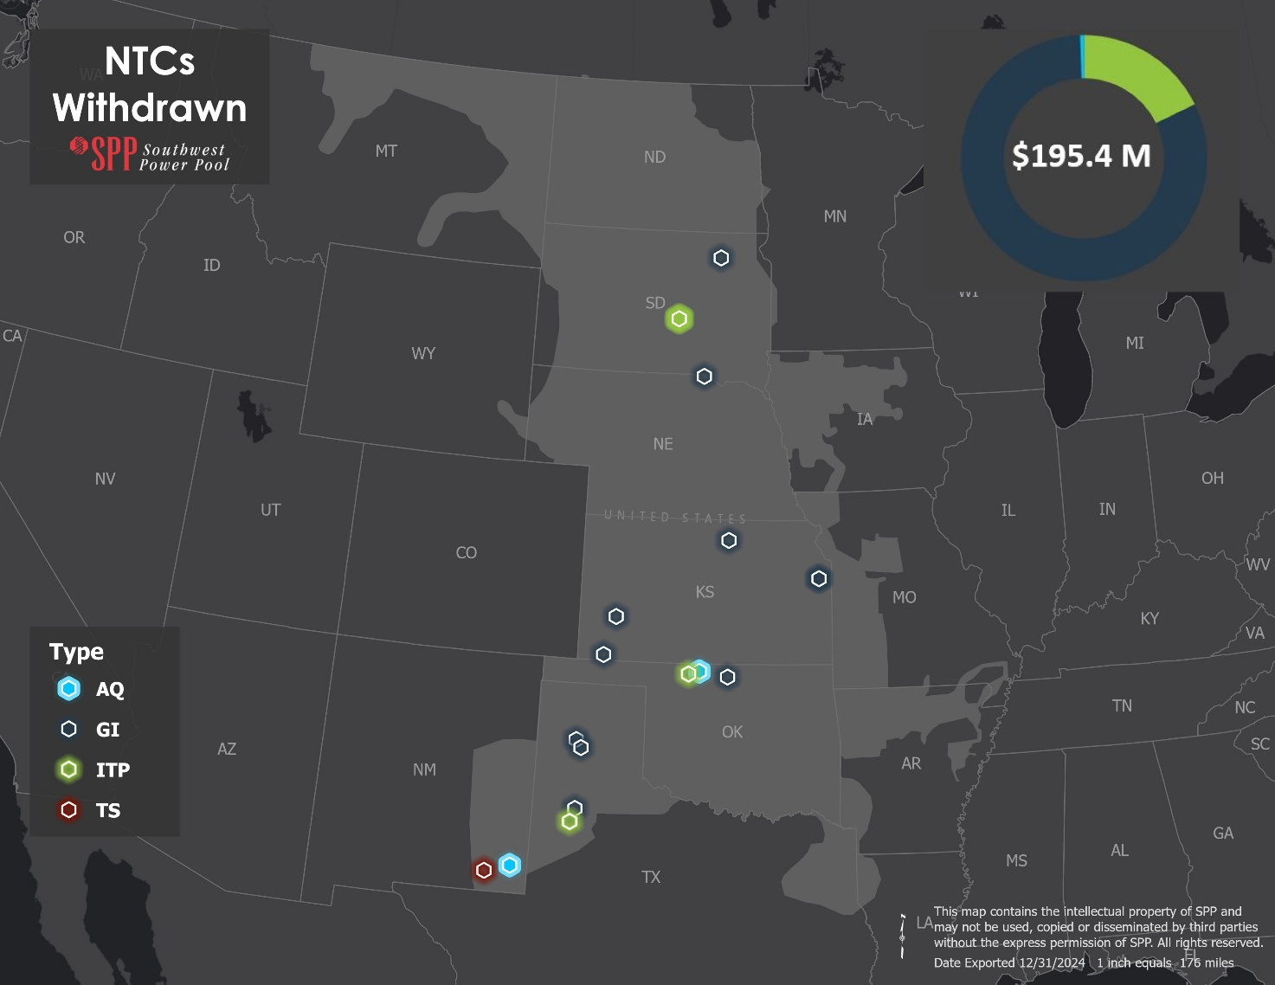
Figure 8: NTCs Withdrawn

NTC ID | NTC WITHDRAWN DATE | UID | OWNER | UPGRADE NAME | SOURCE STUDY | COST ESTIMATE OF WITHDRAWN UPGRADES
220861 | 11/26/2024 | 51531 | WFEC | DeGrasse 138 kV Substation (WFEC) | 2016 ITPNT | $1,200,000
220788 | 8/14/2024 | 72095 | SPS | Carlisle - Murphy 115 kV Terminal Upgrades | 2018 ITPNT | $0
220781 | 5/24/2024 | 157551 | WAPA | Fort Thompson 345/230 kV Transformer Ckt 1 (345 kV) | 2023 ITP | $12,963,375
220781 | 5/24/2024 | 157552 | WAPA | Fort Thompson 345/230 kV Transformer Ckt 2 (230 kV) | 2023 ITP | $4,891,214
220781 | 5/24/2024 | 157553 | WAPA | Fort Thompson 345/230 kV Transformer Ckt 2 (345 kV) | 2023 ITP | $12,963,375
220781 | 5/24/2024 | 157554 | WAPA | Fort Thompson 345/230 kV Transformer Ckt 1 (230 kV) | 2023 ITP | $2,728,949
220786 | 8/9/2024 | 122622 | EKC | Swissvale 345 kV Substation Upgrades | DISIS-2016-002 | $136,893
220786 | 8/9/2024 | 122623 | EKC | Swissvale 345 kV Terminal Upgrades | DISIS-2016-002 | $10,000
220793 | 11/5/2024 | 156850 | WAPA | Ft Randall - Spencer 115 kV Ckt 1 Rebuild | DISIS-2017-002 | $14,433,360
220794 | 11/7/2024 | 156495 | SPS | Carpenter 345 kV-Finney 345 kV Line Reactors | DISIS-2017-002 | $1,884,762
220795 | 11/7/2024 | 156494 | SPS | Potter County 345 kV Line Reactor | DISIS-2017-002 | $1,228,089
220796 | 11/8/2024 | 156497 | SPS | Border 345 kV-Tuco 345 kV Line Reactors | DISIS-2017-002 | $3,763,620
220798 | 11/8/2024 | 156857 | SPS | Randall 230 kV Reactive Support | DISIS-2017-002 | $78,579,111
220799 | 11/8/2024 | 156493 | SPS | Carpentar 345 kV Line Reactor | DISIS-2017-002 | $836,245
220800 | 11/8/2024 | 156471 | EKC | Viola to Renfrow 345 kV Rebuild | DISIS-2017-002 | $47,418,633
220801 | 11/8/2024 | 156454 | SEPC | Concordia West 230/115 kV Transformer | DISIS-2017-002 | $7,720,372
220802 | 11/8/2024 | 156469 | WAPA | Groton South - Groton BE7 115kV CKT2 New Line | DISIS-2017-002 | $3,630,000
220787 | 8/9/2024 | 72012 | WFEC | Cherokee SW 69 kV Cap Bank | DPA-2017-August-767-774-776 | $1,000,000
220768 | 2/12/2024 | 156387 | SPS | 3 Bear Libby – Pearl 115 kV | DPA-2021-December-1478 | $0
220779 | 5/24/2024 | 51567 | SPS | Carlsbad - Pecos 115 kV Terminal Upgrades | SPP-2015-AG1-AFS-6 | $0
20 Upgrade(s) Withdrawn |  |  |  |  |  | $195,387,998
Table 4: NTCs Withdrawn

In-service date delays
Through the Project Cost Working Group (PCWG), stakeholders voiced concerns about SPP issued projects that were delayed past their need date and/or first reported in-service date. SPP staff and stakeholders worked together to develop a phased approach to fully address the issue and provide increased transparency on In-Service Date Delays.

The In-Service Date (ISD) Delay Report was developed and provided via a new section to the Quarterly Project Tracking (QPT) Report. The ISD Delay Report includes network upgrades that show an estimated in-service date at least one year past the identified in-service date at NTC acceptance also known as the First Reported In-Service Date. The ISD Report includes visuals of the delayed upgrades by severity, Transmission Owner, and cost.

1Q 2024 Quarterly Project Tracking Report Appendix 1&2
2Q 2024 Quarterly Project Tracking Report Appendix 1&2
3Q 2024 Quarterly Project Tracking Report Appendix 1&2
4Q 2024 Quarterly Project Tracking Report Appendix 1&2

Study Overviews

Transmission Service Studies
The Transmission Services department evaluates long-term requests for network integration and point-to-point transmission service through various processes, including the Aggregate Transmission Service Study (ATSS) process under Attachment Z1 of the tariff, performs screening studies through the Delivery Point Transfer (DPT) and Long-Term Service Request (LTSR) processes under Attachment AR of the tariff and Delivery Point Addition (DPA) studies under Attachment AQ of the tariff. Links to studies posted during the reporting period are below.

COMPLETED AGGREGATE FACILITY STUDIES
2024-AG1-AFS-2 Report Tables Facility Log
2023-AG2-AFS-2 Report Tables Facility Log
ATTACHMENT AR STUDIES
2023 Long Term Service Request
LTSR-2023-003

ATTACHMENT AQ REQUEST
2024 Delivery Point Addition Studies
2023 Delivery Point Addition Studies
2022 Delivery Point Addition Studies
2021 Delivery Point Addition Studies
2020 Delivery Point Addition Studies

Generator Interconnection Studies
SPP’s Generator Interconnection team creates stakeholder value by evaluating impacts of connecting new power sources to the existing transmission system. We facilitate agreements between generation producers and transmission owners while ensuring positive outcomes for the regional power grid. Links to studies posted during the reporting period are below.

Generator Interconnection Studies

Transmission Planning (ITP)
SPP Board approved the 2024 ITP Assessment reports and portfolios on October 29, 2024.

2024 ITP Assessment Report v1.0

Balanced Portfolio
SPP did not perform a Balanced Portfolio study during the reporting period.

High Priority Studies
SPP did not perform a High Priority study during the reporting period.

Sponsored Upgrade Studies
Study Name | ILTCRs Studied | Study Report Final | Board Approval
SUS-031 Forman 115 kV Facilities Upgrade | Yes⁵ | 4/4/2024 | 8/6/2024
SUS-032 Split Rock Sioux City 345 kV Line Upgrade | Yes | 4/4/2024 | 8/6/2024
SUS-033 Split Rock White 345 kV Line Upgrade | Yes⁵ | 4/4/2024 | 8/6/2024
Table 5: 2024 Sponsored Upgrades

Interregional Studies
SPP coordinates interregional transmission planning activities with neighboring Planning Regions as approved by the FERC for purposes of Order 1000. Furthermore, SPP coordinates interregional planning and operations activities across all applicable areas of the organization in accordance with SPP's Joint Operating Agreements (JOAs) and other similar coordination arrangements that may not be required by FERC Order 1000.
Throughout 2024, SPP maintained strong collaboration with the Midcontinent Independent System Operator (MISO) by advancing the Joint Targeted Interconnection Queue (JTIQ) project. A significant milestone was the coordination with the Minnesota Department of Commerce and the Department of Energy to secure $464 million in funding through the Grid Resilience and Innovation Partnership (GRIP) Program. Additionally, SPP and MISO achieved a key regulatory milestone with the Federal Energy Regulatory Commission (FERC) acceptance of updates to the Joint Operating Agreement and Tariff filings. Completing the year with Board approvals and the issuance of the Notice to Construct to the Transmission Owners for the portfolio of JTIQ transmission projects.

The MISO-SPP Joint Planning Committee (JPC) mutually agreed to initiate a Coordinated System Plan (CSP) study in 2024 to focus on interregional transfer capability. This study will be conducted throughout 2025. The goal of this study is to identify immediately actionable transmission system enhancements that will improve reliability and resiliency in MISO and SPP; these solutions will also enhance the transfer capability between the two systems. Additionally, the project will identify other transmission enhancements that could further increase this transfer capability and that could be considered for implementation at a later date upon adoption of new RTO planning criteria and cost allocation after engaging states and stakeholders.

Furthermore, SPP and Associated Electric Cooperative, Inc. (AECI) performed a Joint Coordinated System Plan (JCSP) in 2024 in accordance with the AECI-SPP Joint Operating Agreement. The 2024 JCSP study assessed the reliability and resilience of the combined SPP and AECI transmission systems, focusing on specific areas identified by stakeholders and staff. Given the increasing frequency of extreme winter weather events, the study emphasized the SPP-AECI seam and regions most impacted by Winter Storm Elliott, including Northeast Oklahoma, Southwest Missouri, and Northwest Arkansas.
In addition to working with MISO and AECI, SPP also participated in planning coordination with the Southeastern Regional Transmission Planning (SERTP) group in accordance with Addendum 4 to Attachment O of the SPP Tariff.

ITP20 Upgrades
ITP20 assessments were performed in 2010, 2013, and 2022. While the projects proposed by those studies are incorporated into the STEP Project List, they were not included in SPP’s project tracking effort as part of the Quarterly Tracking Report prior to Q1 2019. A list of active ITP20 projects will be maintained in the STEP Report and Quarterly Project Tracking Report lists going forward. The 2013 ITP20 projects are listed below in Table 6. The 2022 ITP20 projects are listed below in Table 7.
Project ID | Upgrade ID | Owner | Upgrade Name | Study | RTO Determined Need Date | Latest Cost Estimate
30401 | 50492 | TBD | Cass Co. - S.W. Omaha (aka S3454) 345 kV Ckt1 | 2013 ITP20 | 1/1/2033 | $33,126,800
30599 | 50769 | AEP | South Fayetteville 345/161 kV Transformer Ckt1 | 2013 ITP20 | 1/1/2033 | $12,600,000
30599 | 50770 | TBD | Chamber Springs - South Fayetteville 345 kV Ckt1 | 2013 ITP20 | 1/1/2033 | $21,295,800
30600 | 50771 | EMW | Maryville 345/161 kV Transformer Ckt1 | 2013 ITP20 | 1/1/2033 | $12,600,000
30602 | 50773 | TBD | Keystone - Red Willow 345 kV Ckt1 | 2013 ITP20 | 1/1/2033 | $130,141,000
30603 | 50774 | TBD | Tolk - Tuco 345 kV Ckt1 | 2013 ITP20 | 1/1/2033 | $75,718,400
30604 | 50775 | SEPC | Holcomb 345/115 kV Transformer Ckt2 | 2013 ITP20 | 1/1/2033 | $12,600,000
30605 | 50776 | TBD | Neosho - Wolf Creek 345 kV Ckt1 | 2013 ITP20 | 1/1/2033 | $117,126,900
30606 | 50777 | TBD | Clinton - Truman 161 kV Ckt1 Reconductor | 2013 ITP20 | 1/1/2033 | $15,701,325
30606 | 50778 | TBD | North Warsaw - Truman 161 kV Ckt1 Reconductor | 2013 ITP20 | 1/1/2033 | $1,082,850
30608 | 50779 | EKC | Auburn 345/115 kV Transformer Ckt2 | 2013 ITP20 | 1/1/2033 | $12,600,000
30608 | 50780 | TBD | Auburn - Swissvale 345 kV Ckt1 Voltage Conversion | 2013 ITP20 | 1/1/2033 | $20,112,700
30608 | 50781 | TBD | Auburn - Jeffrey EC 345 kV Ckt1 Voltage Conversion | 2013 ITP20 | 1/1/2033 | $35,493,000
30607 | 50782 | OGE | Muskogee/Pecan Creek 345 kV Terminal Upgrades | 2013 ITP20 | 1/1/2033 | $34,605,675
14 Total Projects |  |  |  |  |  | $534,804,450
Table 6: 2013 ITP20 Upgrades

Project ID | Upgrade ID | Owner | Upgrade Name | Study | RTO Determined Need Date | Latest Cost Estimate
93109 | 157811 | TBD | Ft. Smith - Thistle 345 kV CKT 1 | 2022 20 Year Assessment | 1/1/2042 | $461,160,280
93109 | 158510 | OGE | Ft. Smith 345 kV Terminal Equipment | 2022 20 Year Assessment | 1/1/2042 | $2,428,753
93109 | 158511 | SEPC | Thistle 345 kV Terminal Equipment | 2022 20 Year Assessment | 1/1/2042 | $2,428,753
93110 | 157812 | TBD | Flint Creek - Buffalo Flats 345 kV | 2022 20 Year Assessment | 1/1/2042 | $349,831,855
93110 | 158512 | EKC | Buffalo Flats 345 kV Terminal Equipment | 2022 20 Year Assessment | 1/1/2042 | $2,428,753
93110 | 158513 | AEP | Flint Creek 345 kV Terminal Equipment | 2022 20 Year Assessment | 1/1/2042 | $2,428,753
93111 | 157813 | OGE | Ft Smith - Sooner 345 kV CKT 1 | 2022 20 Year Assessment | 1/1/2042 | $290,563,847
93111 | 158514 | OGE | Ft. Smith 345 kV Terminal Equipment #2 | 2022 20 Year Assessment | 1/1/2042 | $2,428,753
93111 | 158515 | OGE | Sooner 345 kV Terminal Equipment | 2022 20 Year Assessment | 1/1/2042 | $2,428,753
93113 | 157905 | TBD | Huben - Lacygne 345 kV Ckt 1 New Line | 2022 20 Year Assessment | 1/1/2042 | $198,791,206
93113 | 158520 | AECI | Huben 345 kV Terminal Equipment | 2022 20 Year Assessment | 1/1/2042 | $2,428,753
93113 | 158521 | EM | Lacygne 345 kV Terminal Equipment | 2022 20 Year Assessment | 1/1/2042 | $2,428,753
93114 | 157824 | TBD | Riverside Station - Matthewson 345 kV (OGE) | 2022 20 Year Assessment | 1/1/2042 | $180,577,999
93114 | 158522 | OGE | Matthewson 345 kV Terminal Equipment | 2022 20 Year Assessment | 1/1/2042 | $2,428,753
93114 | 158523 | AEP | Riverside Station 345 kV Terminal Equipment | 2022 20 Year Assessment | 1/1/2042 | $2,428,753
93115 | 157825 | SPS | Potter County Interchange - Tolk Station 345 kV | 2022 20 Year Assessment | 1/1/2042 | $147,667,045
93115 | 158524 | SPS | Potter County Interchange 345 kV Terminal Equipment | 2022 20 Year Assessment | 1/1/2042 | $2,428,753
93115 | 158525 | SPS | Tolk Station 345 kV Terminal Equipment | 2022 20 Year Assessment | 1/1/2042 | $2,428,753
93116 | 157826 | MDU | Twin Brooks 3 to Ellendale 3 345 kV Tap | 2022 20 Year Assessment | 1/1/2042 | $16,467,621
93116 | 157827 | WAPA | Groton Tap - Groton 345 kV | 2022 20 Year Assessment | 1/1/2042 | $32,935,242
93116 | 157828 | WAPA | Broadland - Groton 345 kV | 2022 20 Year Assessment | 1/1/2042 | $32,935,242
93116 | 157873 | TBD | Twin Brooks 3 to Ellendale 3 345 kV Tap (OTP) | 2022 20 Year Assessment | 1/1/2042 | $16,467,621
93116 | 157875 | WAPA | Groton Tap 345 kV Sub | 2022 20 Year Assessment | 1/1/2042 | $0
93117 | 157829 | EM | Sibley - Nashua 345 kV | 2022 20 Year Assessment | 1/1/2042 | $43,969,609
93117 | 158526 | EM | Nashua 345 kV terminal Equipment | 2022 20 Year Assessment | 1/1/2042 | $2,428,753
93117 | 158527 | EM | Sibley 345 kV Terminal Equipment | 2022 20 Year Assessment | 1/1/2042 | $2,428,753
93120 | 157846 | TBD | Sibley - Hawthorn 345 kV CKT 2 | 2022 20 Year Assessment | 1/1/2042 | $25,368,257
93120 | 158530 | AEP | Hawthorn 345 kV Terminal Equipment #2 | 2022 20 Year Assessment | 1/1/2042 | $2,428,753
93120 | 158531 | EM | Sibley 345 kV Terminal Equipment #2 | 2022 20 Year Assessment | 1/1/2042 | $2,428,753
93121 | 157847 | WFEC | Anadarko 345/138 kV Transformer | 2022 20 Year Assessment | 1/1/2042 | $4,891,214
93121 | 157848 | TBD | Anadarko - Gracemont 345 kV | 2022 20 Year Assessment | 1/1/2042 | $5,619,548
93121 | 157849 | WFEC | Anadarko - Gracemont 345 kV (WFEC) | 2022 20 Year Assessment | 1/1/2042 | $5,619,547
93121 | 157850 | WFEC | Anadarko 345 kV Substation | 2022 20 Year Assessment | 1/1/2042 | $13,972,613
93121 | 122591 | OGE | Gracemont 345 kV Terminal Equipment | 2022 20 Year Assessment | 1/1/2042 | $0
93122 | 157851 | TBD | Cimarron - Norman Hill 345 kV CKT 2 | 2022 20 Year Assessment | 1/1/2042 | $20,616,250
93122 | 158532 | OGE | Cimarron 345 kV Terminal Equipment | 2022 20 Year Assessment | 1/1/2042 | $2,428,753
93122 | 158533 | OGE | Norman Hill 345 kV Terminal Equipment | 2022 20 Year Assessment | 1/1/2042 | $2,428,753
37 Total Projects |  |  |  |  |  | $1,891,172,550
Table 7: 2022 ITP20 Upgrades

Appendix 1
(See accompanying list of STEP Projects)

SPP OATT Business Practices
Pursuant to RR 467, all Upgrades resulting from under attachment AQ are tracked independently of transmission service upgrades as of 6/1/2022
2024 ITP upgrades for the Short-Term Reliability Projects and Winter Weather Projects were not issued an NTC in 2024 due to timing of Board Approval, NTCs are expected to be issued in the first quarter of 2025. Competitive Upgrades were not issued an NTC in 2024 and are expected to follow the RFP schedule. The total cost of the remaining upgrades to be issued NTCs is estimated at $4.9 Billion.
There are no Generator Retirement, Balanced Portfolio or Interregional projects included in the STEP report.
Mileage not available for all upgrade categories.
SPP Revision Request 548 implemented Services recommendation number four (S4) of Strategic and Creative Re Engineering of Integrated Planning Team (SCRIPT) to eliminate the rarely-used screening study processes for Long-Term Service Requests (LTSR) and Delivery Point Transfers (DPT). This Revision Request was approved by the applicable SPP stakeholder groups and was accepted by FERC, effective December 4th, 2023, per Docket No. ER24-16-000. SPP will not be performing DPT or LTSR studies submitted after this time. The LTSR-2023-003 study was submitted prior to this brightline but was studied in 2024.
Documents contains ILTCR information

