
By SPP Engineering
Published on 01/05/2026
Version 0.2

2027 ITP Sunset / RTOE Transition Assessment Scope
Subtitle

Revision History
Date or version number | Author | Change Description | Comments
12/03/2025  v0.1 | SPP Staff | Final Draft | Posting for ESWG & TWG approval
01/05/2026  v0.2 | SPP Staff | Minor formatting cleanup | Posting for MOPC approval

Table of Contents
Revision History i
Table of Contents 2
1. Overview 1
1.1. SPP RTOE CPP Transition Assessment 1
2. Modeling Details and Scenarios (Futures) Assumptions 1
2.1. Model Year Definitions 1
2.2. Model Shelf-Life and Late Data Recommendations 1
2.3. Market Economic Models 1
2.4. SPP RTOE Generation Expansion Models (GEM) 2
2.4.1. SPP RTOE Base Generation Expansion Models (B-GEM) 2
2.4.2. SPP RTOE Transfer Generation Expansion Models (T-GEM) 3
2.5. SPP RTOE Local Generator Interconnection Models (L-GIM) 5
2.6. SPP RTOE Year-20 Models 7
2.7. Model Use Summary 8
2.8. Market Economic Model Overview 1
2.8.1. Futures 1
2.8.2. Zone Resource Siting Allocation 1
2.8.3. Must-Run Units 2
2.8.4. Wind Repowers and Curtailment Price 2
2.8.5. Hurdle Rates and Interchange 3
2.8.6. Resource Plan 3
2.8.7. Resource Accreditation 4
2.8.8. Planning Reserve Margin Values 5
2.8.9. New Resource Allocation and Assignment 5
2.8.10. State Renewable Portfolio Standards (RPS) 7
3. Needs Assessment 7
3.1. Economic Needs Assessment 8
3.2. Reliability Needs Assessment 9
3.2.1. SPP RTOE Generation Expansion Models (GEM) 9
3.2.2. SPP RTOE Local Generator Interconnection Models (L-GIM) 10
3.2.3. SPP RTOE GEM and L-GIM Needs Correlation with Constraint Assessment 11
3.2.4. Short Circuit Ratio (SCR) Screening 12
3.2.5. Non-Converged Contingencies 14
3.2.6. Violation Identification and Filtering Criteria 14
3.3. Interconnection Requirement Information 15
3.4. Facility Rating Data 15
3.5. Limited Operation Information 15
3.6. Affected System Coordination 16
4. Solution Evaluation 16
4.1. Persistent Economic Operational Solution Evaluations 17
4.1.1. Flowgates 17
4.1.2. Manual Commitment of Generators 17
4.2. Economic Solution Evaluation 17
4.3. SPP RTOE L-GIM Reliability Solution Evaluation 17
5. Portfolio Development 18
5.1. Reliability Portfolio Development 19
5.1.1. L-GIM Portfolio Development 19
5.2. Economic Portfolio Development 19
5.2.1. Usage of SPP RTOE 20-Year Adjusted Production Cost (APC) Datapoint 19
5.3. Portfolio Optimization 20
5.3.1. Reliability Portfolio Optimization (Future-Specific) 20
5.3.2. Reliability and Economic Optimization (Future-Specific) 20
5.4. Portfolio Consolidation 21
5.4.1. Overview of Consolidation Scenarios 22
5.4.2. Economic Portfolio Consolidation 23
5.4.3. Reliability Portfolio Consolidation 25
5.5. Project Staging 27
5.6. Final Reliability Assessment 27
6. Informational Analysis 28
6.1. Benefit Metrics 28
6.2. Sensitivity Analysis 28
6.3. Rate Impacts 28
6.4. DataPoints to Support GRID-C Policy (SPP RTOE Only) 28
7. Schedule 29
8. Changes in Process and Assumptions 31

Overview
This document outlines the scope and schedule of activities for the 2027 ITP Sunset & RTOE CPP Transition Assessment, which is targeting MOPC approval in January 2026. The assessment will be conducted in accordance with established SPP protocols and will incorporate input from applicable working groups and committees to ensure a comprehensive and collaborative planning process, as described in Section 1 of the ITP Manual. This will be the first assessment to include the SPP RTO Expansion (RTOE) footprint in the Western Interconnection.
The objective of the 2027 ITP Sunset & RTOE Transition Assessment is to develop a regional transmission plan that ensures reliable and economic delivery of energy, facilitates calculation of the GRID-C fee for the SPP RTOE footprint, supports applicable public policy objectives, and maximizes value to the end-use customer.
The scope includes planning assumptions and methodologies that are not fully standardized within existing manuals, including the ITP Manual, the Generator Interconnection Procedures (SPP Business Practice 7250), or the 20-Year Assessment Manual. These documents should be referenced collectively to gain a comprehensive understanding of the processes, assumptions, and planning approach that will guide the 2027 ITP Sunset & RTOE Transition Assessment.

SPP RTOE CPP Transition Assessment
The SPP RTOE CPP Transition Assessment will utilize the approved technical framework: Invest, Connect, Manage (ERIS) or Deliver (NRIS+). This framework is included in the subsequent section of the scope for model development, analysis, and portfolio development. The approach will be part of the 2027 ITP Sunset & RTOE Transition Assessment, which will inform future decisions on financial contributions from Generator Interconnection (GI) customers for long-term transmission expansion. The framework will outline the technical approach for evaluating system impacts from prospective ERIS and NRIS+ service types.
Looking forward, the CPP technical policies from this scope will be transitioned to planning criteria, CPP Manual, 20-Year Assessment Manual, and GI Manual (SPP Business Practice 7250) language with the goal of Q4 2025 or Q1 2026 approval.
The Generator Interconnection Advisory Group (GIAG) and the Transmission Working Group (TWG) will review and provide feedback on elements related to incorporating the GI process considerations into the SPP RTOE CPP Transition Assessment, ensuring that the transition meets both operational and regulatory requirements.
Figure 1.1 below provides a holistic overview for the modeling framework for the 2026 Combined Assessment.
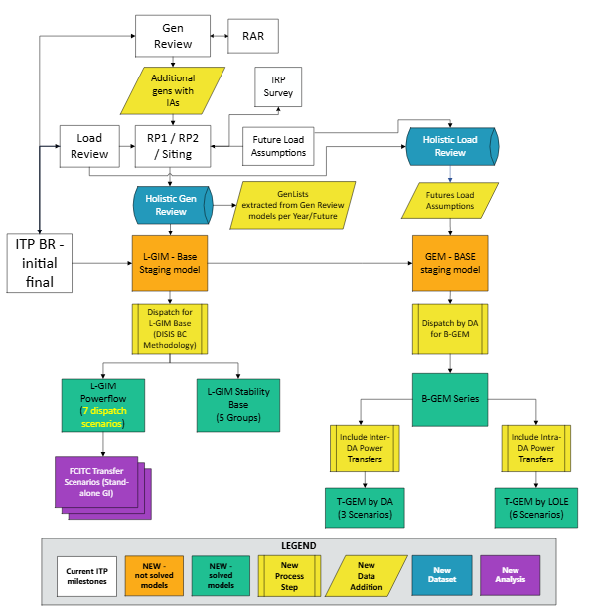
Figure 1.1: Technical Assessment Model Development Flow
One important note for this process flow is that additional generators with an interconnection agreement (IA) include generators with a suspended IA. See Section 2.8 (Market Economic Model Overview) below for additional details.
Table 1.1: GI Inclusion in the CPP
Model Set | Dispatch (Approved) | Reliability  Analysis  Dispatch (Approved) | Needs criteria | Solution Evaluation | Portfolio Development | Portfolio Optimization | Portfolio Consolidation
B-GEM | DA level using MDAG Manual / ITP dispatch procedures to include all modeled resources | ITP Manual Base Reliability (BR) Procedures | ITP Manual BR Procedures | ITP Manual BR Procedures | ITP Manual BR Procedures  Reliability Metrics | SCRIPT O1 | New Reliability Methodology for three consolidation scenarios for two futures
T-GEM | B-GEM plus Transfers using MDAG Manual / ITP dispatch procedures to include all modeled resources | ITP Manual BR Procedures | ITP Manual BR Procedures | ITP Manual BR Procedures | ITP Manual BR Procedures  Reliability Metrics | SCRIPT O1 | New Reliability Methodology for three consolidation scenarios for two futures
L-GIM Steady State | HVER, LVER, NRIS PQ models with CQ modeled as PQ using BP7250 dispatch procedures (Transition and ongoing Annual) | Standalone DC FCITC per BP7250 with electrically equivalent POI Criteria (Transition and ongoing Annual) | Same as BP7250 Thermal Only  No Cumulative Impact Criteria with Need correlation to or replication as Economic Model Constraint | ITP Manual  BR Procedures  (requires automation) | Same as BP7250  Least cost  No ITP Manual BR Procedure  Reliability Metrics | SCRIPT O1 | New Reliability Methodology for three consolidation scenarios for two futures
L-GIM Stability | Same as BP7250 (GI DISIS Manual) | ITP Manual BR Procedures and  BP7250 TDF Criteria (Steady-State as proxy for Transition Only) | Same as BP7250 Voltage and Non-converged with Need correlation to or replication as Economic Model Constraint | ITP Manual BR Procedures | Same as BP7250  Least cost  No ITP Manual BR Procedure  Reliability Metrics to include Cost-Effective Reliability Evaluation | SCRIPT O1 | New Reliability Methodology for three consolidation scenarios for two futures

Modeling Details and Scenarios (Futures) Assumptions

Model Year Definitions
The 2027 seasonal models for years two, five, and ten, as well as the CPP Transition Assessment year twenty are listed below based on the SPP Model Development Procedure Manual developed by the Model Development Advisory Group (MDAG).
Table 2.1: Model Year Definitions
2027 ITP Sunset / RTOE Transition Assessment
& NERC TPL Assessment Study Years
ITP & TPL Assessment (Study Year) | 2027
Year 1 | 2027
Year 2 | 2028
Year 5 | 2031
Year 10 | 2036
Year 20 (RTOE Models Only) | 2046

Model Shelf-Life and Late Data Recommendations
For the 2027 ITP Sunset/RTOE Transition Assessment, and in accordance with ITP Manual Section 10.3, late model change requests must be submitted by June 30. Rating changes may be submitted and implemented either during or at the conclusion of the ITP and CPP shelf-life periods. Additional enhancements to the late data submission process will be considered in a future revision request to ITP Manual Section 10.3.

Market Economic Models
The Market Economic Models (MEMs) for the 2027 ITP Sunset/RTOE Transition Assessment will include generators with an IA on suspension. These resources have been planned through the Generator Interconnection process.
Approval of this scope document serves as a waiver from existing ITP Manual Section 2.2.1.4 (Generation Resource Inclusion).

SPP RTOE Generation Expansion Models (GEM)
The GEM methodology is a proactive approach to planning the system for existing and future resource expectations and load and maintaining a level of transfer capability across the system. The GEM series will be developed incrementally to the ITP BR model series.

SPP RTOE Base Generation Expansion Models (B-GEM)
The B-GEM approach assumes a level of capacity value of all expected future resources, treating all existing and forecasted generators equally, to serve baseline load requirements. This model set serves as a foundation to meet the needs of both existing and future baseline generator and load deliverability and will be used as the base model for transfer analysis to further support system resiliency and reliable interconnection.
Inclusion of resources: Incremental to the ITP base reliability, all generators with non-firm service eligible for inclusion in the BR models and those from the resource expansion plan assigned to a load group in a manner consistent with the ITP BR methodology for conventional and renewable resources will be included for dispatch.
Priority of dispatch: All generators available for dispatch will be considered concurrently.
Definition of load groups: Generators available for dispatch will be dispatched at a Deliverability Area (DA) level, consistent with NRIS+.
Inclusion of load groups: All load areas of the system will be aggregated, and served, at a DA level.
Inclusion of MEM Future Driver Peak Demand Growth Rates: Future driver large loads will be added, and electrification will be distributed pro rata across existing conforming bus loads with stakeholder exceptions consistent with MEM inclusion.
The B-GEMs will be dispatched at the DA level, utilizing all modeled generation to meet the requirements of all load-responsible entities, as shown in Table 2.2 below. This approach aligns with current base reliability model development practices or any improvements under development. It will model renewable and storage generation using the ITP 5 year-year average or replacement data expected output methodology and economically dispatch remaining conventional generation up to nameplate capacity amounts while maintaining ITP BR dispatch of units identified as must run.
Table 2.2: B-GEM Models
 | FUTURES 1 & 2
Description | Year 5 | Year 10 | Year 20 | Total
B-GEM | Summer  Winter | Summer  Winter | Summer  Winter | 12

SPP RTOE Transfer Generation Expansion Models (T-GEM)
The T-GEM models consist of the same model inclusion requirements for generation as noted for B-GEM models. The T-GEM models are created to provide models for deliverability transfer scenarios. This approach integrates and coordinates transfer analysis from GI studies and expands the ITP to include system resiliency analysis, enhancing and streamlining scenario planning previously used in SPP regional planning.
These transfer scenarios are designed to reflect expected system operations under normal and extreme conditions, not the full injection of any specific resource. The analysis will include resource expansion plans developed for the applicable future and year, regardless of customer activity.

Transfer Case Model Development
The model set will consist of two scenario types to address the needs of the footprint and the needs of each DA.
This will allow the CPP to better meet proactive planning objectives, ensure the transmission system is planned holistically, and better isolate the process from customer withdrawal and suspension activity.
Because the SPP RTOE deliverability area study has not yet been finalized, the following sections will be revised upon completion of the study and selection of the SPP RTOE deliverability areas.

Inter-Deliverability Areas Transfers
The first scenario set will consist of transfers between DAs, as defined in Figure 2.1 below. Generation from each individual DA will be increased while generation in the other two DAs will decrease in order to induce power transfers across the footprint to maintain each DA’s ability to provide for the system. The level of power transfers at a minimum will be based on the lower of the sink load or source generation accreditation plus the planning reserve margin (PRM) in the PRM Values section. Additional power transfer capability requirements may be approved by the appropriate stakeholder working groups.

Figure 2.1: [RTOE DA map to be added]

SPP RTOE Deliverability Areas (DA)
DAs used as the sink for modeling existing and new NRIS+ requests will consist of the generation of Transmission Owners located in the following zones, as shown in Figure 2.2 below:
The current deliverability area options under study are:
- Single Deliverability Area “DA West”: APS, WAPA L.C., MONTANA, WAPA U.W., PACE, PSCOLORADO, WAPA R.M.
- Two Deliverability Areas “DA1 North & DA2 South”:
  - DA1 North: WAPA U.W.
  - DA2 South: APS, WAPA L.C., MONTANA, PACE, PSCOLORADO, WAPA R.M.

Dispatch Methodology
These scenarios will utilize the economic dispatch methodology consistent with MDAG/ITP methodology for source and sink conventional generation and scaling methodology for source and sink renewable generation using a conventional to renewable ratio based on B-GEM expected levels. In the source definitions, generation will be dispatched with a potential increase not to exceed an assumed level of reserves on an aggregate basis.

Figure 2.2: SPP RTOE Deliverability Areas Transfer Scenarios – Inter-Deliverability Area

Intra-Deliverability Areas Transfers
The second scenario set will consist of transfers between zones within each DA, as defined in Figure 2.3 and Table 2.3 below. It is recommended to use the zones used for Loss of Load Expectation (LOLE) studies which are subsets of each DA. These zones provide a natural geographical separation of each DA, the boundaries of which represent historically weak points in the SPP transmission system. This set of scenarios will serve to protect and enhance deliverability of generators to all load within each DA. The level of power transfers at a minimum will be based on the lower of the sink load or source generation accreditation plus the PRM in Section 2.8.8 (Planning Reserve Margin Values). Additional power transfer capability requirements may be approved by stakeholders.

Dispatch Methodology
These scenarios will utilize the economic dispatch methodology consistent with MDAG/ITP methodology for source and sink conventional generation and scaling methodology for source and sink renewable generation using a conventional to renewable ratio based on B-GEM expected levels. In the source definitions, generation will be dispatched with a potential increase not to exceed an assumed level of reserves on an aggregate basis.

Figure 2.3: SPP RTOE Study Zones Transfer Scenarios – Intra-DA Inter-LOLE (Intra-Deliverability Area transfers)]
Table 2.3: SPP RTOE T-GEM Models
Description | Year 5 | Year 10 | Year 20 | Total
T-GEM Inter-DA | Summer (# DAs)  Winter (# DAs) | Summer (# DAs)  Winter (# DAs) | Summer (# DAs)  Winter (# DAs) | # TBD
T-GEM Intra-DA LOLE-to-LOLE | Summer (# DAs,  # LOLE per DA)  Winter (# DAs,  # LOLE per DA) | Summer (# DAs,  # LOLE per DA)  Winter (# DAs,  # LOLE per DA) | Summer (# DAs,  # LOLE per DA)  Winter (# DAs,  # LOLE per DA) | # TBD
TOTAL: |  |  |  | # TBD

SPP RTOE Local Generator Interconnection Models (L-GIM)
The steady-state Local Generator Interconnection Models (L-GIM) will use Base and Prior Queue (PQ) models consistent with SPP Business Practice 7250, DISIS Steady-State Model Methodologies by modeling Current Queue (CQ) as PQ and studying CQ at Resource Plan Nameplate Capacity to not exceed Maximum Injection Capability for Resource Plan co-located wind and solar with storage for ERIS and at Resource Plan Accredited Capacity to not exceed Maximum Injection Capability for co-located wind and solar with storage for NRIS basis, similar to ITP Generator Outlet Facility (GOF) DC FCITC analysis performed during the Resource Siting milestone. The CQ will be Future Resource Plan per future per year. Year 5 will be considered as PQ for Year 10, and Year 5 and Year 10 as PQ for Year 20. For Year 5 and Year 10, the ITP BR, with the Resource Addition Requests (RARs) and Resource Plan topology added, will be considered the Base Model in Table 2.5 below. The RARs will be considered PQ, and the Resource Plan will be considered CQ for both ERIS and NRIS+ Service Types dispatched consistent with SPP Business Practice 7250. For Year 20, the B-GEM model with the RARs and Resource Plan dispatched consistent with B-GEM methodology will be considered the Base Model in Table 2.6.
Table 2.4: SPP RTOE L-GIM Steady-State Base Models
Description | FutureS 1 & 2 |  |  | Total
Description | Year 5 | YEAR 10 | Year 20 | Total
BASE | Summer  Winter | Summer  Winter | Summer  Winter | 12
Table 2.5: L-GIM Steady-State Study Models
Service Type | Dispatch Scenario | FutureS 1 & 2 |  |  | PRIOR QUEUE MODEL TOTALs | CURRENT QUEUE MODEL TOTALS
Service Type | Dispatch Scenario | Year 5 | Year 10 | Year 20 | PRIOR QUEUE MODEL TOTALs | CURRENT QUEUE MODEL TOTALS
ERIS | HVER | Summer  (# groups)  Winter  (# groups) | Summer  (# groups)  Winter  (# groups) | Summer  (# groups)  Winter  (# groups) | # TBD | 0
ERIS | LVER | Summer  (SPP Region)  Winter  (SPP Region) | Summer  (SPP Region)  Winter  (SPP Region) | Summer  (SPP Region)  Winter  (SPP Region) | # TBD | 0
NRIS+ | NR | Summer  (SPP Region)  Winter  (SPP Region) | Summer  (SPP Region)  Winter  (SPP Region) | Summer  (SPP Region)  Winter  (SPP Region) | # TBD | 0
TOTAL: |  |  |  |  | # TBD
For the purposes of the CPP Transition Assessment, the Stability L-GIM models will use steady-state Base and CQ models consistent with SPP Business Practice 7250, DISIS Stability Model Methodologies to capture voltage criteria violations and proxy stability criteria violations as non-converged planning events. PQ models will not be built to manage the number of models being developed. Without the PQ models, a Power Transfer Voltage Response Factor (PTVF) will not be calculated, and all CQ model voltage criteria violations will be addressed as if the PTVF of 0.02 has been met. The CQ will be the Future Resource Plan per future per year at Resource Plan Nameplate Capacity to not exceed Maximum Injection Capability for Resource Plan co-located wind and solar with storage for ERIS. Year 5 will be considered as PQ for Year 10, and Year 5 and Year 10 as PQ for Year 20. For Year 5 and Year 10, the ITP BR, with the RARs and Resource Plan topology added, will be considered the Base Model in Table 2.6 below. The RARs will be considered PQ, and the Resource Plan will be considered CQ consistent with SPP Business Practice 7250. For Year 20, the B-GEM model with the RARs and Resource Plan dispatched consistent with B-GEM methodology will be considered the Base Model in Table 2.7 below. The approximate location of current GI regional cluster groups is shown in Figure 2.4 below.
Table 2.6: L-GIM Stability Base Models
 | FutureS 1 & 2
Description | Year 5 | YEAR 10 | Year 20 | Total
BASE | Summer  Winter | Summer  Winter | Summer  Winter | 12
Table 2.7: SPP RTOE L-GIM Stability Study Models
Service Type | Dispatch Scenario | FutureS 1 & 2 |  |  | Prior QUEUE MODEL TOTALS | Current QUEUE MODEL TOTALs
Service Type | Dispatch Scenario | Year 5 | YEAR 10 | Year 20 | Prior QUEUE MODEL TOTALS | Current QUEUE MODEL TOTALs
ERIS | N/A | Summer  (# groups)  Winter  (# groups) | Summer  (# groups)  Winter  (# groups) | Summer  (# groups)  Winter  (# groups) | 0 | # TBD
 | # TBD

Figure 2.4: SPP RTOE Approximate Location of Current Regional Cluster Groups [to be added]

SPP RTOE Year-20 Models
A 20-year Summer and Winter B-GEM, market economic, T-GEM, and L-GIM model will be developed from the 10-year Summer and Winter datasets for the RTOE region. Modeling assumptions will follow the 20-Year Assessment Manual and this scope document. The 20-year peaks in the load review and peak demand growth rates to include future driver large loads and electrification will be uniformly distributed across existing conforming bus loads consistent with the MEM. For Summer peaking and Winter peaking demand groups, a 20-year Summer peak for Winter peaking demand groups and Winter peak for Summer peaking demand groups will be based on the 10-Year Summer peak and Winter peak ratio. Due to anticipated shortfall expected in the 20-year base reliability model, solving the model will be difficult using existing shortfall methodologies. In that regard, the 20-year B-GEM will be considered a 20-year BR model and the starting point for the 20-year L-GIM models. Pursuant to the System Topology section of the 20-Year Assessment Manual, the models will include SPP upgrades that have been approved for construction.
[Remainder of page intentionally left blank.]

Model Use Summary
Table 9 and Table 10: below provide a summary of the models used and purpose of each for the 2027 ITP Sunset/RTOE Transition Assessment.
Table 2.8: Non-Futures-Driven Models
Model | Model Type | Dispatch Scenario | YEAR 2 | Year 5 | Year 10 | Year 20 | Study requirement | Portfolio Development?
ITP BR | Steady-State | BASE | Summer  Light Load  Winter | Summer  Summer-Shoulder  Winter | Summer  Winter | NA | ITP/TPL | Yes
TPL | Steady-State | Sensitivity | Summer  Light Load | Summer | NA | NA | TPL | No
TPL | Stability | BASE | Summer  Light Load | NA | Summer | NA | TPL | No
Table 2.9: Futures-Driven Models
Model | Model Type | Dispatch Scenario | Year 2 | Futures 1 & 2 |  |  | Study requirement | Portfolio Development
 |  |  |  | Year 5 | Year 10 | Year 20 | Study requirement | Portfolio Development
ITP MEM | PCM | SCUC / SCED | Annual | Annual | Annual | Annual | ITP | Yes
L-GIM | Steady-State | BASE | NA | Summer  Winter | Summer  Winter | Summer  Winter | NA | No
L-GIM | Steady-State | ERIS/NRIS+ | NA | See Table 6 | See Table 6 | See Table 6 | GI | No
L-GIM | Steady-State | Standalone FCITC | NA | Summer  Winter | Summer  Winter | Summer  Winter | GI/FAC | Yes
L-GIM | Stability proxy | BASE | NA | Summer  Winter | Summer  Winter | Summer  Winter | GI | No
L-GIM | Stability proxy | ERIS | NA | Summer  (5 groups)  Winter  (5 groups) | Summer  (5 groups)  Winter  (5 groups) | Summer  (5 groups)  Winter  (5 groups) | GI/FAC | Yes
B-GEM | Steady-State | BASE | NA | Summer  Winter | Summer  Winter | Summer  Winter | ITP | Yes
T-GEM | Steady-State | Transfer (Inter-DA) | NA | Summer  (3 scenarios)  Winter  (3 scenarios) | Summer  (3 scenarios)  Winter  (3 scenarios) | Summer  (3 scenarios)  Winter  (3 scenarios) | ITP | Yes
T-GEM | Steady-State | Transfer (Intra-DA) | NA | Summer  (6 scenarios)  Winter  (6 scenarios) | Summer  (6 scenarios)  Winter  (6 scenarios) | Summer  (6 scenarios)  Winter  (6 scenarios) | ITP | Yes

Market Economic Model Overview

Futures
The Economic Studies Working Group (ESWG), with input from the CPP Task Force (CPPTF), Strategic Planning Committee (SPC), and Transmission Working Group (TWG), reviewed two futures for the SPP RTOE and one future for SPP East. The MOPC reviewed preliminary versions of both futures in October 2025, and the final versions are scheduled to be reviewed in January 2026.
In order to support CPP process readiness and better facilitate calculation of the GRID-C metric for the SPP RTOE, the SPP East assessment will include a limited economic analysis consisting of a single future. This future will be based on the 2026 Future 1 scenario, with targeted updates and modifications as appropriate.
Table 2.10: East Future Drivers
KEY  ASSUMPTIONS | EAST FUTURE DRIVERS
KEY  ASSUMPTIONS | Future 1 (F1) –  2026 CPP Transition Assessment Future 1 assumptions: incorporating siting, retirement, and generation updates.
KEY  ASSUMPTIONS | Year 2 | Year 5 | Year 10
Peak Demand Growth Rates | As submitted in load forecast | As submitted in load forecast  +  High confidence large loads
Energy Demand Growth Rates | As submitted in load forecast | As submitted in load forecast  +  High confidence large loads
Natural Gas Prices | Current industry forecast (ESWG approved data sources)
Coal Prices | Current industry forecast (Hitachi)
Emissions Prices | Current industry forecast (Hitachi)
Fossil Fuel Retirements | Current forecast | Based on Integrated Resource Plan (IRP) feedback; subject to generator owner (GO) review
Environmental Regulations | Current regulations
Demand  Response | As submitted in load forecast | As submitted in load forecast (Separate load forecast may be submitted for use in Resource Planning)
Distributed Generation  (Solar) | As submitted in load forecast | As submitted in load forecast (Separate load forecast may be submitted for use in Resource Planning)
Energy  Efficiency | As submitted in load forecast | As submitted in load forecast (Separate load forecast may be submitted for use in Resource Planning)
Resource  Siting | N/A | CPP Methodology + new commercial operation status + retirements
General Escalation (Inflation) | N/A | 2.5%
Total Resource Capacity (GW)
Solar (GW) | Existing + RARs | 11 | 21
Wind (GW) | Existing + RARs | 46.6 | 50
Storage (GW) | Existing + RARs | 5 | 10
Storage Duration | N/A | 4-hour | 4-hour
[Remainder of page intentionally left blank.]
Table 2.11: West Futures Drivers
KEY  ASSUMPTIONS | WEST FUTURE DRIVERS
KEY  ASSUMPTIONS | Future 1 (F1) –  Continued Technologies Transition |  |  |  | Future 2 (F2) –  Accelerated Growth
KEY  ASSUMPTIONS | Year 2 | Year 5 | Year 10 | Year 20 | Year 5 | Year 10 | Year 20
Peak Demand Growth Rates | As submitted in load forecast | As submitted in load forecast  +  High confidence large loads |  |  | As submitted in load forecast  +  Applicable electrification data  +  All submitted large loads
Energy Demand Growth Rates | As submitted in load forecast | As submitted in load forecast  +  High confidence large loads |  |  | As submitted in load forecast  +  Applicable electrification data  +  All submitted large loads
Natural Gas Prices | Current industry forecast (ESWG approved data sources)
Coal Prices | Current industry forecast (Hitachi)
Emissions Prices | Current industry forecast (Hitachi)
Fossil Fuel Retirements | Current forecast | Based on Integrated Resource Plan (IRP) feedback; subject to generator owner (GO) review
Environmental Regulations | Current regulations
Demand  Response | As submitted in load forecast | As submitted in load forecast (Separate load forecast may be submitted for use in Resource Planning)
Distributed Generation  (Solar) | As submitted in load forecast | As submitted in load forecast (Separate load forecast may be submitted for use in Resource Planning)
Energy  Efficiency | As submitted in load forecast | As submitted in load forecast (Separate load forecast may be submitted for use in Resource Planning)
Resource  Siting | N/A | CPP Methodology
General Escalation (Inflation) | N/A | 2.5%
Total Resource Capacity (GW)
Solar (GW) | Existing + RARs | 2.4 | 2.6 | 5.6 | 3.7 | 3.8 |  | 8.4
Wind (GW) | Existing + RARs | 4.5 | 5.6 | 8.3 | 6.8 | 8.4 |  | 12.5
Storage (GW) | Existing + RARs | 0.56 | 0.58 | 1 | 0.84 | 0.87 |  | 1.5
Storage Duration | N/A | 4-hour | 4-hour | 4h/8h | 4-hour | 4h/8h |  | 4h/8h

Zone Resource Siting Allocation
The CPP process focuses on identifying optimal zones for renewable resources over a 20-year horizon, ensuring they are aligned with necessary transmission capacity. The process will be resilient to customer withdrawal or suspension, enabling cost-sharing across various customer types, ensuring that GI cost contributions are allocated appropriately without hindering essential transmission expansion. The approach begins with broad zonal planning, followed by detailed assessments within zones, using metrics of First Contingency Incremental Transfer Capability (FCITC) and stakeholder input to identify the best interconnection sites. Resource Siting will be split up by LOLE zone to allocate all new additions by fuel type. These values are for additions needed to reach the renewable totals for each future after inclusion of the existing gen and RARs for each scenario.
For the SPP RTOE region, staff will develop a zonal siting allocation by deliverability area and present that to stakeholders for approval prior to resource site assignment.
Table 2.12: SPP East Zonal Resource Siting Allocation by percentage
Zone | Solar | Wind | Storage
North | 8% | 9% | 5%
Nebraska | 13% | 17% | 6%
Kansas West | 4% | 19% | 2%
Kansas East | 24% | 19% | 27%
Southwest | 21% | 16% | 14%
Southeast | 30% | 20% | 46%
Table 2.13: [Zonal resource siting table to be inserted for SPP RTOE]
Zone | Solar | Wind | Storage
[ ] | % | % | %

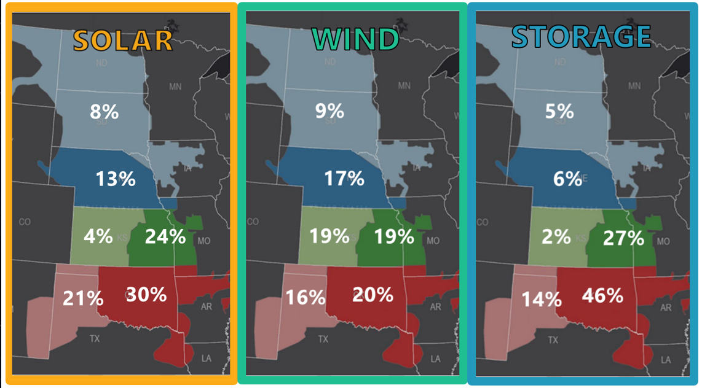
Figure 2.5: SPP East Zonal Resource Siting Allocation percentage by resource maps

Figure 2.6: [Zonal resource siting map to be inserted for SPP RTOE]

Must-Run Units
Must-run designations for SPP areas within both East & RTOE models will be assigned to co-generation, nuclear, landfill gas, and hydroelectric units, unless an exception is requested during the generation review and approved by the ESWG. Co-generation units will be identified based on Energy Information Administration (EIA) Form EIA-860 data, as well as Hitachi simulation-ready data. If a unit was originally identified as a must-run in a previous study, but was removed as an exception, it will not be identified as a must-run unit. External areas will have the same criteria, with the deviation that external co-generation units will be assigned a must-run status subject to SPP review.

Wind Repowers and Curtailment Price
An automatic repower will be assumed for all wind units after 10 years of being in service. For future planned wind & solar units, the curtailment price will be set at $0/MWh to reflect changes under OBBBA. However, any wind or solar project that begins construction after July 4, 2026, will not qualify for credits unless it is placed in service by December 31, 2027.

Hurdle Rates and Interchange
Hurdle rates for all futures will be based upon the latest vendor data set. However, prior to and during the MEM benchmarking and initial MEM builds, SPP and ESWG will review the reasonableness of the latest vendor data set hurdle rates and respective interchange. SPP and ESWG may utilize, as appropriate, previous ITP MEMs in this review. This review may result in adjustments to the MEM hurdle rates and/or other economic model parameters that impact MEM interregional “economy-energy” transactions. Any ESWG-approved adjustments and MEM interchange results will be documented in the final 2027 ITP Sunset/RTOE Transition Assessment report.

Resource Plan

Resource Plan Powerflow Modeling
The following parameters will guide how the resource plans, both internal and external, are modeled in all applicable models with regards to reactive settings, such as maximum and minimum volt-amps reactive (VAR) support and voltage schedule.
All resources included in the internal or external resource plans (excluding distributed generation, such as rooftop solar) will be modeled as directly injecting power at the point of interconnection (i.e., ESWG-approved site). Maximum and minimum reactive capability of generators will be determined by utilizing a .95 power factor and the maximum real power capability of the resource. Resources sited where existing generation is already interconnected will follow the voltage schedule and remote bus determination of the existing resource. The following information is resource fuel type specific and references settings observed in the powerflow modeling software utilized in the ITP/CPP process. The following settings apply to both the internal and external resource plans.

Conventional Generation
The control mode for conventional generation will be set to “Not a wind machine.” The voltage schedule (i.e., vsched) will be set at 1.015 per unit for system peak models and 1.00 per unit for off- peak models, unless a voltage set point warning is observed. For sites with no existing generation, the remote bus will be the point of interconnection of the new resource. These parameters may be reviewed and adjusted to ensure erroneous system issues are not identified.

Solar, Wind, or Energy Storage Resources
The control mode for renewable and energy storage resources will be “+ or – Q limits based on Wind Power Factor (WPF), which will be set at .95. The voltage schedule will be set at 1.015 per unit for system peak models and 1.00 per unit for off peak models, unless a voltage set point warning is observed. For sites with no existing generation, the remote bus will be the point of interconnection of the new resource. These parameters may be reviewed and adjusted to ensure erroneous system issues are not identified.

Economic Prototypes (All Fuel/Resource Types)
Generator prototype parameters will be set using the Capital Cost and Performance Characteristics for Utility-Scale Electric Power Generating Technologies – EIA; Industrial combustion turbine (CT) will be the default. Stakeholders will be allowed to request an exception to the combustion turbine for either the combined cycle (CC) single shaft or 95% Carbon Capture & Sequestration (CCS) Is from the EIA-Annual Energy Outlook (AEO). Exceptions must be approved by the ESWG. The table below details the characteristics of the approved prototypes in 2024 dollars for currency values.
Table 2.14: Generator Prototype Parameters
Generation Type | Data Source | Technology Type | Size (MW) | Total Capital Cost ($/kW) | Variable O&M ($/MWh) | Fixed O&M ($/kW-yr) | Heat Rate (Btu/kWh)
Combined Cycle (CC) | EIA CC&P Report – Jan 2024 | 95% CCS | 543 | $2,365 | $5.05 | $24.78 | 7,239
Combined Cycle (CC) | EIA CC&P Report – Jan 2024 | Single Shaft | 627 | $921 | $3.33 | $15.51 | 6,226
Combustion Turbine (CT) | EIA CC&P Report – Jan 2024 | Industrial | 419 | $836 | $0.85 | $6.87 | 9,142

Resourece Accreditation
SPP staff will ensure all LREs are resource adequate within all MEM scenarios, relative to the latest summer and winter PRM determinations for each planning region.
SPP staff will categorize renewable resources into two categories, Tier 1 and Tier 2. Tier 1 resources include existing renewables with long-term firm transmission service or future renewables requested by a utility’s integrated resource planning template response submitted to SPP during scope development. All remaining renewable resources will be considered Tier 2.
Two Effective Load Carrying Capability (ELCC) percentage values for each season (summer and winter) will be used based upon SPP’s latest ELCC study results for each planning region. A total accreditation amount for each resource type in each scenario and season will be determined. Tier 1 resources will be given an accreditation value consistent with the ELCC percentage based on the Tier 1 amount. The total accreditation available from Tier 1 resources will be subtracted from the total accreditation value. Tier 2 resources will receive the remaining accreditation on a pro-rata basis. The following visual will replicate the process.
Figure 2.7: Accreditation Process

Planning Reserve Margin Values
The PRM values utilized for the summer and winter seasons for applicable study years will be from the latest approved LOLE study for each planning region. If the study has not been approved, the PRM values utilized for the summer and winter seasons will be equivalent to those in the SPP governing documents. For the RTOE region, the latest known values will be used.

New Resource Allocation and Assignment
Non-policy resources requested through the IRP template will be assigned 100% to the requesting utility. Conventional resources requested through the IRP template will also be assigned in full to the requesting utility. Policy-driven additions will be allocated 50% wind and 50% solar to the area in shortfall. All resource assignments will be determined in parallel with the siting milestone for the 2027 ITP Sunset/RTOE Transition Assessment.
Renewables will be allocated first and based upon resource planning template responses to those utilities forecasting additions and also depending on either the excess or deficit scenarios described in Figure 2.8 and Figure 2.9 below, whichever applicable:
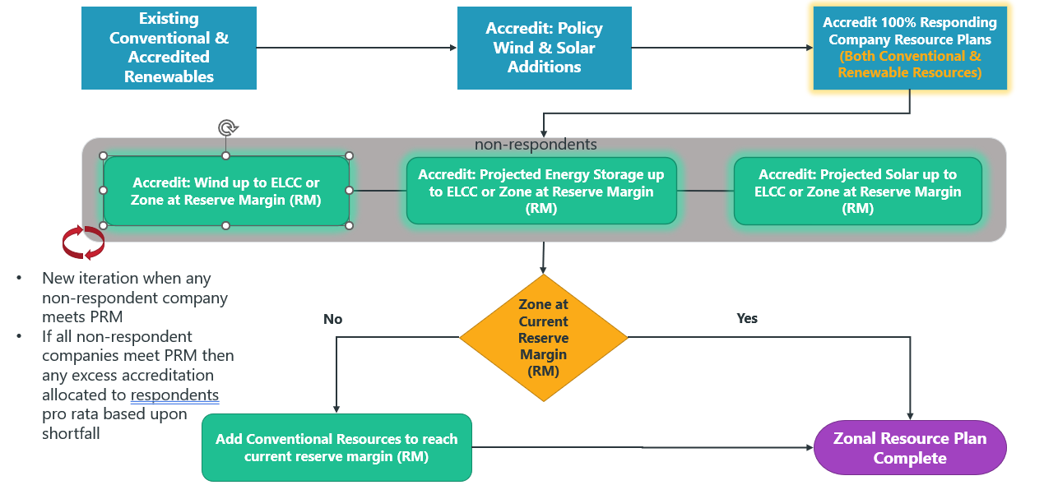
Figure 2.8: Resource Accreditation - Excess Scenario
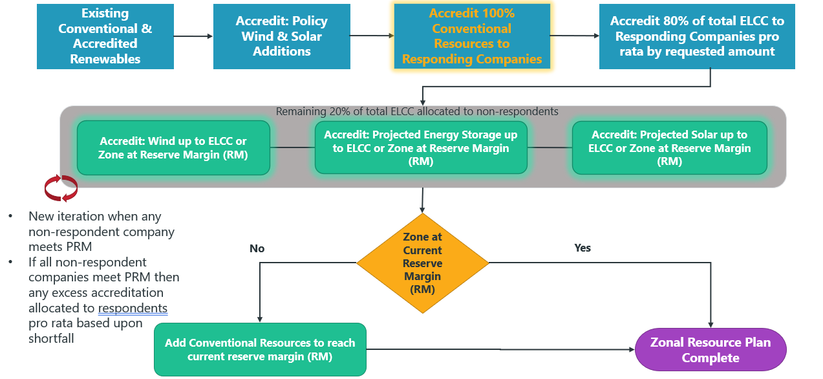
Figure 2.9: Resource Accreditation - Deficit Scenario
In the excess scenario, responding companies receive the full amount of renewable capacity requested in their resource planning template. The remaining ELCC will be allocated to non-responding companies pro-rata (all fuel types) based upon shortfall, capped at the PRM.
In the deficit scenario, responding companies will receive 80% of total ELCC on a pro rata basis by the requested amount. The remaining 20% of ELCC will be allocated to non-responding companies on a pro rata basis (by fuel type) based upon shortfall, capped at the PRM.

State Renewable Portfolio Standards (RPS)
The following values will be used in accordance with Section 2.2.1.3 of the ITP Manual and represent binding or required mandates or goals:
Table 2.15: RPS by State
State | RPS Type | Generation Type | Capacity or Energy Based | State wide or by utility | Year 5 Percent | Year 10 Percent | Year 20 Percent
Colorado | Mandate | Both | Energy (MWh) | Utility | 30% | 30% | 30%
Minnesota | Mandate | Both | Energy (MWh) | Utility | 25% | 55% | 55%
Missouri | Mandate | Both | Energy (MWh) | Utility | 15% | 15% | 15%
Nevada | Mandate | Both | Energy (MWh) | Utility | 50% | 50% | 50%
New Mexico | Mandate | Both | Energy (MWh) | Utility | 50% | 67%* | 80%
Oregon | Mandate | Both | Energy (MWh) | Utility | 42%* | 63%* | 100%
Washington | Mandate | Both | Energy (MWh) | Utility | 38%* | 60%* | 100%

Needs Assessment
The needs assessments will be performed as outlined in the ITP Manual, Section 4 (Needs Assessment), except as detailed below. The flowchart of the new process from Needs Assessment to Portfolio Consolidation begins in Figure 3.1 below and is continued in Section 5 (Portfolio Development) in Figure 5.1. This includes specific assessments that will be performed for the SPP RTOE set of models.
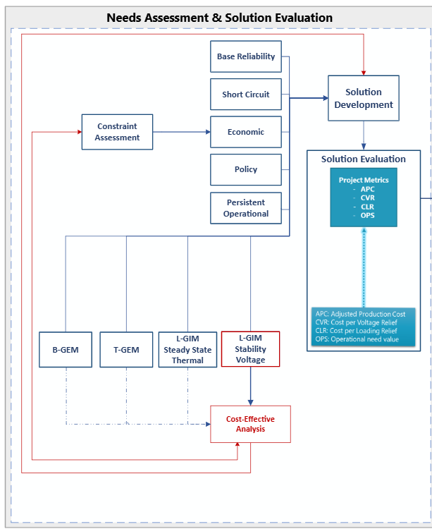
Figure 3.1: Needs Assessment flowchart

Economic Needs Assessment
The economic needs assessment for all futures and years will be performed consistent with the methodologies outlined in Section 4.1 of the ITP Manual. SPP staff will conduct separate economic needs assessments for the SPP regions within the Western and Eastern Interconnections. For the Eastern Interconnection, a limited economic analysis was approved in August 2025 by TWG & ESWG to enhance CPP readiness, improve affordability, and address delay-avoidance considerations. The resulting impacts are incorporated into the congestion scores referenced below.
For SPP East, the list of binding constraints will be reduced to those congested flowgates with an annual flowgate congestion score approved by ESWG. For the SPP RTOE assessment, the list of binding constraints will include congested flowgates with an annual flowgate congestion score greater than $50,000/MW.
The SPP East economic analysis will utilize the applicable event file from the 2026 CPP Transition Assessment with only minimal modifications.

Reliability Needs Assessment
Reliability analysis utilizing SPP RTOE year-20 models will be performed consistent with year 10 requirements unless otherwise detailed in this section.

SPP RTOE Generation Expansion Models (GEM)
Contingency analysis for the Base Generation Expansion Model (B-GEM) and the Transmission Generation Expansion Model (T-GEM) will follow the base reliability needs assessment methodology as described in Section 4.2.1 of the ITP Manual, with the exclusion of NERC TPL-001 Category P3 planning events. Modifications to existing EHV contingency events—including P2.2, P2.3, P4.1 through P4.5, and P5 categories—and the development of new EHV proxy events (P4.1–P4.5) will be made for each modeled future year. These updates reflect changes in EHV substations and system topology driven by CPP planned generation additions, associated Generation Interconnection Agreements, and future resource expansion plans at CPP Planned Interconnection Locations.
The newly created proxy events are designed to represent expected adjustments necessary to modify existing P2.2, P2.3, and P5 events consistent with the updated system conditions. Both modified existing events and new proxy events will be named in accordance with the SPP Contingency Naming Convention as detailed in Appendix B of the 2026 SPP Annual Engineering Data Request Schedule.
Specifically, modified existing events addressing changes to EHV substations and line tapping will retain their original naming structure, with the addition of the substation point of interconnection bus number and the “LTAP” designation appended to Field 6: Event Description. Proxy events reflecting only line tapping modifications will similarly retain their naming conventions, appending “LTAPOnly” to Field 6. New proxy events that capture changes exclusively at EHV substations will preserve existing naming conventions, with the substation point of interconnection bus number appended to Field 6.
Where modifications are made solely for EHV substation changes, these proxy events will intentionally duplicate existing events. Both the original and duplicated events will be flagged as informational during preliminary violation reviews on a per-future-year basis, as outlined below.
For new P4.1 through P4.5 events associated with EHV substation changes, the following fields will be specified: Field 1—TPL-001-5 Table 1 Planning Event; Field 2—Nominal Voltage; Field 3—Transmission Owner; Field 6—Event Description (including substation point of interconnection bus number); and Field 7—Voltage Level Designation. Modified and new proxy events will utilize Field 8, the Special Contingency Flag, set to “GEM/L-GIM EHV F#Y#” to clearly identify these events as applicable exclusively to the corresponding future and year models. This flag also aids in identifying event duplications and supports the review of thermal, voltage, and non-converged violations contingent upon interconnection requirement data specified elsewhere in this scope.
Except for the “LTAPOnly” modified events, all thermal, voltage, and non-converged violations associated with these proxy events will initially be classified as informational. However, during the preliminary violation review or the needs posting window, the Transmission Owner may designate any such violation as a valid non-informational need, based on interconnection requirement data, to support the integration of existing and planned generation in the ITP Base Reliability model, CPP planned generation additions, and future resource expansion plans. This classification facilitates the identification of solutions and supports portfolio development.
SPP will provide Transmission Owners with comprehensive lists of existing and planned generation reflected in the ITP Base Reliability models, CPP planned generation additions, and associated Generation Interconnection Agreements. These lists will include CPP Planned Interconnection Location points of interconnection, existing interconnection points for both current and planned generation, and responses from the ITP siting milestone and the Interconnection Requirement Information section of this scope. This information is intended to expedite Transmission Owner reviews and assist in distinguishing which events require inclusion in solution evaluations as non-informational needs.

SPP RTOE Local Generator Interconnection Models (L-GIM)
In alignment with Table 6, thermal needs for the L-GIM steady-state analysis will be determined through standalone DC FCITC analyses performed on each resource plan unit by fuel type, following BP7250 fuel-based dispatch scenarios. This approach accounts for simultaneous dispatch of multiple resource plan units only when BP7250 electrically equivalent criteria require it. The contingency definitions applied will be consistent with those used in the base reliability needs assessment, except for the exclusion of NERC TPL-001 P3 planning events.
Modifications to existing EHV P2.2, P2.3, P4.1-P4.5, and P5 contingencies, along with the creation of new EHV P4.1-P4.5 proxy contingencies, will be developed on a per-future-per-year basis to incorporate changes in EHV substations and network topology. These changes result from CPP planned generation additions to the ITP base reliability models, incorporating Generation Interconnection Agreements and the siting of CPP Planned Interconnection Location points of interconnection, consistent with procedures documented for the GEM.
The Transfer Distribution Factor (TDF) impact for thermal overloads will follow BP7250 Section 4.2.2.2, except that ERIS cumulative impact criteria of 5% TDF and 20% of the constrained element’s emergency rating will be omitted due to the standalone nature of this analysis for each resource plan unit.
The L-GIM steady-state voltage and stability assessment will follow contingency analysis protocols outlined in the ITP Manual Section 4.2.1 and BP7250 Section 4.2.2, focusing on identification of voltage violations per BP7250 Sections 4.2.2.3 (Voltage Violations) and 4.2.2.1 (Non-converged events), apart from excluding NERC TPL-001 P3 events.
Consistent with EHV event modification for the GEM and L-GIM Steady State analysis, modifications and new proxy contingencies will be applied to HV and HV P2.2, P2.3, P4.1-P4.5, and P5 events similarly to the GEM, reflecting CPP planned generation additions. Non-converged blown-up violations will not initially be flagged as informational only by default unless the point of interconnection Transmission Owner identifies them as an invalid need during the preliminary review or posting window. Modified and new proxy events will utilize Field 8, the Special Contingency Flag, set to “GEM/L-GIM HV F#Y#” to clearly identify these events as applicable exclusively to the corresponding L-GIM Stability future and year models.
TDF impacts associated with voltage violations and non-converged events will adhere to BP7250 Sections 4.2.2.3 and 4.2.2.1, respectively.

SPP RTOE GEM and L-GIM Needs Correlation with Constraint Assessment
Thermal violations identified through GEM and L-GIM needs assessments will be cross-referenced with thermal constraints found during the constraint assessment milestone. Thermal violations present in GEM or L-GIM but absent from the constraint assessment will be incorporated into the economic model event file.
Single or multiple element transmission line contingencies causing severe voltage violations or non-converged conditions, indicative of potential system instability, will be correlated to thermal constraints from the constraint assessment. If no correlated violations are found in the economic model event file for GEM or L-GIM contingencies, proxy Power Transfer Distribution Factor (PTDF) flowgates will be included to represent these contingencies. These flowgates will be based on the elements or electrically similar elements involved in the contingency, oriented in the direction of system intact flow.
The ratings used to identify violations will apply 150% Surge Impedance Loading (SIL) for single element contingencies, or the aggregated 150% SIL of all elements for multiple element contingencies, limited to the lesser of Rate A or the actual MW loading of the contingent element(s) where the violation was observed in GEM or L-GIM.
For single element transformer contingencies, a proxy PTDF flowgate will be added with a rating equal to 75% of Rate A, provided that 75% of Rate A is less than the actual MW loading of the contingency element.

Short Circuit Ratio (SCR) Screening
The purpose of the short circuit ratio (SCR) screening analysis is to identify areas of the system that have low grid strength, which can be an indication of future stability needs. Indicators for stability needs may not be captured in reliability and economic assessments. This information will be used as an additional means of assessing reliability and economic transmission upgrades; however, this assessment alone will not identify new transmission upgrades for construction.
“System strength” refers to the voltage stiffness of an area or bus, meaning perturbations in the system near buses of concern will impact the bus voltage to some degree, depending on its strength. For example, a strong bus means a fault near the bus will cause a small voltage at the bus; conversely, a weak bus will experience a large voltage change. Weak areas are more susceptible to voltage oscillations, voltage instability or even voltage collapse.
The SCR metric measures the relative strength of the bus at the IBR point of interconnection (POI). An SCR of 3.0 or less is considered weak corresponding to reduced stability. More analysis is required for low system strength as the IBR may be susceptible to instability. To assess the SPP system's strength, an SCR check will be performed for each IBR point of interconnection. Further analysis for those buses areas with SCR less than studied further.
Screening at each candidate interconnection point is performed to evaluate system strength using the SCR, calculated with the equation:
$$SCR= \frac{S_{SCMVA}}{P_{RMW}}$$
Where:
- S_{SCMVA}: Maximum Available Short Circuit Power (MVA) before connection of the new resource
- P_{RMW}: Real Power (MW) rating of resource(s) connected.
An SCR below a 3.0 will be considered during solution evaluation and development.
The S_{SCMVA} may be calculated by leveraging the formula shown below:
$$S_{SCMVA}= \sqrt{3}*V_{L-L}*I_{SC}$$
Where:
- V_{L-L}: Line to line voltage at the interconnection point
- I_{SC}: Three-phase short-circuit current at the interconnection point

Short-Circuit Current (I_{SC}) Calculation
- I_{SC} is determined through a short-circuit analysis using the latest stability models in PSS®E by applying a three-phase fault at each candidate interconnection point.
- Alternatively, I_{SC} may be calculated using the Thevenin Impedance Z_{TH} from PSS®E, with the formula:
$$I_{SC}= \frac{V_{L-L}}{Z_{TH}}$$
The SCR will be calculated for existing generation at the interconnection point and updated to include the incremental change associated with prospective generating projects.
The Weighted Short Circuit Ratio (WSCR) will also be evaluated. This metric considers a high penetration of IBRs in a general area. Based on the electrical proximity of these IBRs, the WSCR determines an area SCR that can encompass anywhere from two to any number of IBRs. This metric consolidates the strength of the area into a single metric derived from the collective influence of the grouped IBRs. The WSCR is defined as:
$$WSCR=\frac{\sum_{i=1}^{n}{S_{{SCMVA}_{i}}* P_{R{MW}_{i}}}}{{\left(\sum_{i=1}^{n}{P_{R{MW}_{i}}}\right)}^{2}}$$
If the final SCR or WSCR (current + prospective generation) is less than 3.0, an Electromagnetic Transient (EMT) analysis is deemed necessary to determine system stability.

SCR Screening Contingencies
The SCR will be performed on system intact conditions.

Non-Converged Contingencies
Non-converged contingency analysis will follow the ITP Manual section 4.2.3 approach with consideration of BP7250 non-convergence analysis approach for B-GEM, T-GEM, and L-GIM stability models.

Violation Identification and Filtering Criteria
Violations will be identified utilizing the following criteria for ACCC analysis shown in Table 3.1 below.
Table 3.1: Violation Identification and Filtering Criteria
Description | Model Year | Base Reliability | SPP RTOE  B-GEM | SPP RTOE  T-GEM | SPP RTOE  L-GIM  Steady State | SPP RTOE  L-GIM  Proxy Stability
Number of most severe violations for each facility per season per contingency type (single, non-single or Base Case) | Y5/Y10: | 10 | 5 | 5 | 5 | 5
 | Y20: | n/a | 5 | 5 | 5 | 5
Minimum contingency case voltage change for range violations | Y5/Y10: | 0.009 pu | 0.02 pu | 0.02 pu | n/a | 0.02 pu
Minimum contingency case voltage change for range violations | Y20: | n/a | 0.04 pu | 0.04 pu | n/a | 0.04 pu
Minimum contingency case flow change for overload report | Y5/Y10: | 3 MW | 5 MW | 5 MW | 5 MW | n/a
Minimum contingency case flow change for overload report | Y20: | n/a | 10 MW | 10 MW | 10 MW | n/a
Minimum contingency case percentage loading increase for overload reports | Y5/Y10: | 0.5% | 1% | 1% | 1% | n/a
 | Y20: | n/a | 2% | 2% | 2% | n/a
Bus mismatch tolerance (MVA) | Y5/Y10: | 3 MVA | 3 MVA | 3 MVA | n/a | 3 MVA
Bus mismatch tolerance (MVA) | Y20: | n/a | 5 MVA | 5 MVA | n/a | 5 MVA
System mismatch tolerance (MVA) | Y5/Y10: | 10 MVA | 10 MVA | 10 MVA | 10 MVA | 10 MVA
System mismatch tolerance (MVA) | Y20: | n/a | 20 MVA | 20 MVA | 20 MVA | 20 MVA
Resulting violations will be filtered after excluding invalid and informational violations to determine a list of valid non-informational violations that will be included in the needs assessment, consistent with ITP methodologies. All valid informational violations related to modified and new GEM and L-GIM events that did or did not receive feedback during the preliminary violations review will be included in the needs assessment to allow for further review as needed during the DPP window in conjunction with the gathering Interconnection Requirement Information.

Interconnection Requirement Information
After the conclusion of the siting milestone approval, SPP will request additional interconnection requirement information from applicable Transmission Owners for CPP Planned Interconnection Locations for posting as pre-screening information for the 2028 CPP10 generation connection process, to facilitate the review of modified or new proxy planning events as described in the SPP RTOE GEM and L-GIM reliability needs section, inform changes to approved site infeasibility designations, and inform as necessary transmission plan recommendations.
SPP will supply Transmission Owners for each Planned Interconnection Location point of interconnection site a list of existing, planned generation in the ITP BR, CPP planned generation additions to the ITP base reliability models with Generation Interconnection Agreements grouped by the dedicated or shared interconnection gen lead for each, and the additional approved stand-alone and co-located sites. The listing will include the interconnection feasibility information received from the ITP siting milestone. The applicable Transmission Owners will identify the number of cost effective/commercially viable gen lead bus breaker connections needed to connect the CPP Planned Interconnection Location sites for each nodal point of interconnection consistent with Transmission Owner Interconnection Requirements and standards.

Facility Rating Data
Comprehensive facility rating data will be required to develop least cost solutions in support of SPP RTOE L-GIM portfolio development and consideration as cost-effective alternatives for development of other portfolios. To expedite the development of these least cost and cost-effective alternatives, Transmission Owners shall supply readily available facility rating databases and data or facility rating data sheets to include all monitored elements identified during the preliminary violation review for use by SPP staff and consulting agents. In instances where the Transmission Owner does not supply the requested facility data, transmission owners can expect comprehensive generation interconnection process data requests as schedules allow or defaulting to line rebuilds and transformer replacements for project alternative comparisons to new lines and transformation.

Limited Operation Information
To support the Invest, Connect, and Manage policy direction of the Consolidated Planning Process, thermal violations identified in the SPP RTOE L-GIM needs assessment will be categorized as:
- Thermal constraints with and without a Market Operations Redispatch solution based on:
  - whether or not the contingency is consistent with the normal operation of the SPP Integrated Marketplace and,
  - there are no directly related soft constraint violations identified in the MEM
- A voltage and non-converged constraint that is proxied by thermal constraints with and without a Market Operations Redispatch solution based on:
  - whether or not the contingency is consistent with the normal operation of the SPP Integrated Marketplace, and
  - there are no directly related soft constraint violations identified in the MEM
- A voltage and non-converged constraint that is not proxied by thermal constraints and has a proxy PTDF flowgate included with and without a Market Operations Redispatch solution based on:
  - whether or not the contingency is consistent with the normal operation of the SPP Integrated Marketplace and,
  - there are no directly related soft constraint violations identified in the MEM
This information will be utilized to recommend must-fix needs and needs that can be managed by the SPP Integrated Marketplace to allow planned resource plan sites prospective in-service dates prior to construction of approved transmission plans.

Affected System Coordination
Affected systems coordination will follow the process outlined in Section 3.5 of the CPP Manual and will apply specifically to the L-GIM models developed for the SPP RTOE region.

Solution Evaluation
The methodologies outlined in Section 5 of the ITP Manual will serve as the basis for all analysis applicable to the Solution Development and Evaluation milestones. Exceptions and qualifications are outlined below.

Persistent Economic Operational Solution Evaluations

Flowgates
SPP will perform the persistent operational needs assessment prior to the 2027 ITP Sunset/RTOE Transition Assessment benchmarking milestone for further investigation and validation of the year 2 economic models. As part of the 2027 ITP Sunset/RTOE Transition Assessment, SPP will make a recommendation to working groups on whether or not to address persistent operational needs according to ITP Manual section 4.4.

Manual Commitment of Generators
Some transmission system issues require the manual commitment of generation by SPP in the Integrated Marketplace to provide relief on the system. The make-whole payments avoided when a proposed solution is included in the model will be considered in the solution’s benefit. Each solution’s one-year benefit-to-cost (B/C) ratio and its ability to reduce or eliminate the need for manual commitments will be considered during project selection.

Economic Solution Evaluation
The methodologies outlined Section 5.3.1 of the ITP Manual will be utilized to perform economic solution evaluation. For analysis of project performance in the SPP RTOE 20-Year economic models, these methodologies will supersede the requirements outlined in the Solution Development section of the 20-Year Assessment Manual.

SPP RTOE L-GIM Reliability Solution Evaluation
All solutions will be evaluated against L-GIM reliability needs to calculate a loading relief for each solution and mitigated need.

Portfolio Development
The methodologies and criteria outlined in Section 6.1 of the ITP Manual will serve as the basis for portfolio development. Any additional portfolio development criteria, exceptions or qualifications required to meet the holistic objectives of this assessment are listed in this section.
Two economic* portfolios will be developed as part of this assessment, one for SPP East and one for SPP RTOE.
The ITP portfolio development process flow will be modified to accommodate the additional analysis included in this assessment as shown in Figure 5.1 below.
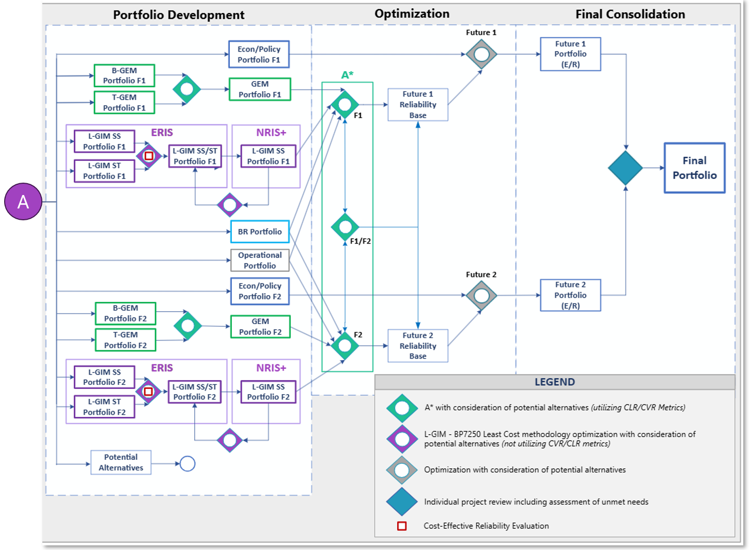
Figure 5.1: Portfolio Development Flowchart

Reliability Portfolio Development
In addition to BR and operational portfolios, draft GEM and L-GIM portfolios will be developed for each RTOE future as shown in Figure 11 above. The reliability portfolio development methodologies outlined in Section 6.1.2 of the ITP Manual will apply to the GEM and L-GIM models, except as outlined below.

L-GIM Portfolio Development
L-GIM ERIS steady-state and stability proxy portfolios will initially be developed separately for this assessment. While transient stability analysis will not be performed and current ITP tools will be able to optimize solutions to address both need types, certain identified needs will follow a cost-effective reliability evaluation based on the cost of the required transmission solution as described in the portfolio optimization section. A least cost approach will generally be utilized instead of the cost-effective CVR/CLR metrics to adhere to generator interconnection principles for resolving issues.
If issues arise utilizing the ITP procedures for reliability portfolio development, the process outlined in section 4.2.3 of BP7250 (GI Manual) may be leveraged to produce an optimized L-GIM portfolio.
L-GIM NRIS steady-state portfolio will be developed, assuming the optimized L-GIM ERIS portfolio. If incremental projects are identified for the L-GIM NRIS steady-state that can avoid L-GIM ERIS portfolio projects, the L-GIM ERIS portfolio project will be replaced by the incremental project and identified as L-GIM ERIS portfolio project.

Economic Portfolio Development
The methodologies outlined in the ITP Manual, Sections 6.1.1, will be utilized to develop economic portfolios. These methodologies will augment or supersede the requirements in the 20-Year Assessment Manual for the purpose of meeting 20-Year Assessment requirements.

Usage of SPP RTOE 20-Year Adjusted Production Cost (APC) Datapoint
The economic portfolio development processes will consider the use of each of the available model years to meet near- and long-term objectives of this combined assessment. Development of a holistic portfolio that can meet needs in the 20-year horizon will consider additional datapoints and voltage classes excluded from consideration in the 20-Year Assessment Manual and a year 20 datapoint not contemplated in the ITP Manual.
It may be necessary to develop a set of portfolios that focus on a medium- and/or long-term horizon. Data will be available to assess the economic benefit of transmission upgrades in each of the model years and perform present value benefit calculations with and without a year 20 datapoint on a 40-year horizon. In addition to addressing potential technical challenges, it may be desirable to develop portfolios to address transmission needs in different time horizons to delineate between near- and long-term portfolios.

Portfolio Optimization

Reliability Portfolio Optimization (Future-Specific)
BR, Operational, RTOE GEM, and RTOE L-GIM portfolios will be optimized to create a holistic reliability portfolio per applicable future.
BR, Operational, RTOE GEM, and RTOE L-GIM portfolios will be jointly optimized to produce a holistic reliability portfolio for each applicable future.

Reliability and Economic Optimization (Future-Specific)
Select reliability needs for the L-GIM will be evaluated as a reliability and economic need during or after the needs assessment to ensure proper evaluation of system needs and solutions.

Review of Sub-Regional Exports for L-GIM Stability Projects
The L-GIM stability analysis will be reviewed when extreme sub-regional group export conditions are identified through analysis performed in Section 3.4.2.3 and Section 4.1.3.2 of the CPP manual. Candidate solutions to mitigate these conditions are identified during the portfolio development milestone(s) but will be subject to further evaluation to verify that observed stability issues reflect credible operating and planning conditions.
This adjusted evaluation involves modifying the relevant models by reducing the sub-regional export level(s) to a to a technically feasible operating point. This export amount is achieved by setting the sum of the sub-regional generation to: the sum of the sub-regional generation accreditation, the PRM, and all sub-regional Future Resource Plan capacity (by future and year) at forecasted nameplate levels, including Electrically Equivalent exceptions for Prior-Queued Generation and Non-Legacy Base Reliability Generation.
In addition, SPP will determine whether the group load within the adjusted model is lower than the corresponding group load within the latest corresponding B-GEM model or BR model. If so:
  - Scale the group load, excluding non-conforming loads, within the adjusted model up uniformly until system intact non-convergence violations are alleviated while not exceeding the group load in the corresponding B-GEM or BR model.
  - Leverage the available out of group sink generation as outlined in Section 3.4.1.4.2 and scale up uniformly while maintaining the steady-state sink order (in reverse order). Perform this step in conjunction with item (a).
To achieve the technically feasible operating point, dispatch adjustments are made by proportionally scaling down Prior-Queued, Legacy, and Non-Legacy Base Reliability Generation within the sub-region, excluding Electrically Equivalent exceptions and any units designated as must-run. Concurrently, dispatch levels of out-of-group Legacy and Non-Legacy Base Reliability Generation are proportionally increased, excluding any must-run units.
Using these adjusted models, a limited reassessment is performed. This includes:
- Reviewing the export-related and out-of-group voltage and stability criteria violations (and proxy stability criteria as non-converged events, where applicable) that initially drove the higher-than-average reliability-based solution cost;
- Identifying any remaining export-related and out-of-group reliability needs and associated solutions; and
- Re-evaluating shared system events that intersect with any sub-regional Future Resource Plan point of interconnection at the minimum requirement reliability export level. This re-evaluation will include, at a minimum, capacity modeled at forecasted nameplate levels with inclusion of Electrically Equivalent exceptions for Prior-Queued and Non-Legacy Base Reliability Generation.
If the original sub-regional export case shows stability issues on a TO identified stability limited boundary or transfer path, SPP will share those results with the TO alongside the adjusted Section 6.2.1 validation case for review and feedback.
Refined solutions developed through this process will be considered as alternatives for inclusion in the comprehensive CPP Portfolio development process.

Portfolio Consolidation
Future-specific portfolios will be consolidated, where applicable, into a single set of projects to determine a recommended plan. The methodology by which this consolidation will occur is based on individual project performance. A systematic approach to evaluate each project’s merits and an SPP-developed narrative of each project’s drivers will guide the decision for inclusion in the recommended plan.
Projects with multiple need drivers will be evaluated through all applicable portfolio consolidation approaches, as needed. SPP may use engineering judgement or other analysis to support or oppose the results of the systematic approaches or criteria described in the sections below. SPP will bring consolidation results and a recommendation for all projects selected for a future-specific portfolio to the ESWG and TWG for review and feedback.
Three different scenarios could occur during the consolidation of the future-specific portfolios into a recommended plan; these are described in the next section.

Overview of Consolidation Scenarios

Scenario 1
Projects selected for inclusion in both futures are considered for evaluation in consolidation scenario 1. Scenario 1 projects address the same or similar needs in both futures and will be included in the final recommended portfolio.

Scenario 2
Different projects selected for each future that address the same or similar needs in both futures are considered for inclusion in the final recommended plan through evaluation under consolidation scenario 2. Economic projects applicable to consolidation scenario 2 will be evaluated using multiple considerations through a scorecard methodology detailed in Economic Portfolio Consolidation. Reliability projects applicable to consolidation scenario 2 will be evaluated similarly to reliability portfolio development methodologies, as described in Reliability Portfolio Consolidation.

Scenario 3
Projects selected for inclusion in only one future are considered for inclusion in the final recommended plan through evaluation under consolidation scenario 3. Economic projects applicable to consolidation scenario 3 will be evaluated using the same considerations as consolidation scenario 2 but a different methodology detailed in the Economic Portfolio Consolidation section. Reliability projects applicable to consolidation scenario 3 will be evaluated using a set of mutually inclusive criteria detailed in the Reliability Portfolio Consolidation section.

Economic Portfolio Consolidation
Economic projects applicable to scenarios two and three will be given a score based on the point system detailed in Table 5.1. Each project will be awarded points based on its performance or ability to meet six different considerations, up to 100 total possible.
Table 5.1: SPP RTOE Economic Consolidation Considerations Scoring Table
No. | Considerations | Points Possible | Threshold
1 | 40-year (1-year) APC B/C in Selected Future | 50 | 1.0 (0.9)
1 | 40-year (1-year) APC B/C in Opposite Future | 50 | 0.8 (0.7)
1 | 40-year (1-year) APC Net Benefit in Selected Future ($M) | 50 | N/A
1 | 40-year (1-year) APC Net Benefit in Opposite Future ($M) | 50 | N/A
2 | Congestion Relieved in Selected Future (by need(s), all years) | 10 | N/A
2 | Congestion Relieved in Opposite Future (by need(s), all years) | 10 | N/A
3 | Operational Congestion Costs or Reconfiguration ($M/year or hours/year) | 10 | >0
4 | New EHV | 7.5 | Y/N
5 | Mitigate Non-Thermal or Resiliency Issues | 7.5 | Y/N
6 | Long Term Viability (addresses constraints that are limiting ARR feasibility) | 5 | Y/N
Total Points Possible |  | 100

For two projects (P1 and P2) applicable to scenario two, points for consideration one will be calculated as follows:
- Test B/C thresholds in opposite future
  - If project has less than 0.8 40-year B/C in opposite future, zero points will be awarded
  - If project meets 0.8 40-year B/C threshold in opposite future, continue calculations
  - If project has less than 0.7 1-year B/C in all years of opposite future, zero points will be awarded
  - If neither of the above conditions are met, continue calculations
- Calculate 40-year net adjusted production cost (APC) benefits
  - Net APC benefit_{P1,AVG}
  - Net APC benefit_{P2,AVG}
  - Net APC benefit_{Max} = Maximum(Net APC benefit_{P1,AVG},Net APC benefit_{P2,AVG})
- Calculate points awarded
  - ${Points awarded}_{P1,\%}=50×\frac{{Net APC benefit}_{P1,AVG}}{{Net APC benefit}_{Max}}$
  - ${Points awarded}_{P2,\%}=50×\frac{{Net APC benefit}_{P2,AVG}}{{Net APC benefit}_{Max}}$
For individual projects (P1) applicable to scenario three, points for consideration one will be calculated as follows:
- Test B/C threshold in opposite future
  - If project has less than 0.8 40-year B/C in opposite future, zero points will be awarded
  - If project has less than 0.7 1-year B/C in all years of opposite future, zero points will be awarded
  - If project has at least 1.0 40-year B/C in opposite future, 50 points will be awarded
  - If project meets 0.8 40-year B/C threshold in opposite future, but is less than 1.0, continue calculations
  - If none of the above conditions are met, continue calculations
- Calculate net APC benefits
  - Net APC benefit_{P1,AVG}
  - Net APC benefit_{P1’,AVG} = Net APC benefit_{P1,AVE} with 1.0 40-year B/C in opposite future
- Calculate points awarded
  - ${Points awarded}_{P1,\%}=50×\frac{{Net APC benefit}_{P1,AVG}}{{Net APC benefit}_{P1',AVG}}$
Points for consideration two will be calculated as the percentage of total congestion relieved on the needs addressed by the project, multiplied by the points possible.
$$Points awarded= {10×\% Congestion relieved}_{F1, addressed needs}+ {10×\% Congestion relieved}_{F2, addressed needs}$$
Points for consideration three will be calculated based on the severity of an operational issue that the project is expected to address, as a percentage of the operational needs criteria multiplied by the points possible, up to 10.
$Points awarded= \left(\frac{{\$ of congestion cost}_{24 months}}{\$10M}\right)×10$
OR
$$Points awarded= \left(\frac{{Hours of system reconfiguration}_{12 months}}{X\% ×8,760}\right)×10$$
All points possible for considerations four, five, and six will be awarded if the project meets the description of the consideration.
For projects applicable to scenario two, the project with the highest score will be considered the favorable project based on the systematic approach. Projects applicable to scenario three with a total score of 70 or greater will be considered for the final recommended plan.

Reliability Portfolio Consolidation
Reliability projects applicable to scenario two will be consolidated following the approach of the optimization milestone, utilizing the same criteria to develop each future’s reliability portfolio. This will allow needs across both futures to be considered and allow for project alternatives to be considered when determining the most optimal solution.
Reliability projects applicable to scenario three will be evaluated according to the following criteria to determine if those projects will be included in the final consolidated portfolio:
- Projects driven by Year 5
This criterion assumes that either of the futures’ drivers included in Year 5 can reasonably be expected to occur.
- Terminal equipment upgrades
Low cost solutions able to provide additional transmission capacity will be included.
- Rebuild of an existing facility
This criterion considers the rebuild of a facility below minimum design standards. This also accounts for potential aging infrastructure considerations.
- Average of loading/voltage severity across futures
These criteria will consider the most severe violation or highest loading of needs across all years when comparing common monitored elements in each future as follows:
  - Thermal: Average of thermal loading across futures greater than 90%
  - Voltage: Average of per unit voltage across futures less than 92% on the low end and greater than 103% on the high end
Projects addressing needs that meet either of these criteria will be included.
- Load-driven projects
This criterion will be based on the size and level of certainty for the expected load driving the project. This will generally be applicable to large load additions identified during scoping development.
- Future generation-driven projects (L-GIM only)
This criterion is based on the level of impact of individual generators. If 10% of the generators within a GI group impact a need by greater than a 3% TDF, the project resolving the need will be included.
- APC benefit
Reliability projects resolving reliability needs in either future and meeting a minimum 40-year 0.8 B/C threshold will be included.
These criteria are mutually inclusive and will likely be assessed considering increasing complexity of the criteria until one is met.
A redundancy check will be performed to avoid overlap between the results of reliability consolidation scenarios 2 and 3.

Project Staging
Projects will be staged based on the criteria in Section 6.3 of the ITP Manual, except as described in this section. The project staging milestone is intended to define the required in-service date of a transmission upgrade and to support recommendation of projects for construction that meet historical precedence of NTC issuance criteria of the SPP Board. Traditionally, the SPP Board does not issue NTCs for projects that do not require financial expenditure within the first four years from approval.
To meet proactive planning objectives, preference will be given to long-term transmission solutions with consideration of short-term mitigations. This could result in projects of longer-term value and less short-term benefit being recommended that may not meet traditional staging criteria for a project to be recommended for construction. This should be considered in determining both incremental upgrades of a project that could be staged in the near-term and projects that may warrant discussion to reconsider the four-year financial expenditure precedent.

Final Reliability Assessment
To ensure reliability of the recommended transmission plan, a contingency analysis will be performed with the final consolidated portfolio included in the base model set(s). At a minimum, this analysis will be performed on the Base Reliability and Base Generator Expansion model sets. Results of the final reliability assessment may require modification or addition to the final consolidated portfolio.
Throughout the solution evaluation and portfolio development milestones targeted analysis will be performed to identify any potential violations caused by proposed transmission projects, but there will not be a comprehensive evaluation of contingencies, models, or aggregate impact of the final portfolio of transmission projects until the final reliability assessment.
Additional analysis may be performed utilizing T-GEM and L-GIM model sets to ensure a more comprehensive evaluation of the impact of the final consolidated portfolio. This will be considered prior to the final reliability assessment milestone and dependent on the completeness of interim analysis, expectation of potential impacts of the specific transmission upgrades, and uniqueness of transmission needs or projects driven by the other model sets.

Informational Analysis

Benefit Metrics
Benefit metrics will be calculated consistent with Section 7.1 of the ITP Manual. The metrics will incorporate the 20-year datapoint where applicable for the SPP RTOE region.

Sensitivity Analysis
Sensitivities will be conducted on the final portfolio in respective futures in each market economic model to measure the flexibility of the portfolio with respect to the uncertainties of certain assumptions. Economic analysis will be performed for the sensitivities below:
- High and low natural gas prices
- High and low demand levels
- High and low solar levels
- High and low wind levels
- High and low storage levels
- Production Tax Credit Assumptions
Additional sensitivities will be determined via stakeholder survey leading up to this analysis and will be documented in the 2027 ITP Sunset/RTOE Transition Assessment report.

Rate Impacts
The net impact of the recommended transmission plan on a typical residential customer within the SPP region will be evaluated on a $/kWh basis. For SPP RTOE models, this assessment will be performed both with and without inclusion of GRID-C contributions from the Resource Plan. Base Plan Funding projections associated with the NRIS+ portion of the Resource Plan will not be considered.

DataPoints to Support GRID-C Policy (SPP RTOE Only)
In order to support calculation of the GRID-C value, data from multiple study milestones must be collected, derived, and summarized. This includes, but is not limited to, the following:
- Max capacity of existing generators
- Resource plan generators (grouped by subregional pricing zone)
  - Maximum capacity
  - Assumed accreditation
  - Annual energy output
  - GSFs on transmission elements (base case monitored)
    - All EHV for the footprint
    - HV by subregional pricing zone
- Final portfolio (consolidated) project costs
- L-GIM-specific upgrades
  - By service type (ERIS/NRIS)
  - By subregional pricing zone
Upgrades unable to be optimized

Schedule
The 2027 ITP Sunset & RTOE Transition Assessment began in July 2025 and will be completed by October 2027.¹ Figure 7.1 and Table 7.1 detail the study timeline.
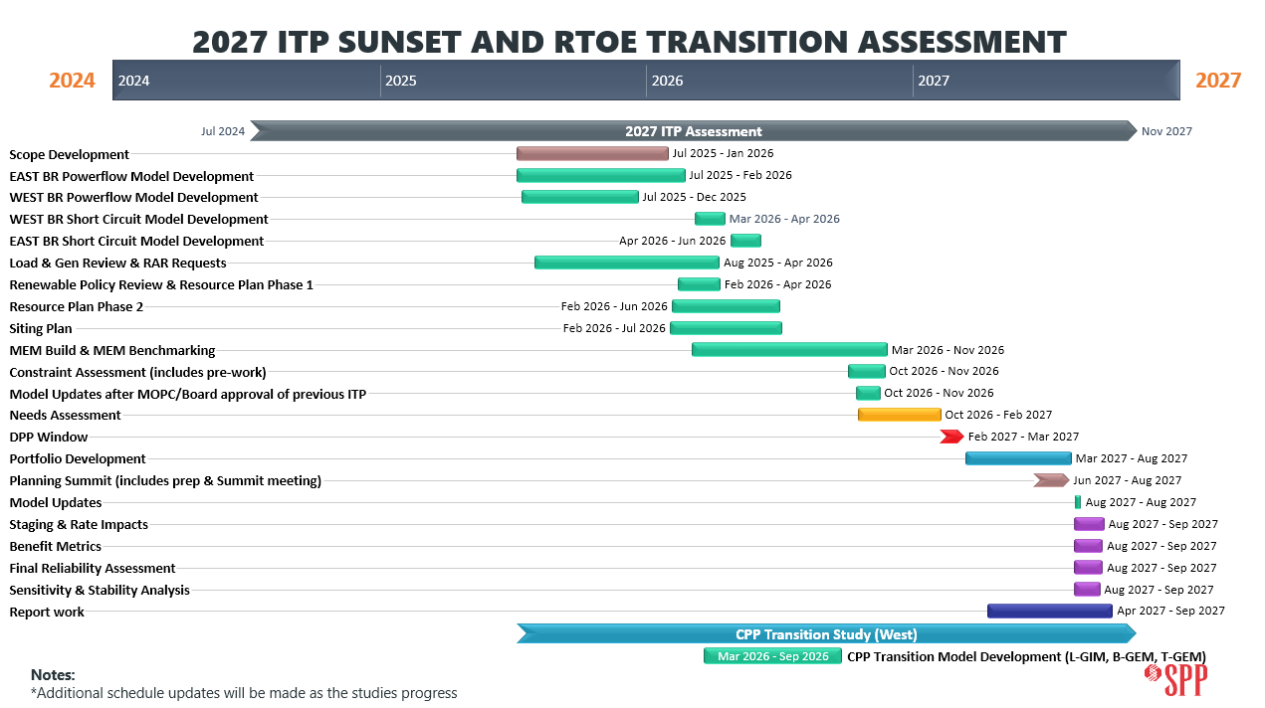
Figure 7.1: 2027 ITP Sunset/RTOE Transition Assessment Schedule Timeline
Table 7.1:2027 ITP Sunset/RTOE Transition Assessment Schedule Dates
Milestone Name | Group(s) to Review/Endorse | Start Date | Completion  Date
Scope Development | ESWG, TWG, MOPC, SPC, CPPTF | Jul 2025 | Jan 2026
Base Reliability Powerflow & Short Circuit Model Development | TWG | Jul 2025 | Jun 2026
Load and Generation Review | ESWG, TWG, MDAG | Aug 2025 | Apr 2026
Renewable Policy Review | ESWG | Feb 2026 | May 2025
Renewable Resource Plan (RP1) | ESWG, CAWG | Feb 2026 | May 2025
Conventional Resource Plan (RP2) | ESWG, CPPTF | Feb 2026 | Jun 2025
Siting Plan & Generator Outlet Facilities (GOFs) | ESWG, CPPTF | Jan 2026 | Jul 2026
Powerflow Model Development | TWG | Mar 2026 | Nov 2026
Short Circuit Model Development | TWG | Mar 2026 | Nov 2026
Economic Model Development | ESWG | Mar 2026 | Nov 2026
Generation Expansion Models | TWG | Mar 2026 | Sept 2026
Generation Interconnection Models | TWG | Mar 2026 | Sept 2026
Model Benchmarking | ESWG, TWG | Jun 2026 | Aug 2026
Model Updates after 2026 ITP Approval MOPC/Board (NTC/Re-evaluations) | TWG | Oct 2026 | Nov 2026
Constraint Assessment | TWG | Sept 2026 | Nov 2026
Needs Assessments | ESWG, TWG | Oct 2026 | Feb 2027
Detailed Project Proposal (DPP) Window | ESWG, TWG | Feb 2027 | Mar 2027
Solutions Development | ESWG, TWG | Feb 2027 | Apr 2027
Project Grouping | ESWG, TWG | Apr 2027 | May 2027
Study Cost Estimates |  | May 2027 | July 2027
Summit |  | July 2027 | July 2027
Final Portfolio Development | ESWG, TWG | July 2027 | Aug 2027
Portfolio Optimization / Consolidation | ESWG, TWG | Aug 2027 | Sep 2027
Project Staging | ESWG, TWG | Aug 2027 | Sep 2027
Benefit Metrics Calculations | ESWG | Aug 2027 | Sep 2027
Stability Analysis | TWG | Aug 2027 | Sep 2027
Sensitivity Analysis | ESWG | Aug 2027 | Sep 2027
Final Reliability Assessment | TWG | Aug 2027 | Sep 2026
Review Draft Report with Recommended Solutions | ESWG, TWG | Aug 2027 | Sep 2027
Final Report with Recommended Solutions | ESWG, TWG | Sep 2027 | Sep 2027
Final Report with Recommended Solutions | RSC, SPC, SSC | October 2027
Final Report with Recommended Solutions | MOPC, SPP Board

Changes in Process and Assumptions
To protect against changes in process and assumptions that could present a significant risk to the completion of the 2027 ITP Sunset/RTOE Transition Assessment, any changes to this scope or assessment schedule must be appropriately vetted and follow the process outlined in the stakeholder accountability section of the ITP Manual as time allows.

https://www.spp.org/Documents/71794/CPPTF%20Entry%20Fee%20Framework%20Recommendation%20Final%20April%202024%20Approved.docx
SPP Model Development Procedure Manual.
Consistent with the SPP Model Development Procedure Manual, existing and resource plan storage resources that are identified as standalone will be modeled at the maximum discharging capability and existing and resource plan storage resources that are identified as co-located will be modeled using the point of interconnection injection limit modeling with the limit being equal to the higher of the sum of non-storage resources or storage resources at the point of interconnection. No charging of storage devices will be modeled.
This includes utilizing BP7250 fuel-based dispatch for solar at 40% Nameplate for Summer Peak and 10% Nameplate for Winter Peak and for wind at 40% Nameplate for Summer Peak and 45% Nameplate for Winter Peak in lieu of replacement data that would result in zero dispatch.
The expected output will be based on the facility’s Nameplate Capacity to not exceed Maximum Injection Capability and can exceed a facility's firm service amount.
Units labeled as must run as identified in the ITP Base Reliability and Economic dispatch methodologies, including but not limited to hydroelectric, cogeneration facilities, landfill gas and nuclear units.
ITP BR dispatch of units identified as must run as previously stated will be maintained.
ITP BR dispatch of units identified as must run as previously stated will be maintained.
Portfolio development flag of “No” indicates model set is used for staging/development of other models only.
L-GIM stability models developed for the long-term assessment are steady-state models dispatched utilizing the stability dispatch methodology. Transmission system needs will be utilized for portfolio development reference and Generalized Rate for Interconnection Development Contribution (GRID-C) considerations.
In the opinion of the submitter that these loads are very likely to develop
As defined in the SPP Model Development Procedure Manual.
In the opinion of the submitter that these loads are very likely to develop
As defined in the SPP Model Development Procedure Manual.
https://www.eia.gov/analysis/studies/powerplants/capitalcost/pdf/capital_cost_AEO2025.pdf
The L-GIM steady-state analysis is adopting the general approach used for ITP Site Screening of the Siting milestone, the Generator Outlet Facilities Analysis, and the SPP Hosting Capacity Tool.
This includes constraints that are not identified by the constraint assessment process in total or by constraint assessment filtering criteria.
Surge Impedance Loading formula: SIL = (V^2) / Z, where V is the line voltage and Z is the surge impedance (characteristic impedance) of the transmission line Z = √L/C.
Soft Constraints are defined as the “soft" penalties representing the cost in $/MW to violate the particular constraint. The constraints include line flow constraints, pool load balance constraints, cost of emergency energy purchase at a bus, and operating reserve constraints.
Regardless of the type of need the solution was submitted to address.
Subject to the use of engineering judgment described above.
Similar termination points determined if they are located no more than 1 station (sub-station, switching station, or other station as identified in the SPP Model) away or within 15 linear miles as noted in SPP BP 7650
Flowgate congestion cost totaling more than $10M over the last 24 months or system reconfiguration through an agreed-upon operating guide implemented 25 percent of year.
X equals 25 percent for operational thermal issues. X equals 10 percent for operational voltage issues.

