
By Amanda Harker Steele, Kirby Willis, Michael McCann and Drew McGilvray
Published on 17 December 2025
Version 1

RTOE Trading Hub Analysis – SWPW_HUB
Western expansion

Revision History
Date or version number | AuthorS | Change Description | Comments
1 | Amanda Harker Steele  Kirby Willis  Michael McCann  Drew McGilvray | Initial Draft

Contents
Revision History i
Executive summary 1
Background 2
Preview of Results 3
Cluster analysis & SAS® FastClus 4
Cluster Analysis 4
SAS®FASTCLUS 5
Analysis & Results 6
Conclusions & Considerations 8

Executive summary
In 2025, Southwest Power Pool (“SPP”) performed an analysis to discern whether a Trading Hub should be established to support Western market operations. SPP Markets Staff used the frequency, standard deviation and Euclidean distance reported by the SAS® FASTCLUS procedure applied to real-time locational marginal prices (“LMP”) from 1/1/2024 to 12/31/2024. Based on the results, SPP Markets Staff recommend a western Trading Hub be established.

At the same time, SPP Markets staff also performed a review of Section 3.1.1 of Attachment AE of the Tariff and Section 4.5.2.3.1 of the Integrated Marketplace Protocols to discern whether revision requests should be pursued given differences in how transmission scheduling and operation occurs within the Western and Eastern Interconnects. The results of the review performed suggest current language need not be revised.

Background
In July 2021, Southwest Power Pool’s (“SPP”) board of directors and strategic planning committee approved the submitted policy-level terms and conditions for regional transmission organization expansion (“RTOE”) into the Western Interconnect. Organizations who pursue membership under RTO West operate facilities in the Western Interconnect but remain subject to the terms and conditions of SPP’s Open Access Transmission Tariff. A condition of which is the maintenance of at least one Trading Hub.
Designed for financial and trading purposes in the day-ahead (“DA”) and Real-Time Balancing Markets (“RTBM”) and/or Auction Revenue Rights (“ARR”)/Transmission Congestion Rights (“TCR”) processes, a Trading Hub is a settlement location representing an aggregation of price nodes (“PNodes”). Currently SPP operates two trading hubs: 1) the North Hub (SPPNORTH_HUB) and 2) the South Hub (SPPSOUTH_HUB).
Per Section 3.1.1 of Attachment AE of SPP’s Open Access Transmission Tariff SPP shall use the following criteria in establishing all Trading Hubs:
- Each Trading Hub shall contain a sufficient number of nodes to ensure that a Trading Hub Locational Marginal Price (“LMP”) can be calculated for that Trading Hub at all times;
- Each Trading Hub shall contain a sufficient number of nodes to ensure that the unavailability of, or an adjacent line outage to, any one node or set of nodes would have only a minor impact on the Trading Hub LMP;
- Each Trading Hub shall consist of nodes with a relatively high rate of service availability; and
- Each Trading Hub shall consist of nodes among which Transmission Service is relatively unconstrained.
- A Trading Hub shall not encompass the combined loads and Resources of a single vertically integrated utility into a single Settlement Location.
Any Market Participant may propose a new Trading Hub. According to Section 4.5.2.3.1 of SPP’s Integrated Marketplace Protocols, the approval process for a proposed new Trading Hub is as follows:
- Submission of proposal of a Trading Hub to the Markets Working Group (“MWG”);
- MWG review to determine if the proposed Trading Hub should be considered for further analysis;
- If approved for consideration, the Trading Hub proposal will be analyzed by SPP staff based on the criteria listed in this Section;
- SPP will bring back the results of the analysis at a subsequent meeting of the MWG for review to determine a recommendation for the Markets Operation and Policy Committee (“MOPC”);
- The MOPC will consider the proposed establishment, modification, or termination of a Trading Hub and will provide its own recommendation to the SPP Board of Directors for review and approval. Updating a Trading Hub to reflect a terminated PNode, due to termination of the load or generation at the PNode, is not considered a modification of the Trading Hub for approval purposes and does not require the consideration, review, or approval of the MOPC or the SPP Board of Directors.
SPP’s Integrated Marketplace Protocols further state, “SPP will post the identification of any approved establishment of a Trading Hub at least 45 days prior to the proposed effective date.” Due to the largely independent nature of operations in the Eastern and Western Interconnects, including scheduling and coordination of transmission, SPP performed an initial analysis to assess whether a Western Trading Hub should be established prior to Go Live in April of 2026.
The primary objective of this paper is to detail the results of the analysis SPP performed, which suggested the 2025 Initial Western Trading Hub – SWPW_HUB – should be established. Secondary objectives include 1) detailing analysis steps to permit routine, consistent evaluations of not only the SWPW_HUB but also SPP’s North and South Hubs – SPPNorth_Hub and SPPSouth_Hub, 2) providing insight into SPP’s rational for selecting the SAS® FASTCLUS procedure to perform the analysis, and 3) outlining the review SPP performed of the Tariff and Protocol language to ensure no changes were needed.

Preview of Results
SPP recommends establishing the 2025 Initial Western Trading Hub – SWPW_HUB – based on the hub having satisfied the criteria under Section 3.1.1 of Attachment AE of SPP’s Open Access Transmission Tariff. Satisfaction of criteria were evaluated based the frequency, Euclidean distance, and standard deviation reported by the SAS® FASTCLUS procedure applied to real-time LMPs recorded at 280 PNodes in SPP’s Western Energy Imbalance Service Market (“WEIS”) in 2024. Figure 1 below presents PNodes (blue dots) constituting the proposed SWPW_HUB.
Figure 1. Price Nodes constituting the SWPW_HUB
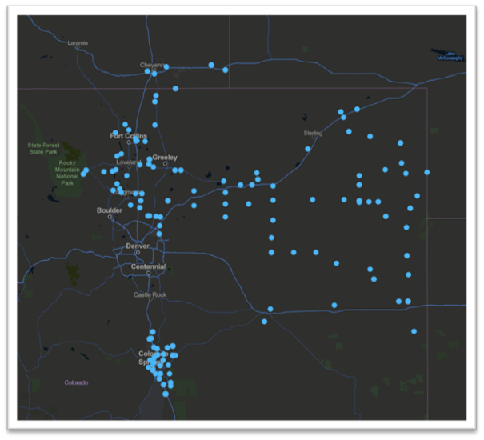

Cluster analysis & SAS® FastClus

Cluster Analysis
Cluster analysis is a versatile, exploratory statistical analysis procedure used to identify natural groupings (or clusters) within a dataset. Its primary aim is not necessarily to infer anything about the data contained within a given set but rather to divide observations from a data set into mutually exclusive groups, such that the degree of association between observations in the same group is maximized and otherwise, is minimized. Figure 2 below presents an example of data groupings identified using Cluster Analysis.
Figure 2. Example of Data Grouping Identified by Cluster Analysis
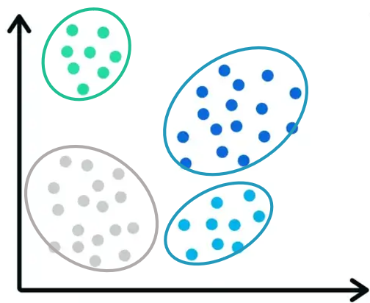
In modern wholesale electricity markets, the price of electricity not only varies over time but also by location (i.e., from one PNode to the next). Wholesale market participants have an interest in there being at least one reference price available to leverage to hedge against certain price risks and settle forward contracts. The designation of a Trading Hub is one such way of providing wholesale market participants with such a price. The reference price provided by a Trading Hub is the result of a specific algorithm having been applied to estimate an average of the real-time LMPs recorded at set locations (i.e., PNodes) that together are considered representative of typical price dynamics in the wholesale market.

SAS®FASTCLUS
SPP performed Cluster Analysis using SAS® FASTCLUS procedure. The SAS® FASTLUS procedure performs disjoint clustering by first randomly selecting observations, referred to as seeds from a given data set. The seeds represent the first guess at the means of different natural groupings within the data set (i.e., clusters contained within the set). Each remaining observation is then assigned to the nearest seed to form a provisional cluster, and the initial seed is then replaced by the arithmetic average of the observations forming each cluster. The process iterates until convergence is achieved as signaled by the minimization of the sum of squared distances between the observations in a cluster and that cluster’s mean (i.e., centroid) or as specified by the user – e.g., a maximum of 50 iterations.

Analysis & Results
SPP applied the SAS® FASTCLUS procedure to real-time LMPs recorded at WEIS PNodes between 1/1/2024 and 12/31/2024 to discover whether groupings of similar PNodes existed in WEIS. Real-time LMPs were sourced from the SPP Portal for each month throughout 2024. Once duplicate values were removed, real-time LMPs were then sorted by interval id and PNode name. Each interval id was replaced with a unique numerical value corresponding to its observation $n$ within the set of all observations $N.$
An initial application of the SAS® FASTCLUS procedure was performed with the maximum number of clusters set equal to 30 and iterations set equal to 100. Clusters with sufficient frequency (i.e., number of PNodes) whose Euclidian distance (i.e., maximum straight-line distance between the arithmetic average of the observations forming each cluster and the observation farthest from that average) indicated there was not much difference in the real-time LMPs contained within a cluster and the average LMP, were then subject to multiple applications of the SAS® FASTCLUS procedure until a maximum number of 10 clusters were identified with no more than 100 iterations.
The resulting 10 clusters were then graded in line with the requirements set forth in Section 3.1.1 of Attachment AE of SPP’s Open Access Transmission Tariff. Namely whether an LMP could always be calculated, even if a PNode were unavailable or adjacent to a line outage, a relatively high rate of service availability exists among which Transmission Service is relatively unconstrained, and the PNodes contained within the cluster do not represent only the combined loads and Resources of a single vertically integrated utility. An ideal Trading hub is one that has a high number of PNodes and a low standard deviation. Table 1 below compares the frequency, root-mean standard deviation (“RMSD”), and Euclidian distance reported for the 10 clusters.
Table 1. Frequency, RMSD, and Euclidian distance reported for 10 clusters
Cluster # | Frequency | RMSD | Euclidian Distance
1 | 135 | 2.16 | 137.5
2 | 41 | 1.57 | 88.96
3 | 131 | 1.48 | 122.7
4 | 36 | 1.31 | 65.20
5 | 66 | 0.90 | 85.02
6 | 69 | 2.08 | 139.8
7 | 129 | 2.55 | 120.8
8 | 5 | 0.20 | 5.71
9 | 5 | 2.88 | 100.3
10 | 323 | 1.99 | 122.5

The cluster with the highest frequency (i.e., the greatest number of PNodes), with a comparative maximum Euclidian distance, whose RMSD indicated the LMPs recorded at the various PNodes contained within the cluster were tightly clustered around that of the average PNode – Cluster 10 – was selected. Further refinement of Cluster 10 to remove potential outliers by tightening the maximum distance allowed resulted in a reported frequency of 280 PNodes compared to 323 PNodes; an improved maximum Euclidian distance of 74.18 compared to 122.5; and a smaller root mean standard deviation of 1.52 compared to 1.99.
While there are no defined or absolute thresholds in determining whether a new Trading hub should be established SPP Markets staff discerned the refined Cluster 10 satisfied the conditions set forth in Section 3.1.1 of Attachment AE of the Tariff and therefore recommended Cluster 10’s PNodes be used to establish the 2025 Initial Western Trading Hub – SWPW_HUB.
Specifically, the 280 PNodes are representative and offer several pathways to mitigate the effects of potential topological issues, suggesting an LMP can always be calculated even if one PNode becomes unavailable or is adjacent to a line outage. Together, the PNodes have a high rate of service availability, among which Transmission Service is relatively unconstrained and do not presently encompass the combined loads and Resources of any single vertically integrated utility. The standard deviation reported is well below that of the existing North Hub and South Hub. The Euclidian distance suggests the LMPs are close to the average and thus prices are not very volatile.
Figure 3 presents all western PNodes SPP performed the FASTCLUS procedure on, differentiated by constituting the proposed SWPW_HUB (blue dots) (i.e., Cluster 10) and not constituting the SWPW_HUB (red dots).
Figure 3. All Western PNodes and those constituting the SWPW_HUB
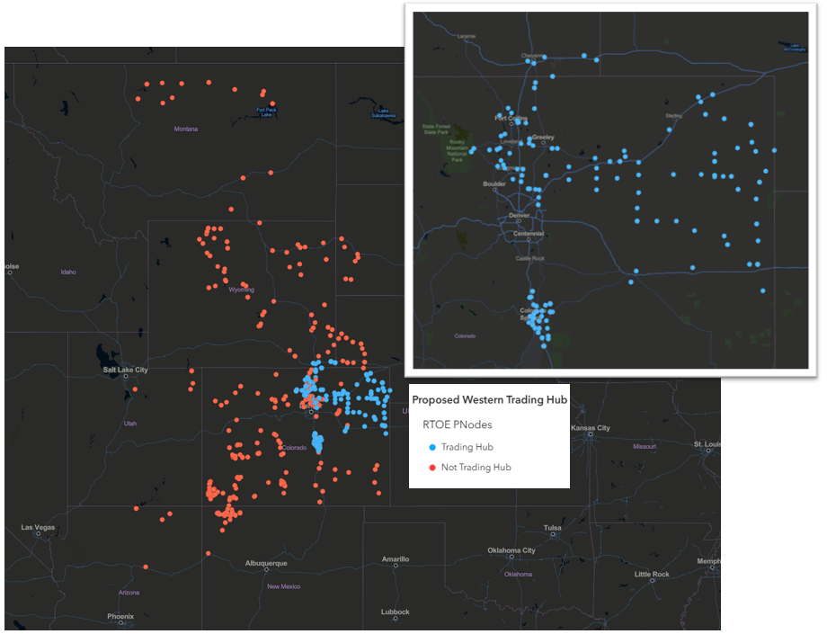
SPP does, however, suggest additional, continuous analysis be performed to ensure at no point the PNodes forming the SWPW_HUB only represent the combined loads and Resources of a single vertically integrated utility given the large number of WAWU and WACM PNodes forming it and the evolving nature of SPP’s Western Operations and Expansion.

Governing Documents Language Review
A detailed review of Section 3.1.1 of Attachment AE of SPP’s Open Access Transmission Tariff and Section 4.5.2.3.1 of SPP’s Integrated Marketplace Protocols suggest, at present, no language changes need to be made in these two governing documents to support the Trading Hub needs of SPP’s Western members. The requirements for establishing a new Trading Hub in the Tariff and the approval process outlined in the Integrated Marketplace Protocols provide a clear direction for establishing, modifying or dissolving a Trading Hub in the Western area of SPP’s footprint. Additionally, the requirements set forth infeasible given differences in the electric market operations in the Western Interconnect. As such, it is SPP’s recommendation that no language changes be made to either governing document at this time.

Conclusions & Considerations
It is SPP’s recommendation the 2025 Initial Western Trading Hub – SWPW_HUB – consisting of 280 PNodes be established. Establishment is recommended based on the proposed Trading Hub having met all the requirements articulated in Section 3.1.1 of Attachment AE of SPP’s Open Access Transmission Tariff, the LMP behavior of the proposed Trading Hub being comparable to the LMP behavior of existing SPP Trading Hubs, namely the North and South Hub, and the standard deviation and maximum variance of the proposed Trading Hub having been deemed optimal compared to all the incoming PNodes combined. LMP data used for the analysis, however, is best available as of 2025.​ RTOE go-live is scheduled for April 2026, and as such, SPP recommends continuous evaluation of all trading hubs. A detailed review of current governing documents, specifically the Tariff and Protocols, suggest at present no changes need to be made.

See RTO Expansion.
SPP began administering WEIS on a contract basis in February of 2021. WEIS not only provides price transparency of wholesale energy but also allows parties to trade bilaterally and hedge against costly transmission congestion. At the time of this analysis, there were twelve participants in WEIS. WEIS participants included Basin Electric Power Cooperative; Black Hills Energy; City of Farmington NM Electric Utility; Colorado Springs Utilities; Deseret Power Electric Cooperative; Guzman Energy; Municipal Energy Agency of Nebraska; Platte River Power Authority; Tri-State Generation and Transmission Association; United Power, Inc.; Western Area Power Administration and Xcel Energy. See Western Energy Imbalance Market (WEIS).
C. C. Aggarwal, "An Introduction to Cluster Analysis," in Data Clustering, Chapman and Hall/CRC, 2014.
W. Webster, "What is cluster analysis? Overview and Examples," Qualtrics, 2025. [Online]. Available: https://www.qualtrics.com/experience-management/research/cluster-analysis/.
P. A. Borisovsky, A. V. Eremeev, E. B. Grinkevich, S. A. Klokov and N. A. Kosarev, "Trading Hubs Construction in Electricity Markets Using Evolutionary Algorithms," Applied Problems, vol. 24, no. 2, 2014.
See SAS/STAT® 13.2 User’s Guide: The FASTCLUS Procedure
See portal.spp.org
If a maximum number of iterations is not specified by the user, the FASTCLUS procedure will run to complete convergence, and the final cluster seeds will be equal the cluster means.

